Supplemental Information:

Supplemental Figures
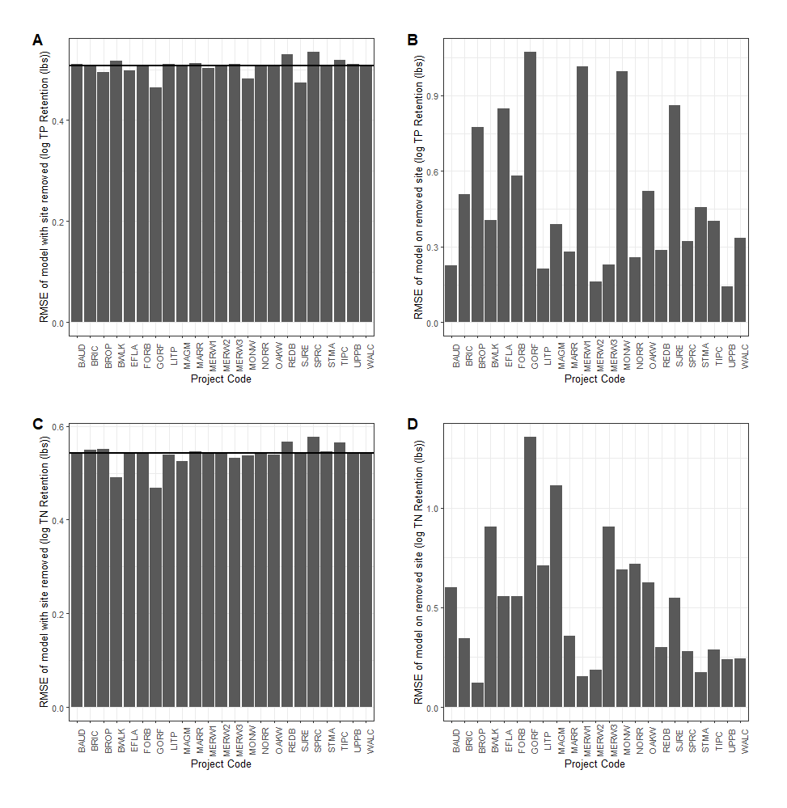
Figure S1. Root mean square error (RMSE) of linear models of monthly TP retention ~ inflow volume. Each bar represents the RMSE for a) the model with the listed wetland removed or b) the performance of the model predicting TP retention of the removed wetland. The horizontal line in A and C is the RMSE of the full model.

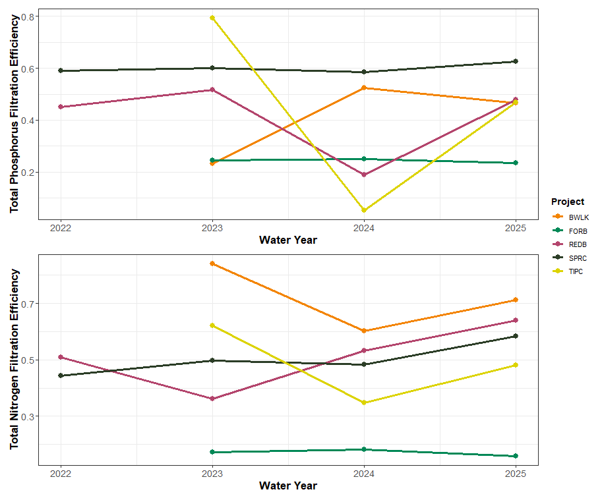
Figure S2. Change in annual phosphorus and nitrogen filtration efficiency over time across the five wetlands with three or more years of data. Nutrient filtration efficiency was calculated as the annual mass of the nutrient filtered divided by the annual total mass of that nutrient that entered the wetland.
Table S1. Nutrient retention across all monitoring years for H2Ohio wetlands. Retention was calculated by measuring inflowing and outflowing nutrients to 24 different wetlands for between one and four years. Nutrient budgets were calculated for total phosphorus (TP), total nitrogen (TN), dissolved reactive phosphorus (DRP), nitrite+nitrate (NO_{x}), and total ammonium nitrogen (NH₄).
 |  |  |  | Retention (lbs of Phosphorus or Nitrogen)
Wetland | Restored Wetland (acres) | Water Year | Inflow volume (m³) | Total P | Total N |  | DRP | NO_{x} | NH₄
BAUD | 12 | 2025 | 301,375 | 50 |  | 864 | 54 | 716 | 9
BRIC | 11 | 2025 | 77,712 | 9 |  | 234 | 1 | 162 | 1
BROP | 5 | 2023 | 1,185,291 | 24 |  | 3,294 | 21 | 2,838 | 65
 |  | 2024 | 1,214,616 | 59 |  | 4,266 | 22 | 3,781 | 94
BWLK | 27 | 2023 | 195,394 | 41 |  | 7,345 | 25 | 6,831 | 203
 |  | 2024 | 438,735 | 238 |  | 5,513 | 120 | 4,976 | 0
 |  | 2025 | 177,637 | 86 |  | 5,627 | 57 | 4,803 | -5
EFLA | 3.5 | 2024 | 867,904 | 1,733 |  | 3,388 | 122 | 647 | 127
 |  | 2025 | 1,434,010 | 611 |  | 1,378 | 61 | 198 | -75
FORB | 5 | 2023 | 15,657 | 12 |  | 29 | 0 | 3 | 0
 |  | 2024 | 10,866 | 9 |  | 21 | 0 | 2 | 0
 |  | 2025 | 20,858 | 15 |  | 36 | 0 | 2 | 0
GORF | 1 | 2024 | 115 | 0 |  | 0 | 0 | 0 | 0
 |  | 2025 | 613 | 0 |  | 0 | 0 | 0 | 0
LITP | 95 | 2025 | 149,847 | 38 |  | 1,177 | 16 | 1,221 | 134
MAGM | 173 | 2024 | 149,224 | 16 |  | 290 | 2 | 8 | 11
 |  | 2025 | 623,492 | 219 |  | 729 | 119 | 227 | 362
MARR | 16 | 2025 | 8,073 | 3 |  | 13 | 3 | 16 | 0
MERW1 | 15 | 2025 | 57,229 | -11 |  | -55 | 9 | 1 | -14
MERW2 | 30 | 2025 | 54,504 | 13 |  | 219 | 7 | 1 | -2
MERW3 | 4.5 | 2025 | 263,764 | 115 |  | 2,528 | 22 | 1,810 | 61
MONW | 10 | 2024 | 11,476 | 9 |  | -33 | -10 | -2 | NA
 |  | 2025 | 18,838 | 29 |  | 184 | 15 | 85 | NA
NORR | 23 | 2025 | 151,978 | 13 |  | 648 | 3 | 532 | 43
OAKW | 20 | 2024 | 7,621 | 4 |  | 106 | 1 | 88 | 0
 |  | 2025 | 52,884 | 28 |  | 694 | 8 | 576 | -2
REDB | 25 | 2022 | 108,974 | 27 |  | 396 | 7 | 260 | 2
 |  | 2023 | 109,881 | 20 |  | 178 | 4 | 126 | 4
 |  | 2024 | 80,006 | 7 |  | 212 | 1 | 167 | 2
 |  | 2025 | 75,195 | 19 |  | 302 | 0 | 279 | 0
SJRE | 33 | 2024 | 66,141 | 1 |  | 1,075 | 14 | 750 | 28
 |  | 2025 | 134,681 | 4 |  | 1,968 | 28 | 1,701 | 89
SPRC | 25 | 2022 | 401,810 | 153 |  | 2,435 | 76 | 1,890 | 37
 |  | 2023 | 278,428 | 103 |  | 1,952 | 57 | 1,684 | 31
 |  | 2024 | 194,282 | 68 |  | 1,394 | 33 | 1,130 | 20
 |  | 2025 | 334,554 | 110 |  | 2,864 | 48 | 2,049 | 53
STMA | 31 | 2025 | 370,350 | 252 |  | 2,385 | 95 | 3 | 421
TIPC | 10 | 2023 | 256,538 | 112 |  | 1,569 | 64 | 1,745 | 25
 |  | 2024 | 269,018 | 6 |  | 1,032 | 13 | 987 | 63
 |  | 2025 | 323,796 | 73 |  | 1,791 | 43 | 1,828 | 35
TRUC | 30 | 2025 | 0 | -3 |  | -56 | -1 | -1 | -9
UPPB | 30 | 2025 | 55,267 | 2 |  | 115 | -1 | 59 | 3
WALC | 17.4 | 2023 | 770,819 | 166 |  | -549 | 117 | 380 | -24
 |  | 2024 | 1,687,419 | 497 |  | 4,789 | 295 | 6,904 | -20

Table S2. Nutrient retention efficiency across all monitoring years for H2Ohio wetlands. Retention was calculated as the proportion of incoming nutrients that were not detected leaving the system. Nutrient retention efficiency was calculated for total phosphorus (TP), total nitrogen (TN), dissolved reactive phosphorus (DRP), nitrite+nitrate (NO_{x}), and total ammonium nitrogen (NH₄).
 |  |  |  | Retention (lbs of Phosphorus or Nitrogen)
Wetland | Restored Wetland (acres) | Water Year | Inflow volume (m³) | Total P | Total N |  | DRP | NO_{x} | NH₄
BAUD | 12 | 2025 | 301,375 | 46% |  | 93% | 36% | 54% | 26%
BRIC | 11 | 2025 | 77,712 | 28% |  | 33% | 31% | 39% | 16%
BROP | 5 | 2023 | 1,185,291 | 8% |  | 26% | 40% | 53% | 54%
 |  | 2024 | 1,214,616 | 19% |  | 29% | 47% | 63% | 63%
BWLK | 27 | 2023 | 195,394 | 23% |  | 51% | 84% | 91% | 94%
 |  | 2024 | 438,735 | 52% |  | 67% | 60% | 73% | 0%
 |  | 2025 | 177,637 | 47% |  | 75% | 71% | 77% | -13%
EFLA | 3.5 | 2024 | 867,904 | 76% |  | 35% | 54% | 45% | 48%
 |  | 2025 | 1,434,010 | 26% |  | 13% | 25% | 13% | -59%
FORB | 5 | 2023 | 15,657 | 25% |  | -12% | 17% | 3% | 17%
 |  | 2024 | 10,866 | 25% |  | -11% | 18% | 4% | 18%
 |  | 2025 | 20,858 | 23% |  | -14% | 16% | 2% | 15%
GORF | 1 | 2024 | 115 | 14% |  | 14% | 14% | 14% | 14%
 |  | 2025 | 613 | 8% |  | 8% | 8% | 8% | 8%
LITP | 95 | 2025 | 149,847 | 57% |  | 57% | 83% | 96% | 72%
MAGM | 173 | 2024 | 149,224 | 38% |  | 28% | 42% | 2% | 20%
 |  | 2025 | 623,492 | 75% |  | 89% | 64% | 92% | 66%
MARR | 16 | 2025 | 8,073 | 80% |  | 95% | 54% | 99% | -8%
MERW1 | 15 | 2025 | 57,229 | -21% |  | 90% | -9% | 25% | -143%
MERW2 | 30 | 2025 | 54,504 | 26% |  | 76% | 37% | 30% | -15%
MERW3 | 4.5 | 2025 | 263,764 | 60% |  | 90% | 62% | 98% | 80%
MONW | 10 | 2024 | 11,476 | 32% |  | -332% | -19% | -2% | NA
 |  | 2025 | 18,838 | 76% |  | 91% | 75% | 76% | NA
NORR | 23 | 2025 | 151,978 | 78% |  | 85% | 97% | 100% | 96%
OAKW | 20 | 2024 | 7,621 | 92% |  | 98% | 96% | 99% | 59%
 |  | 2025 | 52,884 | 87% |  | 90% | 92% | 96% | -83%
REDB | 25 | 2022 | 108,974 | 45% |  | 96% | 51% | 99% | 18%
 |  | 2023 | 109,881 | 52% |  | 47% | 36% | 48% | 50%
 |  | 2024 | 80,006 | 19% |  | 26% | 53% | 93% | 29%
 |  | 2025 | 75,195 | 48% |  | 9% | 64% | 100% | 0%
SJRE | 33 | 2024 | 66,141 | 5% |  | 70% | 77% | 88% | 72%
 |  | 2025 | 134,681 | 6% |  | 69% | 76% | 90% | 83%
SPRC | 25 | 2022 | 401,810 | 59% |  | 69% | 44% | 46% | 48%
 |  | 2023 | 278,428 | 60% |  | 73% | 50% | 54% | 54%
 |  | 2024 | 194,282 | 58% |  | 69% | 48% | 51% | 51%
 |  | 2025 | 334,554 | 63% |  | 71% | 58% | 57% | 61%
STMA | 31 | 2025 | 370,350 | 87% |  | 96% | 79% | 38% | 95%
TIPC | 10 | 2023 | 256,538 | 79% |  | 96% | 62% | 78% | 80%
 |  | 2024 | 269,018 | 5% |  | 36% | 35% | 49% | 80%
 |  | 2025 | 323,796 | 47% |  | 76% | 48% | 70% | 46%
TRUC | 30 | 2025 | 0 | 0% |  | 0% | 0% | 0% | 0%
UPPB | 30 | 2025 | 55,267 | 11% |  | -53% | 44% | 91% | 47%
WALC | 17.4 | 2023 | 770,819 | 63% |  | 99% | -12% | 12% | -82%
 |  | 2024 | 1,687,419 | 58% |  | 97% | 41% | 95% | -10%

Table S3. List of H2Ohio wetlands monitored, the county the wetland is located in, the area of restored wetland and the percent of both agriculture and urban in the drainage area of the wetland.
Wetland Code | Wetland Name | County | Restored Wetland (acres) | % Agriculture | % Urban
BAUD | Baughman Ditch | Allen | 12 | 9% | 81%
BRIC | Bright Wetland | Hancock | 11 | 85% | 7%
BROP | Brooks Park | Fairfield | 5 | 73% | 10%
BWLK | Burntwood-Langenkamp | Mercer | 27 | 90% | 6%
EFLA | Williamsburg Wetland | Clermont | 3.5 | 73% | 7%
FORB | Forder Bridge | Paulding | 5 | 72% | 13%
GORF | Gorman Farms | Hamilton | 1 | 7% | 83%
LITP | Little Portage | Ottawa | 95 | 73% | 8%
MAGM | Magee Marsh | Ottawa | 173 | 73% | 9%
MARR | Martin's Run | Lorain | 16 | 7% | 74%
MERW1 | Mercer Wetland | Mercer | 15 | 78% | 13%
MERW2 | Mercer Wetland | Mercer | 30 | 78% | 13%
MERW3 | Mercer Wetland | Mercer | 4.5 | 78% | 13%
MONW | Montpelier Wetland | Williams | 10 | 64% | 8%
NORR | North Ridge | Ottawa | 23 | 83% | 9%
OAKW | Oakwoods West | Hancock | 20 | 70% | 21%
REDB | Redhorse Bend | Williams | 25 | 80% | 8%
SJRE | St. Joe's Restoration | Williams | 33 | 66% | 7%
SPRC | Springcreek Confluence | Miami | 25 | 86% | 6%
STMA | St. Mary's | Auglaize | 31 | 82% | 8%
TIPC | Tipp City | Miami | 10 | 77% | 11%
TRUC | Trumbull Creek | Ashtabula | 30 | 37% | 4%
UPPB | Upper Blanchard | Wyandot | 30 | 88% | 5%
WALC | Walnut Creek | Franklin | 17.4 | 64% | 20%

Table S4. Water sources and monitoring method summary for monitored wetlands. Lake inflow, tile inflow and river inflow all indicate whether each wetland had source water from one or more of those sources. Inflow and outflow hydrology describes the method used to measure inflow and outflow volume. Event samples indicates the number of event samples collected for each wetland. More detailed methods are included in the supplemental information.
Wetland Code | Lake inflow | Tile inflow | River inflow | Inflow Hydrology |  | Outflow Hydrology | Event Samples
BAUD | No | Yes | No | Stage Storage |  | Stage Storage | 4
BRIC | No | No | Yes | Stage Storage |  | Stage Storage | NA (no storms)
BROP | Yes | No | Yes | Watershed Weighting | Flow Sensor |  | 4
BWLK | No | No | Yes | Evapotranspiration |  | Weir | 5
EFLA | No | No | Yes | Stage Storage |  | Stage Storage | 5
FORB | No | Yes | No | NRCS curve number/Weir |  | Evapotranspiration | 10
GORF | No | No | No | Stage Storage |  | Stage Storage | 8
LITP | No | No | Yes | Stage Storage |  | Stage Storage | 7
MAGM | No | No | Yes | Stage Storage |  | Stage Storage | NA (WCS)
MARR | No | No | Yes | Stage Storage |  | Stage Storage | 7
MERW1 | Yes | No | Yes | Pump Rates |  | Pump Rates | NA (Pumped)
MERW2 | Yes | No | Yes | Pump Rates |  | Pump Rates | NA (Pumped)
MERW3 | Yes | No | Yes | Stage Storage |  | Stage Storage | NA (Pumped)
MONW | No | Yes | No | Weir |  | Weir | 4
NORR | No | Yes | Yes | Pump Rates |  | Weir | NA (Pumped)
OAKW | No | Yes | Yes | Stage Storage |  | Stage Storage | 4
REDB | No | No | Yes | Stage Storage |  | Stage Storage | 5
SJRE | No | Yes | Yes | Stage Storage |  | Stage Storage | 5
SPRC | No | No | Yes | Stage Storage |  | Stage Storage | 2
STMA | No | No | No | Weir |  | Weir | NA (WCS)
TIPC | No | No | Yes | Stage Storage |  | Stage Storage | 4
TRUC | No | No | No | NA |  | Weir | 6
UPPB | No | No | Yes | Stage Storage |  | Stage Storage | 4
WALC | No | No | Yes | Stage Storage |  | Stage Storage | 1

Table S5. ANCOVA Results for A. TP, B. TN, C. DRP, D. NOx, E. NH4.
A. Total Phosphorus: log(TP retention) ~ (log(TP concentration + log(inflow volume)) * Wetland
 | Df | Sum Sq | Mean Sq | F value | P
log(TP concentration mg/L) | 1 | 96.5 | 96.5 | 262.121 | <0.001
log(inflow volume m³) | 1 | 2222.5 | 2222.5 | 6034.328 | <0.001
Wetland | 22 | 87.5 | 4 | 10.801 | <0.001
log(TP concentration mg/L) : Wetland | 20 | 13.3 | 0.7 | 1.799 | 0.0213
log(inflow volume m³) : Wetland | 21 | 6.8 | 0.3 | 0.874 | 0.6255
B. Total Nitrogen: log(TN retention) ~ (log(TN concentration + log(inflow volume)) * Wetland
 | Df | Sum Sq | Mean Sq | F value | P
log(TN concentration mg/L) | 1 | 40.6 | 40.6 | 410.627 | <0.001
log(inflow volume m³) | 1 | 349.5 | 349.5 | 3532.84 | <0.001
Wetland | 22 | 33.8 | 1.5 | 15.524 | <0.001
log(TN concentration mg/L) : Wetland | 20 | 11.1 | 0.6 | 5.603 | <0.001
log(inflow volume m³) : Wetland | 21 | 2.6 | 0.1 | 1.26 | 0.204
Residuals | 233 | 23.1 | 0.1
C. Dissolved Reactive Phosphorus: log(DRP retention) ~ (log(DRP concentration + log(inflow volume)) * Wetland
 | Df | Sum Sq | Mean Sq | F value | P
log(DRP concentration mg/L) | 1 | 100.2 | 100.2 | 1371.361 | <0.001
log(inflow volume m³) | 1 | 439.5 | 439.5 | 6014.155 | <0.001
Wetland | 22 | 15.6 | 0.7 | 9.691 | <0.001
log(DRP concentration mg/L) : Wetland | 21 | 2.1 | 0.1 | 1.383 | 0.127
log(inflow volume m³) : Wetland | 22 | 2.2 | 0.1 | 1.387 | 0.121
Residuals | 241 | 17.6 | 0.1
D. Nox: log(NOx retention) ~ (log(NOx concentration + log(inflow volume)) * Wetland
 | Df | Sum Sq | Mean Sq | F value | P
log(NOx concentration mg/L) | 1 | 329.6 | 329.6 | 5172.647 | <0.001
log(inflow volume m³) | 1 | 441.2 | 441.2 | 6924.695 | <0.001
Wetland | 22 | 45.6 | 2.1 | 32.543 | <0.001
log(NOx concentration mg/L) : Wetland | 19 | 6.1 | 0.3 | 5.018 | <0.001
log(inflow volume m³) : Wetland | 20 | 7.5 | 0.4 | 5.884 | <0.001
Residuals | 277 | 17.6 | 0.1
E. NH4: log(NH4 retention) ~ (log(NH4 concentration + log(inflow volume)) * Wetland
 | Df | Sum Sq | Mean Sq | F value | P
log(NH4 concentration mg/L) | 1 | 209.53 | 209.53 | 2265.549 | <0.001
log(inflow volume m³) | 1 | 303.57 | 303.57 | 3282.416 | <0.001
Wetland | 21 | 11.34 | 0.54 | 5.841 | <0.001
log(NH4 concentration mg/L) : Wetland | 18 | 7.87 | 0.44 | 4.73 | <0.001
log(inflow volume m³) : Wetland | 19 | 5.57 | 0.29 | 3.168 | <0.001
Residuals | 221 | 20.44 | 0.09

Nutrient Retention Methods:
Contents
Baughman Ditch (BAUD) 3
Bright Conservation Area Wetland Restoration Initiative (BRIC) 3
Burntwood-Langenkamp Wetland Conservation Area (BWLK) 9
Williamsburg Wetland Treatment System (EFLM) 12
Forder Bridge Floodplain Reconnection (FORB) 18
Gorman Heritage Farm Treatment Wetland System (GORF) 22
Little Portage Nutrient Reduction & Coastal Wetland Restoration (LITP) (SE-UNIT) 25
Magee Marsh Turtle Creek Bay Wetland Reconnection Project (MAGM) 34
Martin’s Run Wetland and Stream Restoration Project (MARR) 41
Mercer Wetland Complex Restoration Phase 1 (MERW1) 44
Mercer Wetland Complex Restoration Phase 2 (MERW2) 46
Mercer Wetland Complex Restoration Phase 3 (MERW3) 48
Montpelier Wetland (MONW) 51
North Ridge Hunt Club Wetland Restoration (NORR) 54
Oakwoods Nature Preserve Restoration Project West (OAKW) 57
Redhorse Bend Preserve Restoration Project (REDB) 61
St. Joseph River Restoration Project (SJRE) 65
Springcreek Confluence Off-Channel Wetlands (SPRC) 70
City of St. Marys Treatment Train (STMA) 78
Tipp City Off Channel Wetland (TIPC) 81
Trumbull Creek Wetland (TRUC) 84
Upper Blanchard River Watershed Project (UPPB) 88
Evapotranspiration Estimation 91

Baughman Ditch (BAUD)

Introduction
Baughman Petition Ditch (Baughman Project) was constructed in 2024 as a series of three stormwater wetland pools connected through a series of field tiles and water level control structures to prevent flooding in adjacent neighborhoods. Routine collection of surface water samples began in winter of Water Year (2025). Collection of continuous water level data via Solinst Leveloggers also began in winter of WY 2025.
Surface water samples were collected from the inflow(s) and outflow of every wetland pool to be able to determine the nutrient removal efficiency of each pool. Continuous water level data collection in every wetland began in February 2025 to track daily change in volume of each pool over time.
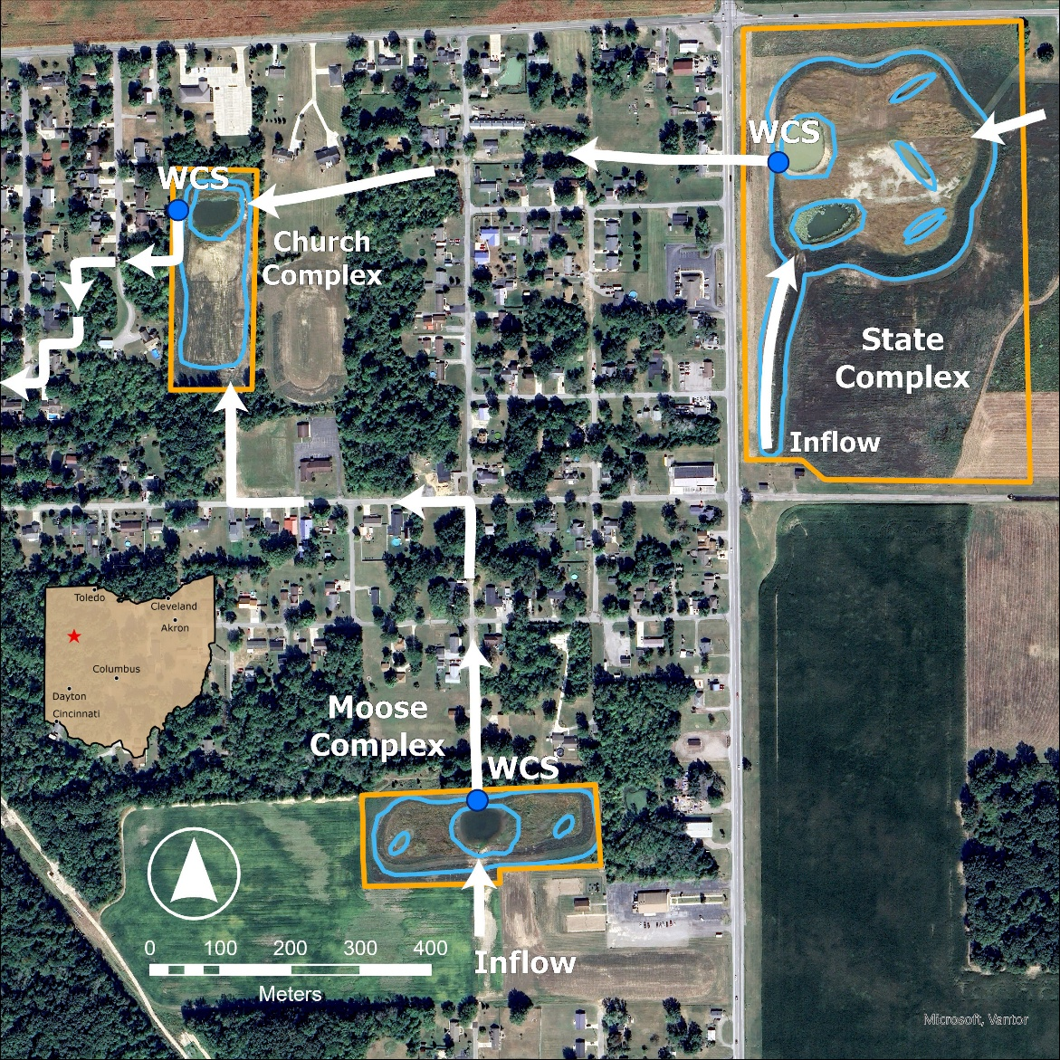
Figure 1. BAUD Flowpath Map. Blue outlines indicate wetland pools and arrows represent water flow direction.

Data used
Table 1. Datasets used in volume and nutrient budget calculations.
Dataset Name | Source | Duration | Data Type
Water Depth (Solinst Levellogger) | H2Ohio WMP | N/A | Water Depth
Weather | Iowa Mesonet | N/A | Wind speed, min/max air temp, min/max relative humidity, Atmospheric pressure
Solar Radiation | NASA | N/A | Solar radiation
Nutrients | H2Ohio WMP | WY 2023-WY 2025 | TP, DRP, TN, Nox, NH3

Volume Budgeting
Using the acreages and average daily depths, an average daily pool volume was calculated using the equations outlined in Table 2.

Table 2. Pool volume equation for the three wetland complexes.
Wetland Complex | Deep Water Pools Volume | Entire Wetland Pool Volume
State | Volume=0.763∗waterdepth∗325852 | Volume=(10.55∗(waterdepth−4)∗325852)+994497
Moose | Volume=0.499∗waterdepth∗325852 | Volume=(3.38∗(waterdepth−4)∗325852)+650399
Church | Volume=0.303∗waterdepth∗325852 | Volume=(3.04∗(waterdepth−4)∗325852)+394931
In the above equations, 325,852 is the volume of water in 1-acre foot. If water level loggers read greater than 4 ft, it is assumed the deep-water pools are full and at capacity volumes are added to the entire wetland volume. A daily change in volume was calculated by subtracting the current days volume by the previous day. Positive daily change in volumes correspond to inflow, and negative daily change in volumes correspond to outflow. All of the positive daily change in volumes can be summed to determine a seasonal inflow volume.
Inflowing volume was calculated as all increases in volume in the pool, while outflowing volume was calculated as all decreases in volume minus the volume of water lost to evapotranspiration. We are calculating evapotranspiration using the Penman-Monteith equation:
ET0=0.408∆(Rn-G)+900T+273u2(es-ea)∆+(1+0.34u2)
Where ET_{o} reference evapotranspiration [mm day⁻¹], R_{n} net radiation at the crop surface [MJ m⁻² day⁻¹], G soil heat flux density [MJ m⁻² day⁻¹], T mean daily air temperature at 2 m height [°C], u₂ wind speed at 2 m height [m s⁻¹], e_{s} saturation vapour pressure [kPa], e_{a} actual vapour pressure [kPa], e_{s} - e_{a} saturation vapour pressure deficit [kPa], D slope vapour pressure curve [kPa °C⁻¹], g psychrometric constant [kPa °C⁻¹]. Historical weather data was downloaded from Iowa Mesonet, and solar radiation data was downloaded from NASA.

Nutrient Concentrations
Surface water samples were collected from the Moose wetland inflow (BAUD_01), the Moose wetland outflow (BAUD_02), the State Road Inflow (BAUD_03), the State wetland outflow (BAUD_04), the Church wetland inflow from State wetland (BAUD_05), the Church wetland inflow from Moose wetland (BAUD_07), and the Church wetland outflow (BAUD_06). An average seasonal concentration was calculated for each inflow and outflow.

Nutrient Load Calculation
Seasonal nutrient loads retained were calculated as:
LoadRetained=[(Inflowconcentration−Outflowconcentration)∗0.0022046∗Volume]/[0.26417∗1000]
Where load retained is in pounds, concentrations are in mg/L, volume (seasonal pool inflow volume) is in gallons, 1000 converts mg to g, 0.0022046 converts g to lbs, and 0.26417 converts liters to gallons.

Assumptions, Uncertainties, and Data Gaps
This approach assumes no meaningful net influence of groundwater to input or output nutrient loads. It also assumes that inflow and outflow volumes stay constant until another measurement was taken/inflow weir or outflow stoplog height was adjusted. It is assumed that the seasonal averages are the best representative of inflowing nutrient concentrations.

Bright Conservation Area Wetland Restoration Initiative (BRIC)

Introduction
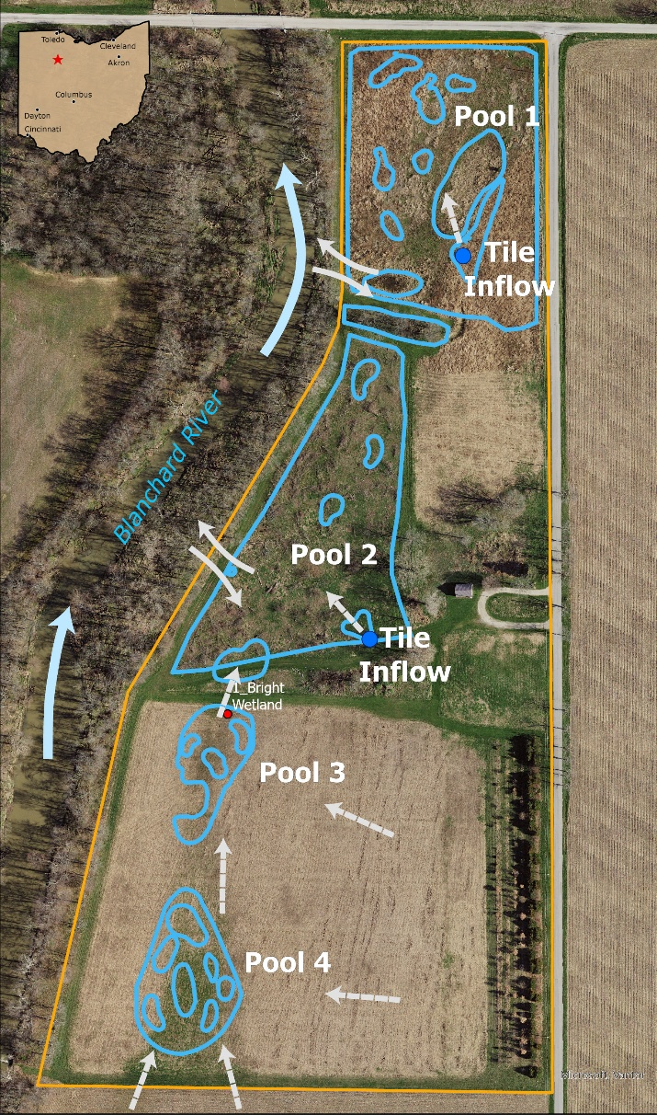
The Bright Conservation Area is a 29.4-acre wetland restoration site in Findlay, Ohio, adjacent to the Blanchard River, containing approximately 8.5 acres of restored wetland pools arranged as four basins parallel to the river. The site occupies former tiled agricultural land and was intended to function as a flow-through treatment wetland receiving agricultural drainage prior to discharge to the river; however, observed hydrologic behavior differs from this design intent. Under baseflow conditions, Pools 1 and 2 primarily receive tile drainage from upgradient agricultural fields, while Pools 3 and 4 receive surface runoff from adjacent fields, with limited discharge observed through water-control structures and water commonly retained within pools and adjacent wetlands. Although not designed as a floodplain system, the wetland rarely becomes hydraulically connected to the Blanchard River during high-flow events, when river water overtops banks, bypasses internal berms and control structures, and directly inundates restored pools. As a result, hydrologic conditions at the site vary over time and can be conceptualized as distinct environmental states, including baseflow conditions dominated by agricultural inputs, transitional periods associated with changing river stage, and flood-driven inundation events characterized by direct river–wetland connectivity.
The nutrient budget for this site is calculated as the difference in monthly mean concentration in each of four wetland pools multiplied by the inflowing and outflow volume of water to each pool. Volume was calculated using a stage storage model built using the change in depth over time at both the main pool and the branching pool. All increases in volume are considered to be inflows, whereas evapotranspiration is calculated to subtract from all decreases in volume to calculate outflow. This is combined with monthly mean nutrient concentrations for each pool to calculate the mass of each nutrient in and out of the wetland. We do not have data for inflowing concentrations, just for concentrations within each pool so the results of this nutrient budget are primarily driven by the volume of water that is retained by each pool.
Figure 2. BRIC Flowpath Map. Blue outlines indicate wetland pools and arrows represent water flow direction.

Data used
Table 3. Datasets used in volume and nutrient budget calculations.
Dataset Name | Source | Duration | Data Type
Water Depth | H2Ohio WMP | WY2022-present | Water depth
Blanchard River Nutrients | NCWQR/H2Ohio WMP | WY2022-present | TP, DRP, TN, Nox
Blanchard River Discharge | USGS | WY2022-present | Q (cms)
Weather | Iowa Mesonet | WY 2022-present | Wind speed, min/max air temp, min/max relative humidity, Atmospheric pressure
Solar Radiation | NASA | 10/1/22-present | Solar radiation
Nutrients | NCWQR/H2Ohio WMP | WY 2022-present | TP, DRP, TN, Nox
Water Level (VEGAPuls) | H2Ohio WMP Sensor Network | WY 2022-present | Water Level

Volume Budgeting
Volume in and out of the 4 pools at BRIC was calculated using a stage storage approach. Water depth was measured with Vega PULS C-21 sensors at pools 1 and 4. Water level data from 5-7 point measurements was used to make a linear relationship between water level at pool 1 and pool 2, and water level at pool 4 and pool 3. Then that relationship was applied to the continuous sensor data at pools 1 and 4 to estimate the water depth of pools 2 and 3 throughout time. Volume was calculated as the pool depth x the area of the pool. The inflowing volume was calculated as all daily positive changes in water volume for each pool, whereas the outflowing volume was calculated as all negative changes in water volume for each pool minus the daily evapotranspiration volume for the pool. We are calculating evapotranspiration using the Penman-Monteith equation:
ET0=0.408∆(Rn-G)+γ900T+273u2(es-ea)∆+γ(1+0.34u2)
Where ET_{o} reference evapotranspiration [mm day⁻¹], R_{n} net radiation at the crop surface [MJ m⁻² day⁻¹], G soil heat flux density [MJ m⁻² day⁻¹], T mean daily air temperature at 2 m height [°C], u₂ wind speed at 2 m height [m s⁻¹], e_{s} saturation vapour pressure [kPa], e_{a} actual vapour pressure [kPa], e_{s} - e_{a} saturation vapour pressure deficit [kPa], D slope vapour pressure curve [kPa °C⁻¹], g psychrometric constant [kPa °C⁻¹]. Historical weather data was downloaded from Iowa Mesonet, and solar radiation data was downloaded from NASA.

Nutrient Concentrations
In WY 2025 there is no evidence that there were any flood events so we assume that all flow into the site comes from upstream. We only have concentrations from the pools, so we do not have distinct inflow and outflow concentrations for this Project, so we assume here that nutrient concentrations do not change between the inflow and outflow for a conservative estimate of nutrient retention at the Project that is primarily driven by retention of water by the wetland. Multiple sampling points within each pool were combined to calculate the mean monthly concentration for each pool: Pool 1 = BRIC_03, BRIC_04, BRIC_05; Pool 2 = BRIC_09, BRIC_11, BRIC_12; Pool 3 = BRIC_15, BRIC_16, BRIC_17; Pool 4 = BRIC_18, BRIC_19, BRIC_20. The vernal pools only ever had standing water in December of 2022, and so are not included in base-flow nutrient concentration calculations.

Nutrient Load Calculation
Nutrient load is calculated for each pool as the mean monthly concentration x the inflowing volume, and outflowing load is calculated as the mean monthly concentration x the outflowing volume. Nutrient filtration is calculated as the inflowing load - the outflowing load. Storm retention is not calculated as there were no events in WY 2025 where the river overtopped the banks and flowed into the Project pools.

Assumptions, Uncertainties, and Data Gaps
There are a number of uncertainties in these estimates, not least of which are the operation of the water control structures on site. They have never been observed acting as level control for the site, and the only time they have been observed with water in them it was determined that it was back-flow from the river. This is not to say that they do not ever operate as designed, and there may be instances where these structures are releasing high-concentration pool water back into the river. Additionally, there are large gaps in the data when the site was completely dry, and little is known about cryptic connections between the site and the river, including sub-surface water exchange. It is assumed in this estimate that sub-surface exchange is negligible, and only surface connections during high-flow events allow for direct exchange between the site and the Blanchard River. Additionally, it is assumed that calculating the volume of each pool as the depth x the total pool area is a reasonable approximation of the bathymetry of each pool. Finally, it is assumed that water that leaves the pools does so rapidly and the majority of filtration by the pools is due to the pools holding water that flows into them.

Burntwood-Langenkamp Wetland Conservation Area (BWLK)

Introduction
Burntwood-Langenkamp Wetland Conservation Area is an actively managed 40-50 acre restored wetland on previous active farmland on a soybean/corn crop rotation on the confluence of Coldwater and Burntwood Creek. The primary flowpath inflows water via a pump or inflow notch (storm inflow event in which the daily average discharge from the USGS Chickasaw Creek gage is >50 cubic feet per second) from Burntwood Creek. Water then enters a settling pool before traveling through a series of vegetated marshy flats and shallow pools eventually outflowing to Coldwater Creek through a water level control structure (“WLCS”; Agri Drain) located in the Outflow Pool. Five groundwater wells have been installed throughout the site, but have not been monitored due to sampling issues (several wells needing to be reinstalled during summer 2025). Active pumping occurs during 3-6 months of the year (pumping is dependent on water levels in Burntwood Creek near the pump site). WLCS controls the wetland pool water volume monitored via a pressure transducing water level sensor (ONSET HOBO) that measures water depth at 30 minute intervals.
The nutrient budget was calculated by first calculating the daily inflow volumes using evapotranspiration and daily outflow data. The inflow and outflow volumes are then multiplied by the concentrations of nutrients analyzed at Burntwood creek and the outflow pool respectively. Daily loads retained were then calculated as inflow load - outflow load, with positive values indicative of loads retained and negative values indicative of loads exported.

Data used
Table 4. Datasets used in volume and nutrient budget calculations.
Dataset Name | Source | Duration | Data Type
River Flow | USGS NWIS | 10/1/24-9/30/25 | Daily water flow in Chickasaw Creek at St. Marys OH in cubic feet per second
Nutrients | H2Ohio WMP | 10/1/24-9/30/25 | TP, DRP, TN, Nox, NH3
Water Level (HOBO 38) | H2Ohio WMP | 7/7/22-10/21/25 | Water Level

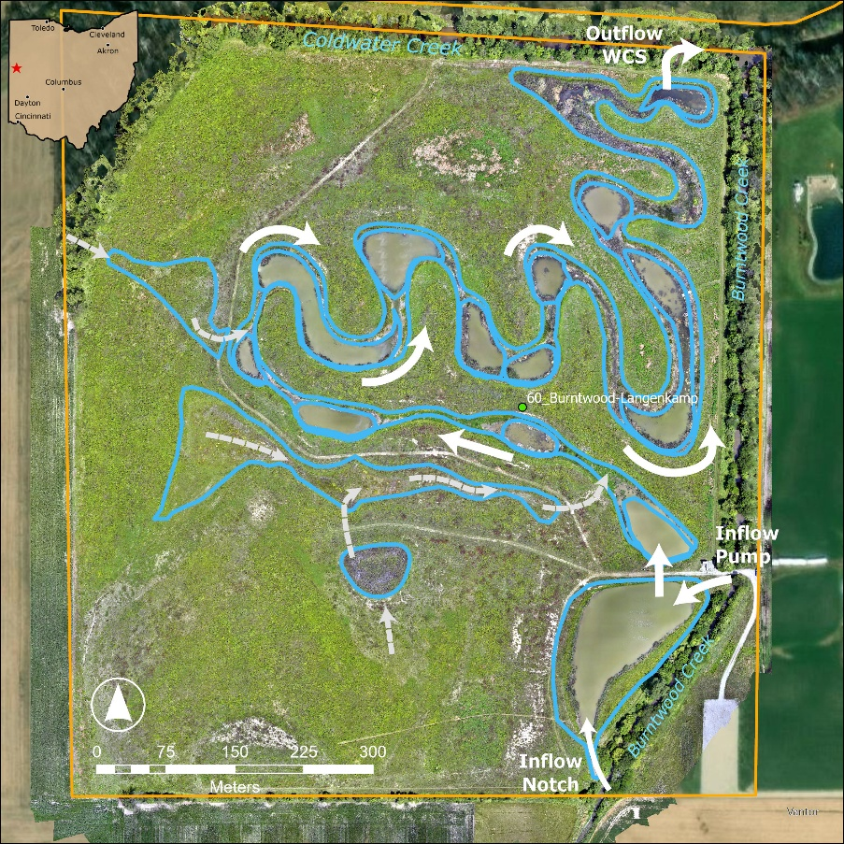
Figure 3. BWLK Flowpath Map. Blue outlines indicate wetland pools and arrows represent water flow direction.

Volume Budgeting
Outflow water volumes were directly measured and calculated by averaging daily water levels retrieved via an Onset HOBO deployed in the WLCS (Agri Drain) located at the Outflow Pool. Discharge in gallons per day (GPD) was then calculated using a simple flow over flat weir equation:
if H≤0.27W,Q=3.19924(W-0.74H)H^1.48 if H>0.27W,Q=3.0318WH^1.37
where H is water height above stoplog in inches, W is the width of the weir, and Q is flow rate in gallons per minute. Daily inflow volumes are calculated by summing the outflow discharge with daily volume lost to evapotranspiration (Penman Monteith equation).

Nutrient Concentrations
Surface water samples were collected from Burntwood Creek (inflow) and the Outflow pool weekly throughout the water year.
Storm events are defined as dates in which the daily average discharge at USGS Chickasaw Creek gage was >50 cubic feet per second. This resulted in a total of seven storm events during Water Year 25, five of which were sampled. Loads were calculated for each day there was water actively flowing into the wetland

Nutrient Load Calculation
Nutrient inflow and outflow loads for Burntwood-Langenkamp Conservation Area were calculated as:
load=[concentration*0.0022046*volume]/[0.26417*1000]
where load retained is in pounds, concentrations are in mg/L, volume is in gallons. These daily loads were then combined seasonally to create a seasonal load for each nutrient. Seasonal loads retained were then calculated for each nutrient by subtracting the outflow load from the inflow load.

Assumptions, Uncertainties, and Data Gaps
This approach assumes no meaningful net influence of groundwater to input or output nutrient loads. It also assumes that all increases in water level within the wetland are caused by pumping or inflow through the notch without accounting for addition directly from precipitation. Nutrient sampling only occurred in four of the six storm events that occurred during Water Year 25.

Williamsburg Wetland Treatment System (EFLM)

Introduction
The Williamsburg wetland is an off-channel wetland in the floodplain of the upper portion of the East Fork of the Little Miami River (EFLMR) watershed in southwest Ohio. The 10-acre constructed riparian wetland system is comprised of three main areas: a wintering pool, a 3-acre reservoir, and a meandering wetland.
When the river’s stage rises above 3.9 ft, water overtops the inlet bank into the wintering pool. As the river’s level continues to rise, more water enters the wetland and is routed along two potential pathways: (1) through the bypass channel into the 2,000-ft sinuous treatment wetland (the “gut”), or (2) through a 24-inch concrete inlet pipe into the reservoir.
The reservoir functions as a temporary storage basin. Its inlet pipe is equipped with a flap gate to prevent backflow and ensure flow movement toward the reservoir outlet. The outlet structure, designed to regulate discharge to the treatment wetland, consists of a buried underdrain system composed of five parallel 4-inch perforated PVC pipes connected to a single 4-inch non-perforated PVC collector pipe. Flow from the collector discharges into a 12-inch reinforced concrete pipe, which conveys water into the gut for further treatment and residence time.
Along with its long sinuous pattern, the gut is a two-stage ditch design populated with log vanes in the channel and bed and bank brush piles. In water year 2025, the vegetation planted after construction via native live stakes and seed mixes has taken root and inhabit the entire gut area. The wetland system outlet has been outfitted with an H-flume.
During a flood event when water enters the wetland through the inlet, the outlet simultaneously sees flow enter the wetland. This is due to a shallow slope of 0.07% from the inlet to the outlet, causing the inlet to become an outlet and the outlet to become an inlet. Furthermore, at high stages, the river can top its banks between in the inlet and outlet and flood into the wetland.
The wetland receives its main source of nutrient runoff from upstream row crop agricultural on 163 square miles of land, reported to contribute 71% of the wetland’s nutrient load (Nietsch 2024).
During water year 2025, eight locations were instrumented to collect water level and/or velocity data. The main instrument locations are the wetland system inlet (SYSINL), reservoir inlet (RESINL), bypass channel (WBWBP), reservoir outlet (RESOUT), and wetland system outlet (SYSOUT). These five main locations also capture water quality samples.
- SYSINL (in the EFLMR): ISCO sampler and bubbler
- SYSINL (in the inlet channel before wintering pool): LaserFlow sensor
- RESINL: ISCO sampler and AV sensor, and HOBO U20 water level sensor
- WBWBP: ISCO sampler and AV sensor, and HOBO U20 water level sensor
- RESOUT: ISCO sampler, AV sensor, and rain gage, and HOBO U20 water level sensor.
- SYSOUT: ISCO sampler and bubbler, and HOBO U20 water level sensor
- Additional HOBO U20 water level sensors: Within the reservoir, near underdrain at its outlet, in the gut portion of treatment wetland, and near the RESINL ISCO unit to account for atmosphere readings.
- ***The HOBO U20 within the reservoir is extremely important. Its water level measurements are used to determine the volume of the reservoir and is used throughout the nutrient load calculations for the reservoir.

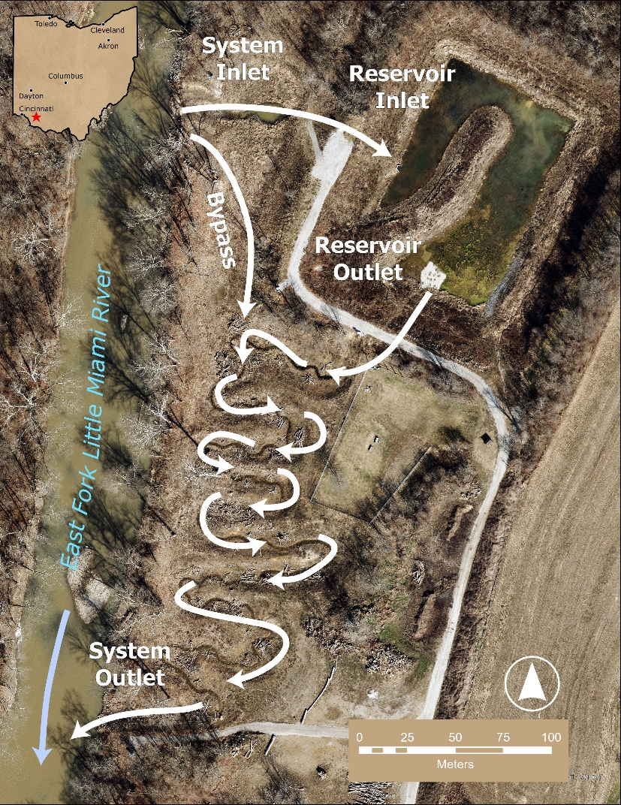
Figure 4. EFLA Flowpath Map. Blue outlines indicate wetland pools and arrows represent water flow direction.

Data used
Table 5. Datasets used in volume and nutrient budget calculations.
Dataset Name | Source | Duration | Data Type
Storage | H2Ohio WMP (Drone & Geophysics Team)/Civil 3D | 2/24 | RGB imagery, DSM, contour areas
Nutrients | USEPA/H2Ohio WMP | 1/25-4/25 | TP, TDP, TRP, DRP, TN, TDN, Nox, TAN, NH4, PP, TON, OrgN, POrgN
Water Level (Flowlink ISCO and HOBO U20) | H2Ohio WMP Sensor Network | WY 2025 | Water Level

Volume Budgeting
In February 2024, an unmanned aerial system (UAS, or drone) survey collected RGB imagery of the wetland system. The image data were post-processed to generate a digital surface model (DSM). The DSM was imported into ArcGIS to down-sample the high-resolution DSM to a raster file of manageable, yet sufficient, size for contour development in AutoCAD Civil 3D. The raster file was imported into Civil 3D as a surface. To generate a stage-storage relationship, contours were extracted from the surface then “trimmed” and “closed” to remove contours exceeding the wetland area of interest. Using the “stagestorage” command, a stage storage report was generated for the Reservoir and Gut (separately), which were exported as .csv files. Next, the Civil 3D 1-ft contour stage-storage results were imported to MS Excel, where they were refined to smaller 0.1 ft increments for analysis. The interpolation and volume calculation processes are described below.
First, a pseudo radius for the Civil 3D generated 1-ft contours was estimated by assuming a circular geometry of the contour area. Next, 0.1-ft incremental radii were calculated using linear interpolation between the calculated 1-ft radii. Areas were estimated using the calculated radii and assuming a circular contour geometry. Finally, conic incremental volumes were calculated for all 0.1-ft contour increments. The difference between Civil 3D and manual calculations for cumulative conic volume ranged from 2% at the highest elevations to 47% difference at the lowest elevations for the Gut, and from 2% at the highest elevations to 51% difference at the lowest elevations for the Reservoir. The large difference at lower elevations is partially an artifact of Civil 3D not calculating volumes when there are multiple contours per elevation, as is the case in a wetland which does not have smooth ground surfaces. Finally, the stage storage relationships were implemented in Excel as lookup tables for use in analyzing hydrology data.

Nutrient Concentrations
All water quality sampling is storm event driven. During a storm event, when the EFLMR stage rises to overcome the wetland inlet (greater than 3.9 ft at USGS stream gage 03246500 - EFLMR at Williamsburg OH), flow enters the wetland. In Water Year 2025, water quality samples were collected for five storm events from January – April 2025. There were eight storm events where flows entered the wetland, three storm events were not sampled. Samples are taken by level-enabled, time-paced ISCO autosamplers. For each sampling occurrence, water samples are collected along both the rising and falling limbs of the event hydrograph. For the rising limb, composite samples were taken at SYSINL (system inflow), RESINL (reservoir inflow), and WBWBP, while for the falling limb, multiple composite samples, usually between 2-5, were taken at RESOUT (reservoir outlet) and SYSOUT (system outlet). Composite samples are collected and analyzed separately.
Water samples were analyzed at US EPA Experimental Stream Facility in Milford, Clermont County, Ohio. The lab measured the concentrations of the following analytes: total phosphorus (TP), total dissolved phosphorus (TDP), total reactive phosphorus (TRP), dissolved reactive phosphorus (DRP), total nitrogen (TN), total dissolved nitrogen (TDN), nitrite+nitrate (NO2+NO3), total ammonium nitrogen (TAN or TNH4), and ammonium (NH4). Calculated values reported by the lab: particulate phosphorus (PP), total organic nitrogen (TON), dissolved organic nitrogen (OrgN), and particulate organic nitrogen (POrgN). We will calculate total kjeldahl nitrogen (TKN) and ammonia (NH3). Total Suspended Solids (TSS) concentrations were not obtained during WY 2025 sampling.

Nutrient Load Calculation
To determine nutrient loads for each event, the rising and falling limb composite samples concentrations were utilized to determine event mean concentrations (EMC) for the influent and effluent, respectively. For each influent location (SYSINL, RESINL, WBWBP), since only one composite sample was obtained, its EMC is the concentration of its one composite sample. For each effluent location (RESOUT and SYSOUT), its EMC is the mean of the composite sample concentrations.
Hydrology data (graphical and tabular) were analyzed to identify the start, peak, and end of each inflow event. The stage-storage lookup table provided wetland storage volumes for each of these three points on the hydrograph, i.e. initial, peak, and final volume (V_{initial}, V_{peak}, V_{final}, respectively). One nuance of the wetland hydraulics that is important to acknowledge and keep in mind for the following load calculations is that the wetland drains slowly over multiple days after a storm event (due in large part to the Reservoir storage). So, falling limb (effluent) concentration measurements span multiple days as the wetland drains and returns to the normal pool level, thus explaining the multiple falling limb composite samples comprising the effluent MC (as mentioned in the introduction section). As a result, there were some cases in which water quality sampling was discontinued prior to full drawdown of the wetland to the initial or normal pool water level. In these cases, the final water level, and corresponding final storage volume (V_{final}), were selected to be consistent with the time of the final effluent water quality sample.
- The Stage-storage and Loads by month folder contains monthly spreadsheets that have stage-storage calculations using wetland water level data. Load calculations are also included for the months when there was wetland inflow event sampling. Below is a guide to these spreadsheets:
  - Open stage-storage file for the month and subsystem of interest (e.g. Reservoir, Gut)
  - Read INFO tab and familiarize with the different spreadsheet tabs
  - The “…Level-Vol-dVol” tab contains the stage-storage relationship.
    - be careful not to inadvertently change the calculations in this spreadsheet; changes may be made if there is an improvement to the method to be made
    - the columns on the right side of the sheet (~ I à O) are the lookup table developed from Civil 3D; there are separate “parent” files from which these are copied – one each for Reservoir and Gut:
      - “WburgWetland_(Gut/Reservoir)_Stage-Storage.xlsx”
        - this is the output from C3D stage-storage calculator, plus manual calculations needed
      - and “WburgWetland_(Gut/Reservoir)_Stg-Stor_DepthdVol_HydroCalc.xlsx”
        - this file adds smaller incremental depths and volumes to the stage-storage table
        - the sheet “(Gut/Res) (UPDATED) Stg Str Lookup” is what is copied/pasted into the monthly/event stage-storage spreadsheets
    - the columns on the left side (~ A à E) of the monthly file “…Level-Vol-dVol” sheet are calculating wetland storage based on actual water level data and the stage-storage lookup table
      - there is also a sheet with raw water level data in the monthly spreadsheet
  - The “Loads” tab is where load calculations are made for each event/month
    - The top several rows, ~ columns A à J, contain volumes calculated in the “…Level-Vol-dVol” sheet
      - Reservoir volumes are included in the Gut spreadsheets, to enable SYSTEM volumes and loads
    - The top rows, ~ columns L à AD, contain WQ sampling times and concentrations
    - The lower rows contain event load calculations
      - The event #1 that started at the end of January is accounted for in the February 2025 spreadsheets.
      - The event #4 that started at the end of March is accounted for in the April 2025 spreadsheets.
      - Loads are calculated using the volumes and concentrations shown within that tab
      - It is possible, for some events, there was an increase in load. This is often due to an event final volume exceeding the event initial volume
Influent and effluent mass loads (lbs) were calculated as follows:

${Load}_{in}={MC}_{influent}×(V_{peak}-V_{initial})$ .

${Load}_{out}={MC}_{effluent}×(V_{peak}-V_{final})$.

Since the stage-storage relationships are defined for each of the wetland subsystems (Reservoir and Gut), nutrient mass loading (lbs) for each of these subsystems, as well as the overall system, were calculated. Due to ease of calculation afforded by clearly defined inlets and outlets, the System and Reservoir loading were calculated first. Gut loading (lbs) was calculated using a simplified mass balance approach:

${Load}_{gut}={Load}_{system}-{Load}_{reservoir}$ .

Assumptions, Uncertainties, and Data Gaps
This approach assumes no meaningful net influence of groundwater to input or output nutrient loads.

Forder Bridge Floodplain Reconnection (FORB)

Introduction
Forder Bridge is a 54-acre restoration Project in the Upper Maumee watershed with 5 acres of restored wetlands. The Project consists of four wetland complexes, three of which only receive rainfall. The fourth complex receives water from tile drained farm fields to the south of the Project. The water enters the project through a culvert and flows through a treatment chain of wetland pools, which then outlet to the Maumee River. Nutrients entering the site are believed to largely originate from agricultural runoff from the tile drained fields. The drainage area estimate for the culvert was adjusted with information provided by the district administrator of the Paulding Soil & Water Conservation District. There are no water control structures at this Project; hydrology of the site is passively managed and water flows through the Project during and after storm events. Rainfall events with >0.5 inches of rain are considered storm events for the Project. There is no evidence yet of surface water/groundwater exchange.
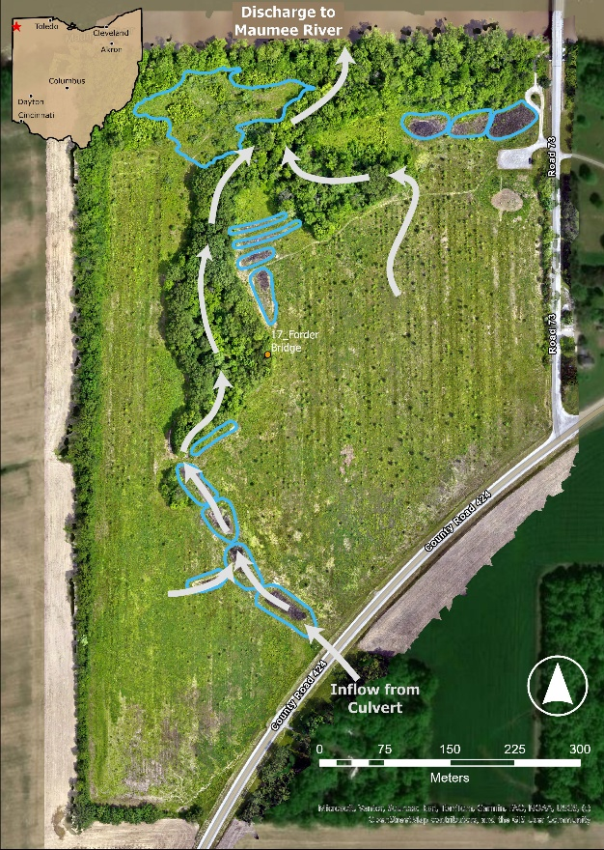
Figure 5. FORB Flowpath Map. Blue outlines indicate wetland pools and arrows represent water flow direction.
Flow values at this site in water years 2023 and 2024 were estimated using the NRCS curve number approach to estimate rainfall in the drainage area, and in water year 2025 were directly measured with an area-velocity meter. Outflowing volumes were estimated by calculating evapotranspiration for the site using the Penman-Monteith equation and subtracting the amount lost to evapotranspiration from inflow volumes. We calculated monthly nutrient baseflow concentrations at the inflow and outflow as the average monthly nutrient concentration across all sampling years and replaced all storm event days with the mean storm event concentration across all samples. We multiplied inflow volume by the inflow nutrient concentrations, and outflowing volume by outflowing nutrient concentrations.

Data used
Table 6. Datasets used in nutrient budget calculations.
Dataset Name | Source | Duration | Data Type
Rainfall 2023 | NOAA | WY 2023 | Rainfall
Rainfall 2024 | H2Ohio WMP | WY 2024-present | Rainfall
Area- Velocity | H2Ohio WMP | 3/25/25-present | Velocity, Water level
Weather | Iowa Mesonet | 10/1/22-present | Wind speed, min/max air temp, min/max relative humidity, Atmospheric pressure
Solar Radiation | NASA | 10/1/22-present | Solar radiation
Nutrients | H2Ohio WMP | WY 2022-present | TP, DRP, TN, Nox, Nh3
Water Level (VEGAPuls) | H2Ohio WMP Sensor Network | 6/23-present | Water Level

Volume Budgeting
Flow volumes into the treatment chain at Forder Bridge were estimated using drainage area and the National Resource Conservation Service (NRCS) curve number method (USDA-NRCS 2004) in water years 2023 and 2024. The drainage area was estimated using digital elevation models and compared with expert opinion. Digital elevation models were found to overestimate drainage area, while expert opinion was more accurate when flow volume was validated with direct flow measurements. A curve number of 91 was selected because the majority of the drainage area is row crop, and the soils were determined to be hydrologic group D (Ohio Department of Natural Resources SOILS MapServer). We additionally added a prediction of sub-surface runoff from the tiled drained portion of the drainage area as 31% of total rainfall based on an analysis of similar tiled fields (Pease et al. 2018). We used daily precipitation data from the NOAA weather station in Paulding OH (GHCND-USC00336465). We calculated the surface and subsurface tile drained flow for each day in our time series.
Starting on April 25th, 2025 inflow volumes to the treatment chain were directly measured using an area-velocity meter (ISCO 6172 Auto-analyzer paired with an ISCO 750 Flow Module and Low Profile Area Velocity Level Sensor) that measured both velocity and water depth in the culvert flowing into the site at 5 minute intervals. We calculated volume from velocity using Mannings equation for partially filled circular pipes.
For both years we did not have direct measurements of outflowing volumes, so we estimated daily outflow as daily inflow - evapotranspiration. We are calculating evapotranspiration using the Penman-Monteith equation:
ET0=0.408∆(Rn-G)+900T+273u2(es-ea)∆+(1+0.34u2)

Where ET_{o} reference evapotranspiration [mm day⁻¹], R_{n} net radiation at the crop surface [MJ m⁻² day⁻¹], G soil heat flux density [MJ m⁻² day⁻¹], T mean daily air temperature at 2 m height [°C], u₂ wind speed at 2 m height [m s⁻¹], e_{s} saturation vapour pressure [kPa], e_{a} actual vapour pressure [kPa], e_{s} - e_{a} saturation vapour pressure deficit [kPa], D slope vapour pressure curve [kPa °C⁻¹], g psychrometric constant [kPa °C⁻¹]. Historical weather data was downloaded from Iowa Mesonet, and solar radiation data was downloaded from NASA.

Nutrient Concentrations
Sampling frequency at this Project was approximately every 4 weeks. Baseflow concentrations were calculated as the average monthly baseflow concentration across all years in the database because our data for the site is limited. For the inflow baseflow concentrations we used the mean concentration for both the culvert pipe (FORB_15) and the first pool of the treatment chain (FORB_09) because we have limited data from just the culvert pipe. For outflowing baseflow concentrations we used concentrations from the stream that outflows from the site into the Maumee River (FORB_17).
Stormflow concentrations were calculated as the mean concentration from 3 storm events that were fully characterized using an ISCO (n samples = 23, 9, 14 respectively for each storm event). The ISCO triggers the start of sampling when the water level in the culvert reaches 12cm. We do not have an ISCO at the outflow so we calculated the percent change in nutrient concentrations from the culvert tile (FORB_15) to the outflow stream (FORB_17) during seven storm event when grab samples were taken at both inflow and outflow and multiplied the fully characterized inflow concentration by the change in concentration to calculate the outflow concentration. Out of 26 total storm events, 3 were characterized with ISCO sampling, and grab samples were collected for 7 storm events.
Baseflow concentrations for each month were applied to all days, and then any days with inflowing volume >30m3 were replaced with storm concentrations.

Nutrient Load Calculation
Daily inflow and outflow nutrient concentrations were multiplied by daily inflow and outflow volumes (inflow - evapotranspiration) to calculate the mass of each nutrient entering and leaving the site. Retention was calculated as the difference between the mass of each nutrient entering and leaving the site. Daily values were summed to calculate monthly and yearly nutrient loading and retention.

Assumptions, Uncertainties, and Data Gaps
This approach assumes no meaningful net influence of groundwater to input or output nutrient loads. This approach assumes that mean nutrient concentrations during storms in 2025 are representative of storms in 2023 and 2024 as well. There is uncertainty in how much baseflow concentrations collected in pools are representative of concentrations in inflowing water.

Gorman Heritage Farm Treatment Wetland System (GORF)

Introduction
Gorman Heritage Farm Treatment Wetland System is a 0.25 acre shallow pool flow through system that is passively managed, treating surface runoff from overland drainage. This project is on land owned by Gorman Heritage Farm. Water inflows into Pool 1 and Pool 2 from the overland drainage and flows into the outflow pool (Pool 3) before discharging into Mill Creek. There is no evidence of groundwater connection at this site. A pressure transducing water level sensor (Onset HOBO) measures the water level of Pool 3 at 30 minute intervals.
Volume entering pool 3 was calculated using a stage storage model, where depth was multiplied by the area of the pool. All increases in volume were used to calculate the inflowing volume. Evapotranspiration was calculated for the pool area and was subtracted from all decreases in volume to calculate the outflowing volume. Average nutrient concentration was calculated for each nutrient in the pool and applied to both inflow and outflow volumes, so the retention of the wetland is primarily determined by the retention of water at the Project.
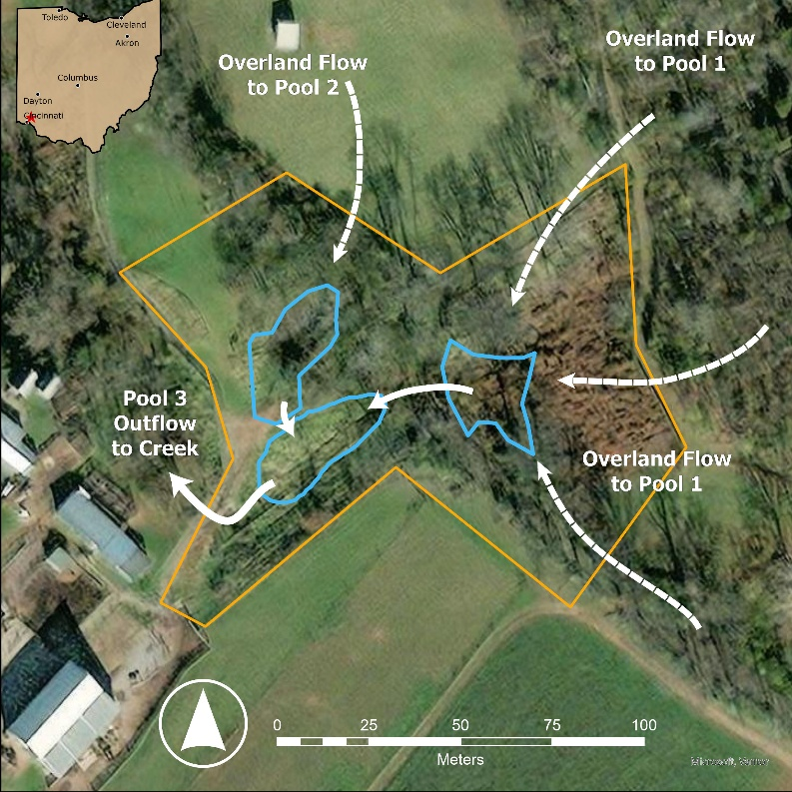
Figure 6. GORF Flowpath Map. Blue outlines indicate wetland pools and arrows represent water flow direction.

Data used
Table 7. Datasets used in volume and nutrient budget calculations.
Dataset Name | Source | Duration | Data Type
Weather | Iowa Mesonet | WY 2022-present | Wind speed, min/max air temp, min/max relative humidity, Atmospheric pressure
Solar Radiation | NASA | 10/1/22-present | Solar radiation
Nutrients | H2Ohio WMP | 1/23/24-5/20/25 | TP, DRP, TN, Nox, NH3
Water Level (HOBO) | H2Ohio WMP Sensor Network | 5/1/24-9/19/25 | Water Level

Volume Budgeting
Using data collected from a pressure transducing water level sensor, average daily depths were calculated for Pool 3. A correction factor of - 0.3 feet was applied based on field measurements taken. The corrected daily water depths were then converted to volume by multiplying acres of Pool 3 (0.026) by water depth and then converting it to gallons.
We estimated daily outflow as daily inflow - evapotranspiration. We are calculating evapotranspiration using the Penman-Monteith equation:
ET0=0.408∆(Rn-G)+900T+273u2(es-ea)∆+(1+0.34u2)

Where ET_{o} reference evapotranspiration [mm day⁻¹], R_{n} net radiation at the crop surface [MJ m⁻² day⁻¹], G soil heat flux density [MJ m⁻² day⁻¹], T mean daily air temperature at 2 m height [°C], u₂ wind speed at 2 m height [m s⁻¹], e_{s} saturation vapour pressure [kPa], e_{a} actual vapour pressure [kPa], e_{s} - e_{a} saturation vapour pressure deficit [kPa], D slope vapour pressure curve [kPa °C⁻¹], g psychrometric constant [kPa °C⁻¹]. Historical weather data was downloaded from Iowa Mesonet, and solar radiation data was downloaded from NASA.

Nutrient Concentrations
Surface water samples were collected by a partner who works at Gorman Heritage Farm whenever there was a storm event (enough precipitation to fill Pool 3) which resulted in 11 total samples for Water Year 2025. These Pool 3 samples (GORF_03) were then calculated as a seasonal average and applied to both inflowing and outflowing volumes.

Nutrient Load Calculation
Seasonal nutrient outflow loads were calculated as follows:
load =[concentration*0.0022046*volume]/[0.26417*1000]
where load is in pounds, concentrations are in mg/L, and volume is in gallons.

Assumptions, Uncertainties, and Data Gaps
This approach assumes no meaningful net influence of groundwater to input or output nutrient loads. It also assumes that all increases in water level within the wetland are caused by inflow from overland drainage without accounting for addition directly from precipitation. This approach assumes that storms do not play a major role in driving nutrient loading to this project.

Little Portage Nutrient Reduction & Coastal Wetland Restoration (LITP) (SE-UNIT)

Introduction
The Little Portage Nutrient Reduction & Coastal Wetland Restoration (LITP) project, located in the Little Portage River Wildlife Refuge in Ottawa County, Ohio, is a restoration project which diverts runoff from surrounding agricultural land to the 433-acre wetland complex before it is released into the Little Portage River¹. The wetland is equipped with water level control structures (WLCS) and pumps that control wetland water volume to manage agricultural runoff during periods of high precipitation. Water from agricultural tile drains and surface runoff enters a ditch and is then pumped into the 71-acre southeast unit of the complex and can be distributed to other units. The ability to quantify water entering the wetland complex using pumping data and controlled outflows from water control structures makes LITP a good candidate for estimating nutrient retention budgets.

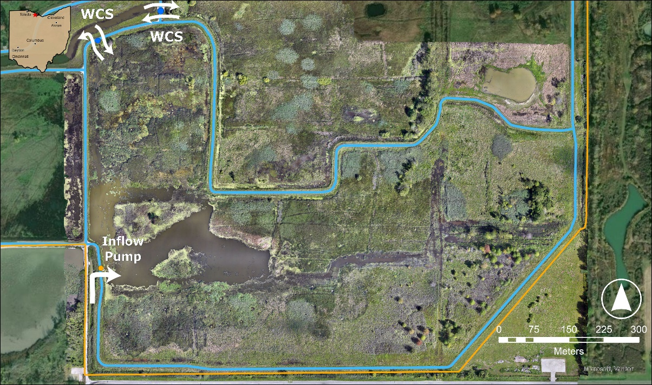
Figure 7. LITP Flowpath Map. Blue outlines indicate wetland pools and arrows represent water flow direction.

Quantifying wetland hydrodynamics and associated nutrient transport is necessary to evaluate wetland performance and nutrient retention capacity. The methodology described in this document integrates remotely sensed elevation data, in situ geophysical surveys, continuous water level measurements, and water quality monitoring data to estimate daily wetland water volume, classify net water exchange, and calculate nutrient loads associated with inflow and outflow.
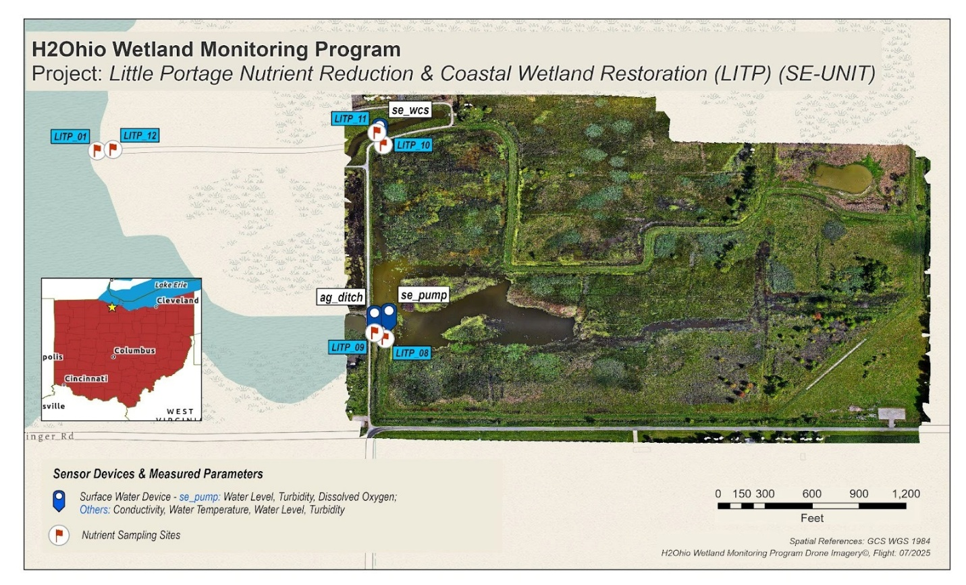
Figure 8. Little Portage Nutrient Reduction & Coastal Wetland Restoration (LITP) (SE-UNIT)

This modeling framework consists of four primary components: (1) terrain (DEM) processing, (2) water surface modeling and volume estimation, (3) hydrologic classification based on daily volume change, and (4) nutrient concentration assignment and load calculation. Together, these components provide a consistent, daily-resolution assessment of wetland water balance and nutrient exchange.

Data used
Table 8. Datasets used in volume and nutrient budget calculations.
Dataset Name | Source | Duration | Data Type
Rainfall | Iowa Mesonet/H2Ohio WMP | 4/25-10/25 | Rainfall
Bathymetry Layer | H2Ohio WMP (Drone & Geophysics Team) | 7/2/25 | Orthorectified DEM Layer (GeoTIFF)
Nutrients | H2Ohio WMP | WY 2022-present | TP, DRP, TN, Nox, NH3
Water Level (Vega PULS) | H2Ohio WMP Sensor Network | 4/23/25-present | Water Level

Volume Budgeting
Wetland water volumes were estimated using a terrain-based water surface modeling approach derived from site-specific elevation data and continuous water level measurements. A high-resolution Digital Elevation Model (DEM) was generated from drone imagery collected by the H2Ohio Wetland Monitoring Program (WMP) during dry conditions to minimize the interference of surface water and vegetation with the true ground elevation. Imagery was processed to produce a bare-earth elevation surface, orthorectified, validated against ground survey data from the WMP geophysics team, resampled to a 0.5-m resolution, and clipped to the wetland boundary.
Daily water surface elevations were estimated using water level measurements from the LITP sensor network. Water level data were obtained from a Vega PULS C-21 sensor located near the pump in the southeast unit of the wetland. The sensor records water level at 10-minute intervals, and values were aggregated to daily averages.
For each day, the observed water level was applied as a constant-value raster representing the wetland water surface elevation. This surface was intersected with the DEM to calculate spatially distributed water depth according to:
D(x,y)=Ew-Et(x,y)
where D(x,y)is water depth, Ewis the daily water surface elevation, and Et(x,y)is the terrain elevation.
Daily wetland water volume was calculated by integrating water depth across inundated raster cells:
V=∑(Di×A)
where Vis total volume, Diis the depth of each inundated cell, and A is the cell area (0.25 m²). Inundated surface area was calculated as:
A=n×c2
where n is the number of cells with positive depth and cis the raster cell size (0.5 m).
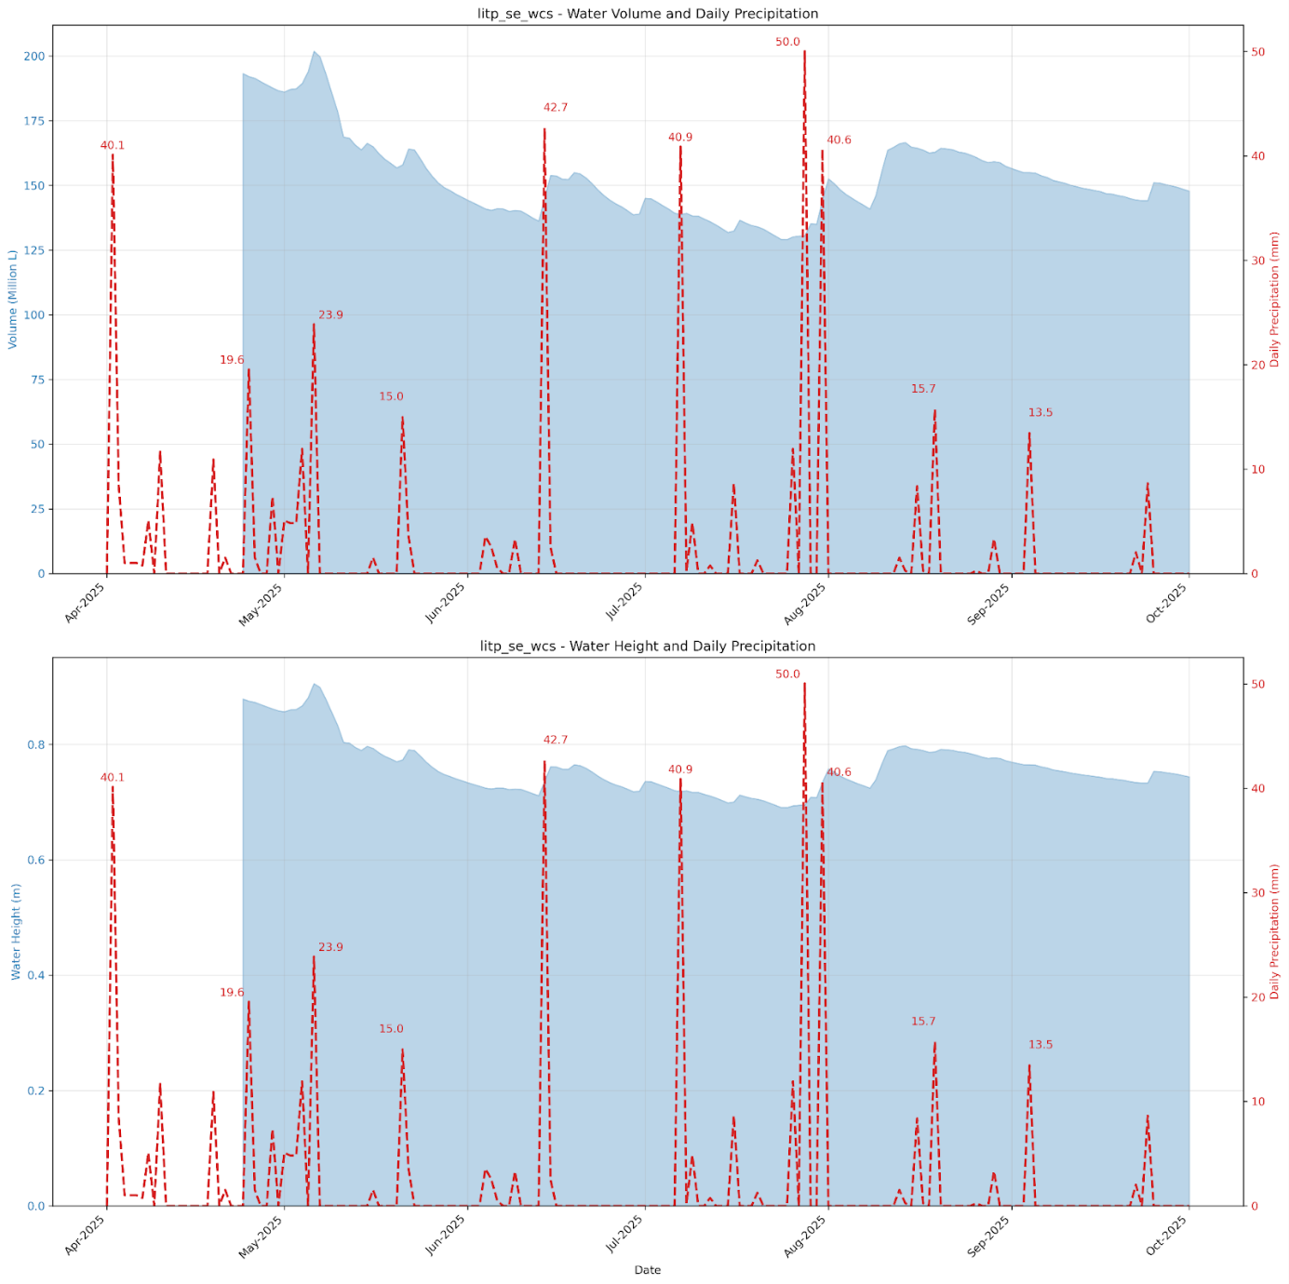
Figure 9. LITP Water Budget (WY-25). Precipitation data from the on-site weather station were used for contextual interpretation of volume changes.

Water Balance Adjustment
Daily water volume changes were adjusted to account for atmospheric water exchange through precipitation and evapotranspiration (ET). These adjustments isolate the net hydraulic exchange between the wetland and ditch from atmospheric contribution to the water budget.

Precipitation Data
Precipitation records were obtained primarily from the WMP sensor network weather station located at the nearby MAGM site, which records cumulative precipitation at 10-min intervals. When on-site precipitation data were unavailable or incomplete (<80% daily coverage), data gaps were filled using measurements from the nearest Iowa Environmental Mesonet (IEM) station, selected based on proximity to the project site.
Daily precipitation volume entering the wetland was calculated as:
PL=Pmm x Aw
Where PL is the precipitation volume, Pmm daily precipitation depth (mm), and Aw is the wetland surface area.

Evapotranspiration Estimation
Reference evapotranspiration (ET₀) was calculated using the FAO-56 Penman-Monteith equation². On-site meteorological data from the MAGM weather station were used as the primary data source. Required variables included:
- Air temperature (min/max, °C)
- Relative humidity (min/max, %)
- Wind speed (m/s at 2m height)
- Atmospheric pressure (kPa)
- Estimated solar radiation (MJ/m2/day)
When on-site weather data were unavailable or incomplete, missing values were gap-filled using IEM station data following the same prioritization approach used for precipitation. Solar radiation estimates were obtained from NASA POWER satellite data, as this parameter is not measured on-site.
Daily ET volume loss from the wetland was calculated as:
ETL=ET0,mm X Aw
Where, ETL is vapotranspiration volume (L), ET0,mm is reference evapotranspiration (mm/day), and ​Aw is the wetland surface area.

Net Water Exchange Calculation
The adjusted daily volume difference, representing net hydraulic exchange with the ditch, was calculated as:
ΔVadj =ΔVraw + ETL - PL
Where, ΔVadj is the adjusted volume difference, ΔVraw is the measured change in wetland volume, ETL is evapotranspiration loss, and PL is precipitation gain. This adjustment isolates inflow/outflow by accounting for water added through precipitation and lost through evapotranspiration.

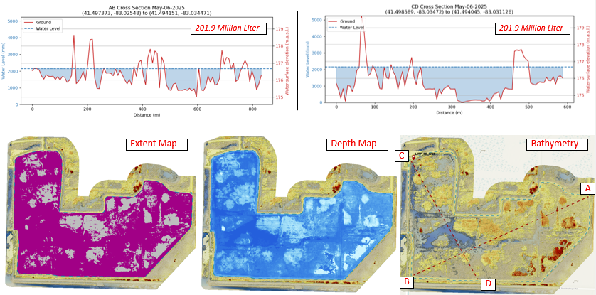
Figure 10. LITP SE unit Highest Recorded Water ( 05/06/2025) WY-25* (~97% filled). incomplete WY record, sensor data collection started from April 2025

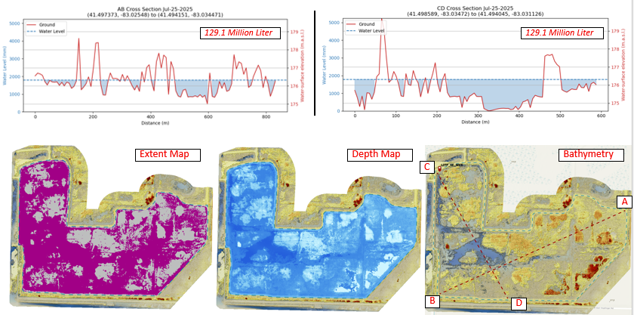
Figure 11. LITP Lowest Recorded Water ( 07/25/2025) WY-25* (~65% filled. incomplete WY record, sensor data collection started from April 2025.)

Meteorological data processing, ET calculations, and water balance adjustments were implemented using custom R functions with automated quality checks and gap-filling. All spatial calculations were performed using an automated ArcPy and NumPy-based modelling workflow. Model outputs include daily estimates of wetland water volume, inundated surface area, mean water depth, and percent wetland inundation.

Nutrient Concentrations
A nearest sampling date approach was used to assign concentrations to each day. Daily values were matched to the closest nutrient sampling date, and the corresponding average concentrations were applied. Inflow nutrient concentration was from ditch monitoring site (LOIs: LITP-09) and applied to all days classified as net inflow. Outflow nutrient concentration was from the interior wetland site (LOIs: LITP-10) and applied to all days classified as net outflow.

Hydrologic Classification
Daily net water exchange was determined from changes in estimated wetland water volume rather than direct flow measurements. The daily volume difference was calculated as the change in total volume between consecutive days. Days with positive volume change were classified as inflow, and days with negative volume change were classified as outflow. Days with no change in volume were treated as having no net exchange. This classification controlled which nutrient concentration dataset was applied for load calculations.

Nutrient Load Calculation
Daily nutrient loads were calculated by multiplying the daily volume difference by the assigned nutrient concentration for each nutrient species. Loads were calculated in milligrams and converted to pounds using a standard mass conversion factor. Positive loads represent nutrients entering the wetland, and negative loads represent nutrients leaving the wetland.
Daily loads may be summed across user-defined periods to estimate cumulative nutrient inputs, outputs, and net exchange.

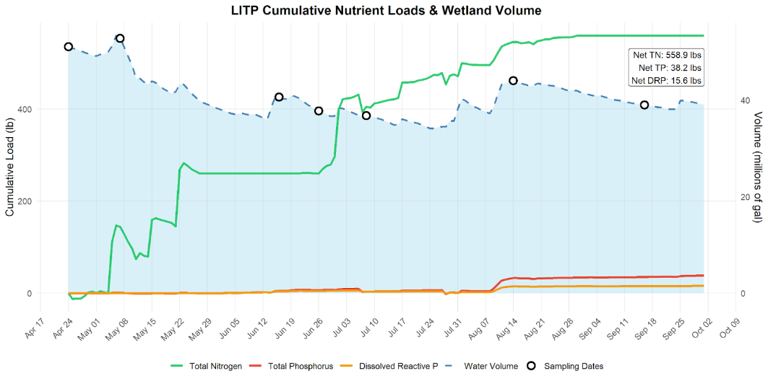
Figure 12. LITP Cumulative Loads (WY-25)

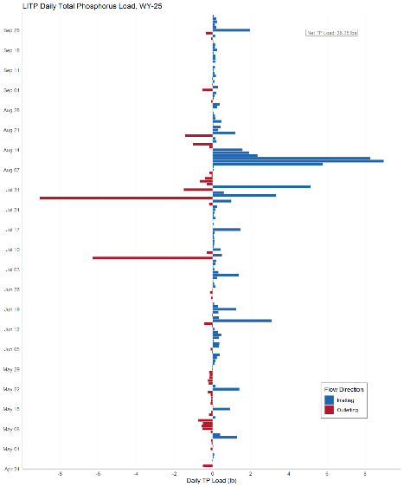
Figure 13. LITP Daily TP Loading (WY-25). Blue bars represent TP load into the wetland unit (SE), Red bars represent TP load exported from the wetland into the canal.

Temporal Aggregation
Daily nutrient loads were retained at the daily resolution for analysis but can be summed across user-defined periods to quantify cumulative nutrient inputs, outputs, and net exchange. Net nutrient exchange over a period is represented by the sum of daily loads, with positive values indicating net nutrient import and negative values indicating net nutrient export.

Notes on Method Assumptions
This approach assumes that nutrient concentrations remain constant between sampling dates and that daily changes in estimated wetland water volume accurately represent net inflow or outflow.
Water volume estimates derived from the sensor network are constrained by the maximum measurable water level of the installed sensor. Water levels exceeding this upper measurement limit cannot be directly quantified and therefore represent a lower-bound estimate for volumes exceeding this threshold, however water levels did not exceed the upper limit of the installed sensor in the 2025 Water Year.

Reference
¹Little Portage H2Ohio Wetland Restoration Project Complete.h2.ohio.gov. Ohio Departments of Natural Resources, Agriculture, and Environmental Protection, August 21, 2024. https://h2.ohio.gov/home/news-and-events/all-news/little-portage-h2ohio-wetland-restoration-project-complete
²Allen, R. G., Pereira, L. S., Raes, D., & Smith, M. (1998). Crop evapotranspiration - Guidelines for computing crop water requirements - FAO Irrigation and drainage paper 56. Food and Agriculture Organization of the United Nations.

Magee Marsh Turtle Creek Bay Wetland Reconnection Project (MAGM)

Introduction
The Magee Marsh Turtle Creek Bay Wetland Reconnection Project (MAGM), located in Ottawa County, reconnects the 165-acre Turtle Creek Bay wetland within Magee Marsh to Lake Erie. The wetland is equipped with water level control structures (WLCS) that regulate wetland water volume to manage agricultural runoff during periods of elevated lake levels. During high-flow events, upstream flows from Turtle Creek can be diverted into the wetland, where suspended sediments and nutrients are retained, reducing direct loading to Lake Erie.¹
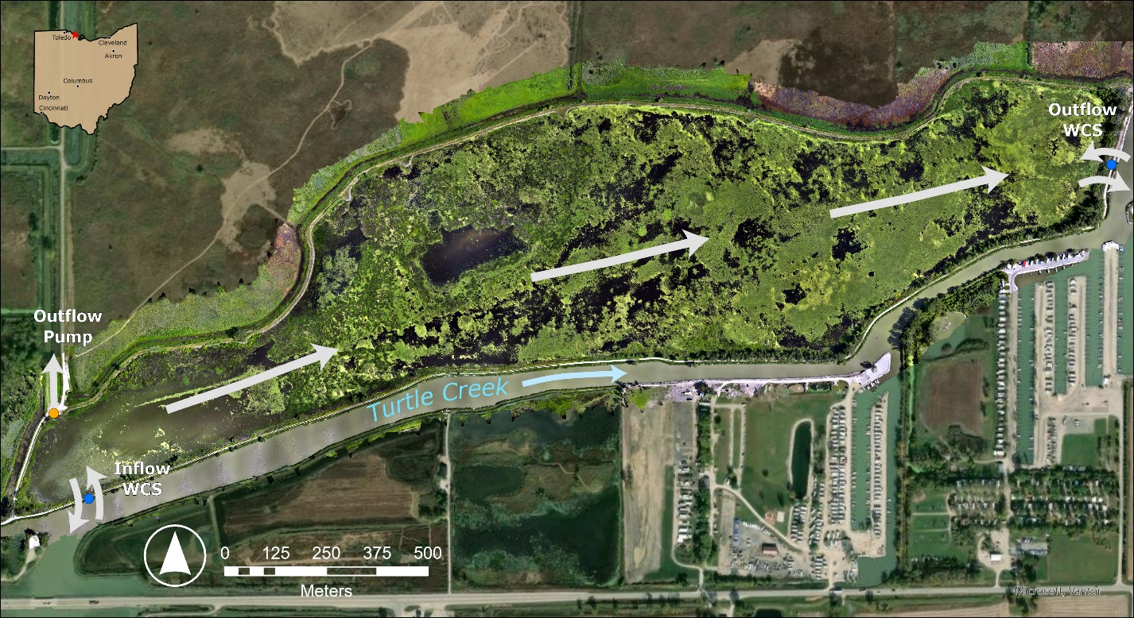
Figure 14. MAGM Flowpath Map. Blue outlines indicate wetland pools and arrows represent water flow direction.

Quantifying wetland hydrodynamics and associated nutrient transport is necessary to evaluate wetland performance and nutrient retention capacity. The methodology described in this document integrates remotely sensed elevation data, in situ geophysical surveys, continuous water level measurements, and water quality monitoring data to estimate daily wetland water volume, classify net water exchange, and calculate nutrient loads associated with inflow and outflow.
This modeling framework consists of four primary components: (1) terrain (DEM) processing, (2) water surface modeling and volume estimation, (3) hydrologic classification based on daily volume change, and (4) nutrient concentration assignment and load calculation. Together, these components provide a consistent, daily-resolution assessment of wetland water balance and nutrient exchange.

Data used
Table 9. Datasets used in volume and nutrient budget calculations.
Dataset Name | Source | Duration | Data Type
Rainfall | Iowa Mesonet/H2Ohio WMP | 10/24-10/25 | Rainfall
Bathymetry Layer | H2Ohio WMP (Drone & Geophysics Team) | 8/20/24 | Orthorectified DEM layer (GeoTIFF)
Nutrients | H2Ohio WMP | WY 2022-present | TP, DRP, TN, Nox, NH3
Water Level (Vega PULS) | H2Ohio WMP Sensor Network | 6/22/23-present | Water Level

Volume Budgeting
Wetland water volumes were estimated using a terrain-based water surface modeling approach derived from site-specific elevation data and continuous water level measurements. A high-resolution Digital Elevation Model (DEM) was generated from drone imagery collected by the H2Ohio Wetland Monitoring Program (WMP) during dry conditions to minimize the interference of surface water and vegetation with the true ground elevation. Imagery was processed to produce a bare-earth elevation surface, orthorectified, validated against ground survey data from the WMP geophysics team, resampled to a 0.5-m resolution, and clipped to the wetland boundary.
Daily water surface elevations were estimated using water level measurements from the MAGM sensor network. Water level data were obtained from a Vega PULS C-21 sensor located near station WCS-1 in the southwestern portion of the wetland. The sensor records water level at 10-minute intervals, and values were aggregated to daily averages.
For each day, the observed water level was applied as a constant-value raster representing the wetland water surface elevation. This surface was intersected with the DEM to calculate spatially distributed water depth according to:
D(x,y)=Ew-Et(x,y)
where D(x,y)is water depth, Ewis the daily water surface elevation, and Et(x,y)is the terrain elevation.
Daily wetland water volume was calculated by integrating water depth across inundated raster cells:
V=∑(Di×A)
where V is total volume, Diis the depth of each inundated cell, and A is the cell area (0.25 m²). Inundated surface area was calculated as:
A=n ×c2
where n is the number of cells with positive depth and c is the raster cell size (0.5 m).
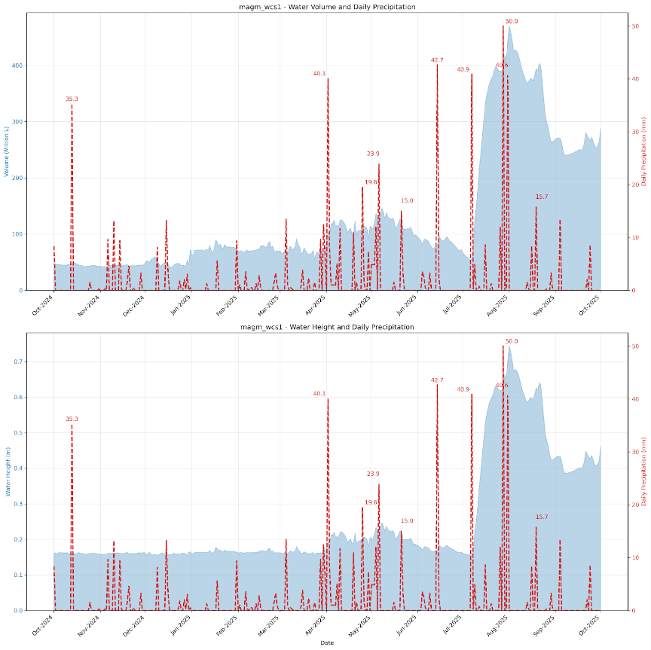
Figure 15. MAGM Water Budget (WY-25). Precipitation data from the on-site weather station were used for contextual interpretation of volume changes.

Water Balance Adjustment
Daily water volume changes were adjusted to account for atmospheric water exchange through precipitation and evapotranspiration (ET). These adjustments isolate the net hydraulic exchange between the wetland and Turtle Creek from atmospheric contribution to the water budget.

Precipitation Data
Precipitation records were obtained primarily from the on-site weather station, which records cumulative precipitation at 10-min intervals. When on-site precipitation data were unavailable or incomplete (<80% daily coverage), data gaps were filled using measurements from the nearest Iowa Environmental Mesonet (IEM) station, selected based on proximity to the project site.
Daily precipitation volume entering the wetland was calculated as:
PL=Pmm × Aw
Where PL is the precipitation volume, Pmm daily precipitation depth (mm), and Aw is the wetland surface area.

Evapotranspiration Estimation
Reference evapotranspiration (ET₀) was calculated using the FAO-56 Penman-Monteith equation². On-site meteorological data from the MAGM weather station were used as the primary data source. Required variables included:
- Air temperature (min/max, °C)
- Relative humidity (min/max, %)
- Wind speed (m/s at 2m height)
- Atmospheric pressure (kPa)
- Estimated solar radiation (MJ/m2/day)
When on-site weather data were unavailable or incomplete, missing values were gap-filled using IEM station data following the same prioritization approach used for precipitation. Solar radiation estimates were obtained from NASA POWER satellite data, as this parameter is not measured on-site.
Daily ET volume loss from the wetland was calculated as:
ETL=ET0,mm × Aw
Where, ETL is evapotranspiration volume (L), ET0,mm is reference evapotranspiration (mm/day), and ​Aw is the wetland surface area.

Net Water Exchange Calculation
The adjusted daily volume difference, representing net hydraulic exchange with Turtle Creek, was calculated as:
ΔVadj =ΔVraw + ETL - PL
Where, ΔVadj is the adjusted volume difference, ΔVraw is the measured change in wetland volume, ETL is evapotranspiration loss, and PL is precipitation gain. This adjustment isolates creek inflow/outflow by accounting for water added through precipitation and lost through evapotranspiration.
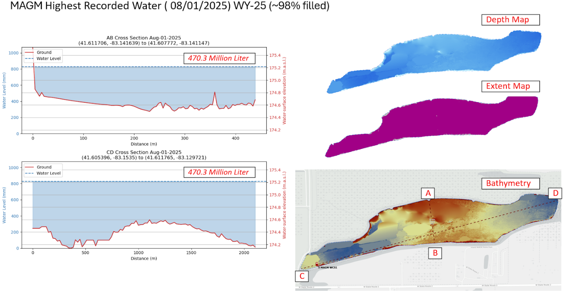

Figure 16. MAGM Highest Recorded Water ( 08/01/2025) WY-25 (~98% filled).
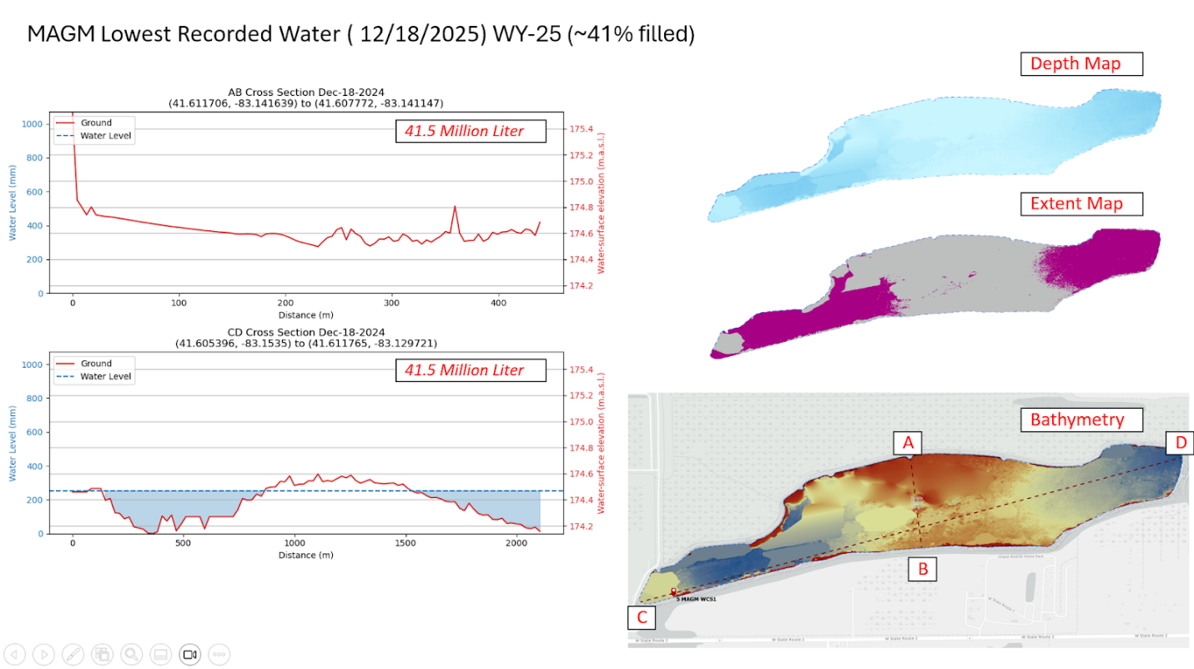
Figure 17. MAGM Lowest Recorded Water ( 12/18/2025) WY-25 (~41% filled)

Meteorological data processing, ET calculations, and water balance adjustments were implemented using custom R functions with automated quality checks and gap-filling. All spatial calculations were performed using an automated ArcPy and NumPy-based modelling workflow. Model outputs include daily estimates of wetland water volume, inundated surface area, mean water depth, and percent wetland inundation.

Hydrologic Classification
Daily net water exchange was determined from changes in estimated wetland water volume rather than direct flow measurements. The daily volume difference was calculated as the change in total volume between consecutive days. Days with positive volume change were classified as inflow, and days with negative volume change were classified as outflow. Days with no change in volume were treated as having no net exchange. This classification determined which nutrient concentration dataset was applied for load calculations.

Nutrient Concentrations
A nearest sampling date approach was used to assign concentrations to each day. Daily values were matched to the closest nutrient sampling date, and the corresponding average concentrations were applied. Inflow nutrient concentrations were averaged from creek sampling sites (LOIs: MAGM-01, 03, 06) and applied to all days classified as net inflow. Outflow nutrient concentrations were averaged from interior wetland sampling sites (LOIs: MAGM-02, 04, 07) and applied to all days classified as net outflow.

Nutrient Load Calculation
Daily nutrient loads were calculated by multiplying the daily volume difference by the assigned nutrient concentration for each nutrient species. Loads were calculated in milligrams and converted to pounds using a standard mass conversion factor. Positive loads represent nutrients entering the wetland, and negative loads represent nutrients leaving the wetland.
Daily loads may be summed across user-defined periods to estimate cumulative nutrient inputs, outputs, and net exchange.
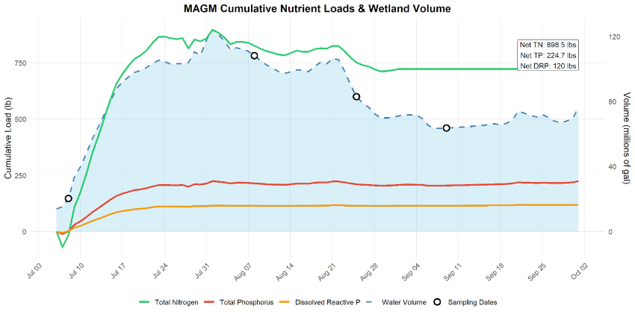
Figure 18. MAGM Cumulative Loads (WY-25)
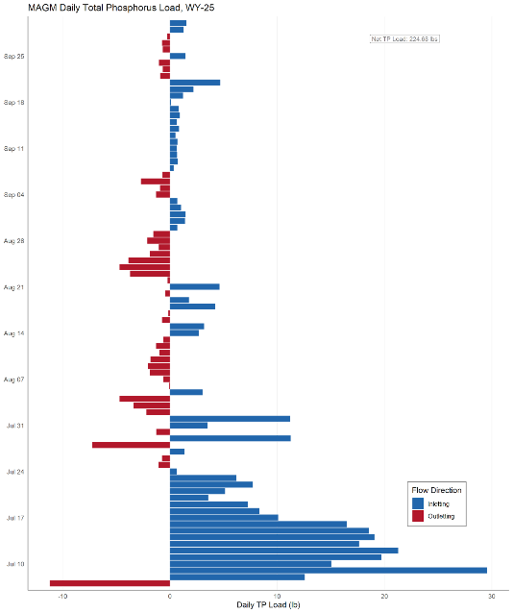
Figure 19. MAGM Daily TP Loading (WY-25). Blue bars represent TP load into the wetland from Turtle Creek. Red bars represent TP load exported from the wetland into the creek.

Temporal Aggregation
Daily nutrient loads were retained at the daily resolution for analysis but can be summed across user-defined periods to quantify cumulative nutrient inputs, outputs, and net exchange. Net nutrient exchange over a period is represented by the sum of daily loads, with positive values indicating net nutrient import and negative values indicating net nutrient export.

Notes on Method Assumptions
This approach assumes that nutrient concentrations remain constant between sampling dates and that daily changes in estimated wetland water volume accurately represent net inflow or outflow. This assumption enables continuous daily nutrient load estimation using limited but systematically applied monitoring data. During months when control structures were closed (October-June) we assumed no exchange between the wetland and Turtle Creek.
Water volume estimates derived from the sensor network are constrained by the maximum measurable water level of the installed sensor. Water levels exceeding this upper measurement limit cannot be directly quantified and therefore represent a lower-bound estimate for volumes exceeding this threshold, however water levels did not exceed the upper limit of the installed sensor in the 2025 Water Year.

References
¹Magee Marsh Turtle Creek Bay Wetland Reconnection.h2.ohio.gov. Ohio Departments of Natural Resources, Agriculture, and Environmental Protection, March 4, 2024. https://h2.ohio.gov/Project/magee-marsh-turtle-creek-bay-wetland-reconnection/
²Allen, R. G., Pereira, L. S., Raes, D., & Smith, M. (1998). Crop evapotranspiration - Guidelines for computing crop water requirements - FAO Irrigation and drainage paper 56. Food and Agriculture Organization of the United Nations.

Martin’s Run Wetland and Stream Restoration Project (MARR)

Introduction
The Martin’s Run Restoration Project is located in a former agricultural field. The goal of the project was to restore a channelized stream to natural sinuosity with adjacent floodplains to the north and south of the stream. During high flow events in the stream, water flows into the adjacent floodplains where it is retained in a series of pothole pools. Water exits the floodplains when it reaches a set height where it flows out through a storm culvert back into the restored stream bed. Martin’s Run is an urban stream that is the primary source of nutrients for the wetland site. There is a tile drain entering the south floodplain from the agricultural field to the south of the project but it has never been observed to be flowing. There is no apparent groundwater movement in or out of the site. A rain event of over 0.5 inches of water within 48 hours as measured by the nearest USGS stream gauge (412300081543400) was used as the baseline for storm event sampling.
Estimates of inflowing and outflowing volume into the north and south floodplain pools connected to Martin’s Run at this site use bathymetry data and water depth to create a stage-storage model where increases in pool volume correspond to inflowing water. Outflowing volumes were adjusted by calculating evapotranspiration for the site using the Penman-Monteith equation and subtracting the amount lost to evapotranspiration from outflow volumes. We calculated monthly nutrient baseflow concentrations in the stream (to estimate inflowing water) and in the pool (to estimate outflowing water) as the average monthly nutrient concentration across all sampling years and replaced all storm event days with the mean storm event concentrations with fully characterized storm event concentrations from Martin’s Run. We multiplied inflow volume by the inflow nutrient concentrations, and outflowing volume by outflowing nutrient concentrations.

Data used
Table 10. Datasets used in nutrient budget calculations.
Dataset Name | Source | Duration | Data Type
Weather | Iowa Mesonet | 10/1/22-present | Wind speed, min/max air temp, min/max relative humidity, Atmospheric pressure
Solar radiation | NASA | 10/1/22-present | Solar radiation
Nutrients | H2Ohio WMP | WY 2022-present | TP, DRP, TN, NOx, NH3
MARR Bathymetry | H2Ohio WMP | N/A | Bathymetry

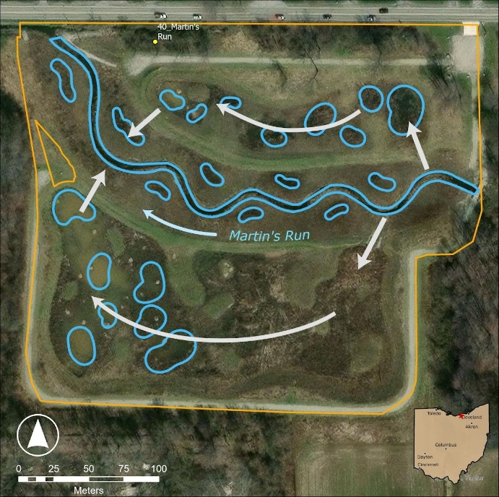
Figure 20. MARR Flowpath Map. Blue outlines indicate wetland pools and arrows represent water flow direction.

Volume Budgeting
Each floodplain pool receives water as a floodplain for Martin’s Run during stormflow when the stream reaches a given height. We created a stage-storage model to estimate the inflowing volume of water. We used bathymetric data of the pool and water depth measured using a Vega PULS and created a generalized additive model to predict the volume based on the depth of each pool and bathymetry data. We calculated the mean depth for each hour (vegetation growth was not an issue for these sensors), calculated volume with our bathymetric model, and then calculated the change in volume between each day. Water level data from the winter months was left out as the ice and snow make accurate water level measurements from the sensor impossible. Ice cover was assumed in between site visit dates where it was verified. We summed up all positive changes in volume to calculate the volume of water flowing into the pool. We summed up all negative changes in volume and then subtracted evapotranspiration to calculate the volume of water flowing out of the pool. We are calculating evapotranspiration using the Penman-Monteith equation:
ET0=0.408∆(Rn-G)+900T+273u2(es-ea)∆+(1+0.34u2)
Where ET_{o} reference evapotranspiration [mm day⁻¹], R_{n} net radiation at the crop surface [MJ m⁻² day⁻¹], G soil heat flux density [MJ m⁻² day⁻¹], T mean daily air temperature at 2 m height [°C], u₂ wind speed at 2 m height [m s⁻¹], e_{s} saturation vapour pressure [kPa], e_{a} actual vapour pressure [kPa], e_{s} - e_{a} saturation vapour pressure deficit [kPa], D slope vapour pressure curve [kPa °C⁻¹], g psychrometric constant [kPa °C⁻¹]. Historical weather data was downloaded from Iowa Mesonet, and solar radiation data was downloaded from NASA.

Nutrient Concentrations
Baseflow concentrations were calculated as the average monthly baseflow concentration across all years in the database because our data for the site is limited. For the inflow baseflow concentrations we used the mean monthly concentration for Martin’s Run (MARR_01 and MARR_07). For outflowing baseflow concentrations for the north and south floodplains we used concentrations from the north pool (MARR_08) and south pool (MARR_09) respectively.
Storm inflow concentrations were calculated as the mean concentration in Martin’s Run (MARR_01 and MARR_02) from storm events that were characterized based on the outlined storm event threshold for the project. Storm outflow concentrations for the north and south floodplains were calculated as the mean concentration from the north pool (MARR_08) and south pool (MARR_09) respectively.

Nutrient Load Calculation
Daily inflow and outflow nutrient concentrations were multiplied by daily inflow and outflow volumes to calculate the mass of each nutrient entering and leaving the site. Retention was calculated as the difference between the mass of each nutrient entering and leaving the site. Daily values were summed to calculate monthly and yearly nutrient loading and retention.

Assumptions, Uncertainties, and Data Gaps
This approach assumes no meaningful net influence of groundwater to input or output nutrient loads. There is no estimate for the water and nutrients entering the site other than from Martin’s Run. Storm event grab samples were taken at times when the surrounding rainfall reached a threshold, not when the stream height reached a threshold to flow into the floodplains. Storm event grab samples were taken on the receding edge of each storm, never while Martin’s Run was actively flowing in the floodplain inlet channels. This approach assumes no water entered or exited the floodplains during the winter.

Mercer Wetland Complex Restoration Phase 1 (MERW1)

Introduction
Mercer Wetland Complex Restoration Phase 1 is a 17.5 acre open water wetland that is actively managed, treating water from Grand Lake St. Marys. This land was originally 40 acres of farmland on a soybean/corn crop rotation. Water is pumped from Lake Inflow (Grand Lake St. Marys) and flows through a series of pools connected via water level control structures (WLCS; Agri Drain) and tiles and eventually outflowing back into Grand Lake St. Marys. Pump inflow rates, as well as the water’s flow path were obtained by the wetland manager Sean Finke (ODNR).
Inflow volume was calculated by multiplying pumping rate by the number of active pump days. The wetland rapidly drains so all water flowing into the Project was assumed to leave; using inflow volumes as outflow volumes. Seasonal averages of nutrient concentrations at the inflow and outflow of the wetland were calculated and multiplied by volumes to calculate the nutrient load in and out of the project.
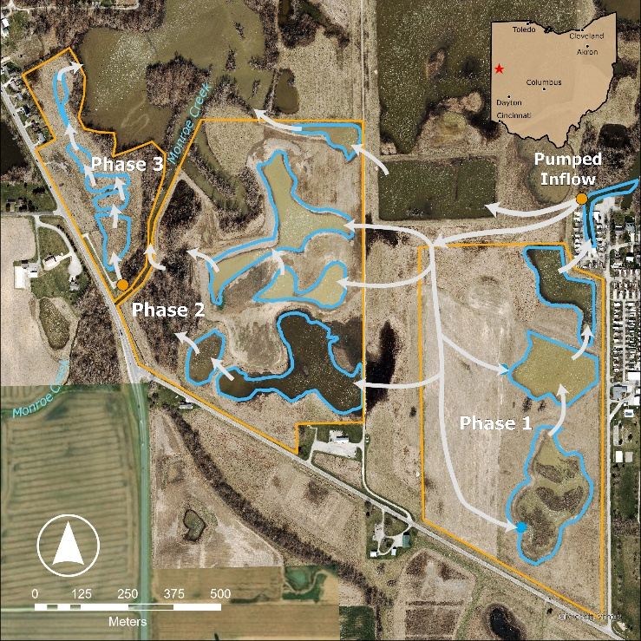
Figure 21. MERW Phase 1 Flowpath Map. Blue outlines indicate wetland pools and arrows represent water flow direction.

Data used
Table 11. Datasets used in volume and nutrient budget calculations.
Dataset Name | Source | Duration | Data Type
Nutrients | H2Ohio WMP | 3/8/23-9/24/25 | TP, DRP, TN, Nox, NH3
Pumping rates | ODNR | 6/30/25-9/24/25 | Pumping rates MCP1

Volume Budgeting
Seasonal inflow volume was calculated using the inflow rate obtained from the wetland manager and multiplying it by the number of days on in a season to determine seasonal total inflow in gallons.

Nutrient Concentrations
Surface water samples were collected from Lake Inflow (Grand Lake St. Marys; MERW_01) and Pool 3 (Outflow; MERW_05) on a bi-weekly basis during the summer season. Lake Inflow and Pool 3 concentrations are a seasonal average, regardless of the pump being on or off as there were not enough samples collected whilst it was on to take an average. This project does not have a defined storm event as the nutrient budget is only calculated for times in which the wetland is active (pump on).

Nutrient Load Calculation
Seasonal nutrient load retained was calculated as the concentration at the inflow multiplied by inflowing volume, and the concentration at the outflow multiplied by the inflowing volume. The formula was used as follows:
load retained=[(Lake Inflow concentration-Pool 3 Outflow concentration)*0.0022046*volume]/[0.26417*1000]
where load retained is in pounds, concentrations are in mg/L and volume is in gallons.

Assumptions, Uncertainties, and Data Gaps
This approach assumes no meaningful net influence of groundwater to input or output nutrient loads. It also assumes that all increases in water level within the wetland are caused by inflow from the pump without accounting for addition directly from precipitation. This approach also assumes that inflow rates were constant, unless informed that the pump was off. This approach assumes that storm events don’t have a strong effect on the Project because water enters through pumps.

Mercer Wetland Complex Restoration Phase 2 (MERW2)

Introduction
Mercer Wetland Complex Restoration Phase 2 is a 14.4 acre open water wetland that is actively managed, treating water from Grand Lake St. Marys. This land was originally farmland on a soybean/corn crop rotation. Water is pumped from Lake Inflow (Grand Lake St. Marys) and flows through a series of pools connected via water level control structures (WLCS; Agri Drain) and tiles and eventually outflowing back into Grand Lake St. Marys. There is no evidence of groundwater exchange. Pump inflow rates, as well as the water’s flow path were obtained by the wetland manager Sean Finke (ODNR).
Inflow volume was calculated by multiplying pumping rate by the number of active pump days. The wetland rapidly drains so all water flowing into the Project was assumed to leave; using inflow volumes as outflow volumes. Seasonal averages of nutrient concentrations at the inflow and outflow of the wetland were calculated and multiplied by volumes to calculate the nutrient load in and out of the project.
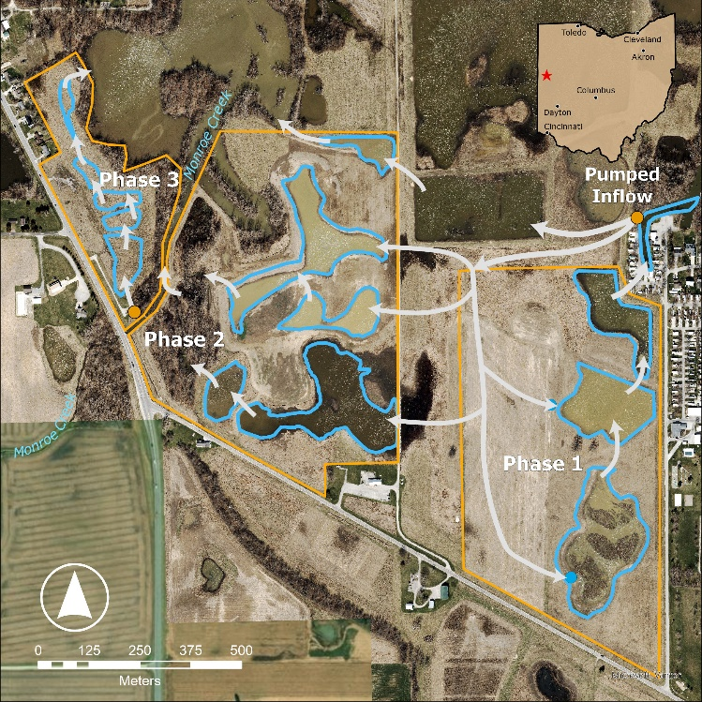
Figure 22. MERW Phase 2 Flowpath Map. Blue outlines indicate wetland pools and arrows represent water flow direction.

Data used
Table 12. Datasets used in volume and nutrient budget calculations.
Dataset Name | Source | Duration | Data Type
Nutrients | H2Ohio WMP | 9/14/23-9/24/25 | TP, DRP, TN, Nox, NH3
Pumping rates | ODNR | 6/30/25-9/24/25 | Pumping rates MCP2

Volume Budgeting
Seasonal inflow volume was calculated using the inflow rate obtained from the wetland manager and multiplying it by the number of days on in a season to determine seasonal total inflow in gallons.

Nutrient Concentrations
Surface water samples were collected from Lake Inflow (Grand Lake St. Marys; MERW_06) and Pool 3 (Forest Outflow; MERW_08) on a bi-weekly basis during the summer season. Lake Inflow and Pool 3 (Forest Outflow) concentrations are a seasonal average, regardless of the pump being on or off as there were not enough samples collected whilst it was on to take an average. This project does not have a defined storm event as the nutrient budget is only calculated for times in which the wetland is active (pump on).

Nutrient Load Calculation
Seasonal nutrient load retained was calculated as the concentration at the inflow multiplied by inflowing volume, and the concentration at the outflow multiplied by the inflowing volume. The formula was used as follows:
load retained=[(Lake Inflow concentration-Pool 3 (forest) Outflow concentration)*0.0022046*volume]/[0.26417*1000]
where load retained is in pounds, concentrations are in mg/L and volume is in gallons.

Assumptions, Uncertainties, and Data Gaps
This approach assumes no meaningful net influence of groundwater to input or output nutrient loads. It also assumes that all increases in water level within the wetland are caused by inflow from the pump without accounting for addition directly from precipitation. This approach also assumes that inflow rates were constant, unless informed that the pump was off. This approach assumes that storm events don’t have a strong effect on the Project because water enters through pumps.

Mercer Wetland Complex Restoration Phase 3 (MERW3)

Introduction
Mercer Wetland Complex Restoration Phase 3 is a 5.5 acre flow through wetland that is actively managed, treating water from Monroe Creek/Grand Lake St. Marys. When the lake is high during the summer the pump typically captures lake water, but when the lake is low it only captures water from Monroe Creek. This land originally held a motel. Water is pumped from Monroe Creek/Grand Lake St. Marys and flows through a series of pools before eventually outflowing back into Grand Lake St. Marys through a water level control structure (WLCS; Agri Drain). There is no evidence of interaction with groundwater. A pressure transducing water level sensor (Onset HOBO) measures the water level of the Outflow pool at 30 minute intervals.
Outflow volumes were calculated using a simple flow over flat-weir equation, and inflow volumes were calculated as outflow + evapotranspiration. Nutrient concentrations at the inflow and outflow were averaged into seasonal concentrations. Seasonal loads retained were then calculated as inflow load - outflow load, with positive values indicative of loads retained and negative values indicative of loads exported.
Figure 23. MERW Phase 3 Flowpath Map. Blue outlines indicate wetland pools and arrows represent water flow direction.

Data used
Table 13. Datasets used in volume and nutrient budget calculations.
Dataset Name | Source | Duration | Data Type
Weather | Iowa Mesonet | N/A | Wind speed, min/max air temp, min/max relative humidity, Atmospheric pressure
Solar radiation | NASA | N/A | Solar radiation
Nutrients | H2Ohio WMP | 9/14/23-9/24/25 | TP, DRP, TN, Nox, NH3
Water level (HOBO) | H2Ohio WMP | 4/10/25-9/15/25 | Water level

Volume Budgeting
We directly measured inflowing volume using data collected from a pressure transducing water level sensor, average daily depths were calculated for the Outflow pool. The daily water depths were then converted to volume using the following flow over flat weir equation:
if H≤0.27W,Q=3.19924(W-0.74H)H^1.48 if H>0.27W,Q=3.0318WH^1.37
where H is the height of water above the stop log in inches, W is the width of the weir (for this project W=10.31) and Q is the flow rate in gallons per minute. We calculate evapotranspiration using the Penman-Monteith equation:
ET0=0.408∆(Rn-G)+900T+273u2(es-ea)∆+(1+0.34u2)

Where ET_{o} reference evapotranspiration [mm day⁻¹], R_{n} net radiation at the crop surface [MJ m⁻² day⁻¹], G soil heat flux density [MJ m⁻² day⁻¹], T mean daily air temperature at 2 m height [°C], u₂ wind speed at 2 m height [m s⁻¹], e_{s} saturation vapour pressure [kPa], e_{a} actual vapour pressure [kPa], e_{s} - e_{a} saturation vapour pressure deficit [kPa], D slope vapour pressure curve [kPa °C⁻¹], g psychrometric constant [kPa °C⁻¹]. Historical weather data was downloaded from Iowa Mesonet, and solar radiation data was downloaded from NASA.
These evapotranspiration rates were converted to average daily volume lost to evapotranspiration as follows:
Volume lost to Evapotranspiration (gallons)=(5.5*325,852*ET_0)/12
where 5.5 is wetland acreage and ET_0 is the evapotranspiration rate in inches/day. The daily volume lost to evapotranspiration was added to outflowing volume to calculate inflowing volume.

Nutrient Concentrations
Surface water samples were collected from Monroe Creek (Inflow; MERW_11) and Outflow Pool (outflow; MERW_13) on a bi-weekly basis. Monroe Creek (Inflow) and Outflow Pool (Phase 3) concentrations were calculated as a seasonal average.

Nutrient Load Calculation
Seasonal nutrient inflow and outflow loads were calculated as follows: load =[concentration*0.0022046*volume]/[0.26417*1000] where load is in pounds, concentrations are in mg/L, and volume is in gallons. Seasonal loads retained were then calculated as inflow load – outflow load, positive values indicative of loads retained and negative values indicative of loads exported.

Assumptions, Uncertainties, and Data Gaps
This approach assumes no meaningful net influence of groundwater to input or output nutrient loads. This approach assumes there are not major differences during storm events, which did not have sufficient sampling frequency to include in this budget. It also assumes that all increases in water level within the wetland are caused by inflow from the pump without accounting for addition directly from precipitation. This approach also assumes that inflow rates were constant, unless informed that the pump was off.

Montpelier Wetland (MONW)

Introduction
The Montpelier Wetland was an existing 4-ac depression that was unfarmed due to constant wet conditions. The total restoration area is 10.9 acres, with 6.4-acres as wetland, and 4.5 as restored surrounding upland. A forebay receives the surface and tile runoff from the surrounding 45-ac agricultural drainage area and then inlets into the wetland; this connection point of the forebay and wetland is where inlet monitoring occurs. This wetland design features a 2,300-ft low-slope circuitous flow path through wetland with five deep pools. The wetland outlets into an inline water control structure which diverts outflow into a Phosphorus Removal Filter and allows for high flow bypass. All outflow is ultimately discharged into a downstream storm sewer catch-basin. Wetland outlet samples are taken in the inline water control structure before the P-Filter.
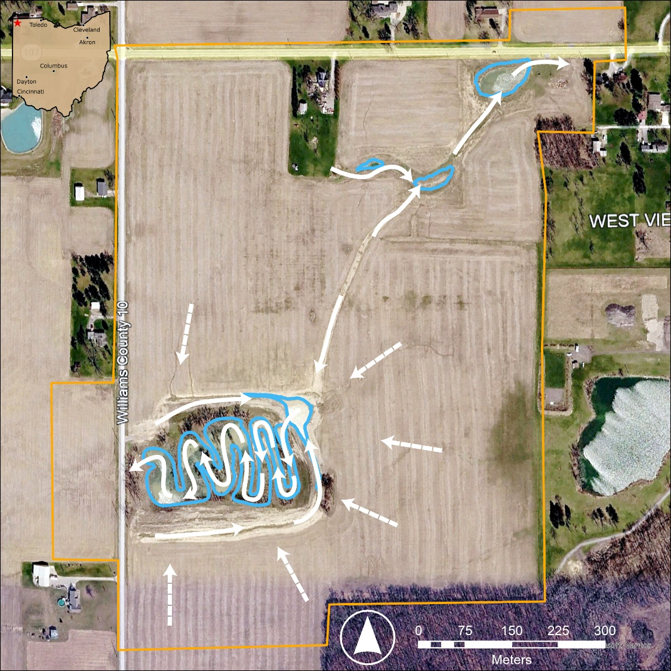
Figure 24. MONW Flowpath Map. Blue outlines indicate wetland pools and arrows represent water flow direction.

Data used
Table 14. Datasets used in volume and nutrient budget calculations.
Dataset Name | Source | Duration | Data Type
Area- Velocity | H2Ohio WMP | N/A | Velocity, Water level
Nutrients | H2Ohio WMP | N/A | TP, DRP, TN, NOx
Water Level | H2Ohio WMP | N/A | Water Level, Flow

Volume Budgeting
Hydrological data were recorded on 5-minute intervals across the monitoring network. Flow entering the wetland originated from a settling basin at the edge of an agricultural field. Water passed through a primary flume, where water level was continuously logged and converted to flow rate using the manufacturer’s level-to-discharge rating. To accurately measure low-flow conditions, water exiting the flume passed through a short tile section equipped with a Thelmar weir, allowing flow estimation at shallow depths through an additional level-to-rate conversion.
Water leaving the wetland passed through an AgriDrain water control structure (WCS) consisting of three cells. The first set acted as an inlet and sampling location to measure the concentrations from the wetland. The next cell directed water into a Phosphorus Removal Structure (PRS; concentrations not reported), and a final cell conveyed water into a bypass outlet, which allowed flow to avoid the PRS. The PRS and bypass discharges were routed separately through pipes that both emptied into the same roadside culvert downstream of the wetland. Because the culvert is susceptible to high-water submergence, flow from the PRS stream was measured using a water-level sensor with additional area-velocity sensor enabling accurate discharge quantification during partial or full submergence conditions. Flow in the bypass stream was measured upstream of the culvert using a V-notch board installed between the second and third WCS cells, where water levels were recorded and converted to discharge.
For wetland outflow, the hydrologic dataset represents the sum of PRS outflow + bypass outflow, ensuring that the complete wetland discharge hydrograph is captured even though PRS-specific results will not be shared. During April 2025, an extreme flooding event led to submerged conditions that may have led to underestimates of flow rates from the bypass tile which did not include an area-velocity sensor.

Nutrient Concentrations
At both the wetland inlet and the outlet (combined PRS + bypass), water samples were collected by automated samplers. Routine baseflow sampling used an 8-aliquot, 48-hour composite cycle, and was supplemented by event-triggered samples during storms or rapid hydrologic changes at the WCS. Inlet sampling followed the same program to ensure comparable inflow and outflow datasets. Baseflow samples are taken every 6 hours whenever there is flow measured. Events samples are taken every 15 minutes while the recorded level rises more than 0.015’ within a 30-minute period. This is to capture the rising limb of the storm event inflow and outflow. The recorded level to trigger the event is at the specific site, so at the inlet, it is if the level in the flume/weir system rises at that rate, and the outlet is monitoring the level in the inline-control structure.
Samples were analyzed for:
- Total Phosphorus (TP)
- Dissolved Reactive Phosphorus (DRP)
- Nitrate + Nitrite (NOx) (reported as N-NO_{x})
- Total Nitrogen (TN)
Analytical procedures followed standard colorimetric and digestion methods, consistent with previously described workflows (e.g., filtration at 0.45 µm, persulfate digestion for TP, and automated colorimetric analysis).
In cases where sampler malfunction or environmental conditions resulted in missing concentration data, the annual mean concentration for that analyte was applied when computing monthly loads.

Nutrient Load Calculation
The total mass of each nutrient that entered the wetland was calculated by multiplying the nutrient concentration of the 48 hour sampling composite or event sample at the inlet by the incoming volume. The total amount of each nutrient released from the wetland was calculated by multiplying the nutrient concentration of the 48 hour sampling composite or event sample at the outlet by the outflowing volume.

Assumptions, Uncertainties, and Data Gaps
This approach assumes no meaningful net influence of groundwater to input or output nutrient loads.

North Ridge Hunt Club Wetland Restoration (NORR)

Introduction
North Ridge Hunt Club Wetland Restoration is an actively managed, 23-acre wetland created on previously active farmland in Ottawa County, Ohio. Water inputs primarily come from the tile drainage in the farm field to the north flowing into a ditch on the north and east sides of the wetland. Water from the ditch is pumped into the wetland at the southern end of the ditch. Water exits the wetland to Packer Creek through a water level control structure (“WLCS”) on the southern edge of the wetland. The pump is active from the spring thaw until the first winter freeze and automatically adds water to the wetland when the water level in the agricultural ditch is sufficiently high, providing a steady source of water to the wetland even during drought conditions. The WLCS is managed for the wetland to retain water throughout the year, flowing out only when the water level exceeds the stoplog level set by the manager to fulfill waterfowl habitat needs. Hydrologic events include the addition of water through pumping or adjustment of the WLCS which alters the volume of water the wetland contains or the direction it flows. There is no evidence of exchange between surface water and groundwater.
The net annual nutrient budget was calculated by first calculating the water volume added to the wetland by the pump from the amount of time the pump was active (“pump hours”) and multiplying that volume by the concentration of nutrients in analyzed samples from the initial input to the agricultural ditch to estimate the nutrient inputs. Then, nutrient loads released from the wetland were calculated by multiplying the calculated water volume released by the wetland by the concentration of nutrients in analyzed samples from the wetland. The nutrient outputs could only be calculated for approximately two months of the water year because the sensor required to calculate water released from the WLCS was installed in late July.

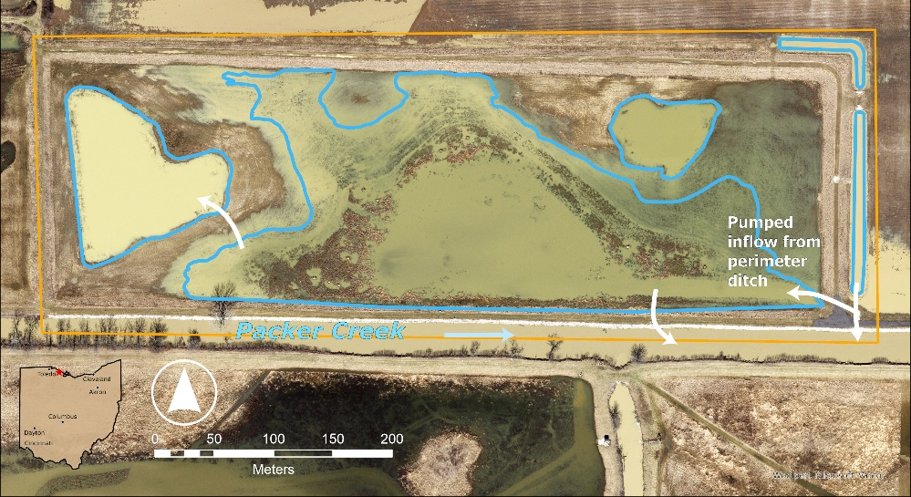
Figure 25. NORR Flowpath Map. Blue outlines indicate wetland pools and arrows represent water flow direction.

Data used
Table 15. Datasets used in volume and nutrient budget calculations.
Dataset Name | Source | Duration | Data Type
Pump Log | H2Ohio WMP | 9/4/24-10/5/25 | Pump hours
Nutrients | H2Ohio WMP | 10/1/24-10/15/25 | TP, DRP, TN, NOx, NH4
Water Level | H2Ohio WMP | 4/16/25-10/1/25 | Water Level
Flow (Solinst Levelogger 5 Junior) | H2Ohio WMP | 7/22/25-12/2/25 | Water Level, Flow

Volume Budgeting
Water volume inputs were directly measured using the pumping rate (from pump technical specifications) multiplied by the pumping time. The volume of water released through the WLCS was calculated using the flow rate (based on the structure size, stoplog height, and water level) multiplied by the amount of time the water level exceeded the stoplog height. All water volume estimates were aggregated to provide daily values.
To calculate the water volume input, the amount of time the pump was active was logged over time at irregular intervals (approximately once per month) through management action surveys. A pump rate was established using the technical specifications of the pump, and the water volume input was calculated for each interval. Prior to the installation of the Vega PULS C 21 water level sensor, the volume of water added was assumed to be equal for each date between pump hour reports when the pump was active. After the water level sensor was installed, specific hydrologic events were identified as dates when the water level increased over the the course of the day. A proportion of the water volume pumped into the wetland between management action surveys was assigned to each input date according to the magnitude of that date’s increase in water level relative to other dates within the interval.
To calculate the water volume output, a water level sensor (Solinst Levelogger 5 Junior) was deployed within the WLCS (a 12-inch wide AgriDrain stoplog structure) to measure the water level within the structure every hour starting on July 22, 2025. When the measured water level within the WLCS was higher than the known stoplog height, water flow was calculated using the appropriate equation for this structure that is provided by the manufacturer. Generally, when the water height over the stoplogs was greater than 3.24 inches, flow was equal to 3.19924*(12-0.437H)*H^1.48, and if the water height was lower than 3.24 inches, flow was equal to 3.0318*12*H^1.37, where flow is in gallons per minute and H is height of water above the stop log in inches. The calculated value for flow was multiplied by sixty to calculate water volume released through the WLCS under the assumption that flow was constant for the entire hour between Levelogger measurements. (Calibrating agridrain water level control structures using generalized weir and orifice equations - Illinois Experts). Water volume released through the WLCS cannot be calculated prior to the installation of the Levelogger because water level within the structure was not measured.

Nutrient Concentrations
Surface water samples were collected within the agricultural ditch feeding the wetland to represent nutrient concentrations of inflows (“North Ditch”; NORR_07). Surface water samples were collected within the center pool adjacent to the WLCS (“WCS”; NORR_02) to represent nutrient concentrations of outflows. Water samples were collected once in each season from spring to fall, and during one spring hydrologic event.
Prior to sensor installation, hydrologic events were defined as known instances of inflows and outflows based on the land manager’s reports of turning on the pump manually or removing stoplogs to lower the wetland water level. After sensor installations, hydrologic events included times when water level increased in the wetland as well as times when water level within the WLCS exceeded the height of the stoplogs. During the timeframes with available sensor data, water flowed out of the WLCS nearly daily for one month and water flowed in on approximately 50% of the dates.

Nutrient Load Calculation
The total amount of each nutrient that entered the wetland was calculated by multiplying the nutrient concentration of the sample collected on the nearest date at the North Ditch sampling location by the water volume added each day. The total amount of each nutrient released from the wetland was calculated by multiplying the nutrient concentration of the sample collected on the nearest date from the “WCS” sampling location by the water volume lost through the WLCS each day.

Assumptions, Uncertainties, and Data Gaps
This approach assumes no meaningful net influence of groundwater to input or output nutrient loads. It also assumes that all increases in water level within the wetland are caused by pumping without accounting for addition from direct precipitation, and may therefore overestimate the load of nutrients by assuming all increases in water level within the wetland are attributed to inputs of agricultural runoff. Nutrient concentrations were only measured following one hydrologic event out of the many events that occurred in the 2025 Water Year, therefore no conclusions could be made about how nutrient concentrations change during events. Increasing sampling frequency and targeting more storm events during different seasons will improve estimates of nutrient loading and release. Load estimates cannot be robustly calculated prior to the addition of sensors to track changes in wetland water volume over time, however they were greatly improved in the 2025 Water Year with the development of the current method using sensor data along with information about management activity.

Oakwoods Nature Preserve Restoration Project West (OAKW)

Introduction
The East and West halves of the Oakwoods Nature Preserve Project consist of 43 total wetland pools. Thirty-eight of these pools are isolated depressional pools (aka Geographically Isolated Wetlands = GIWs) with no discrete water inlets or outlets. Five pools have drainage tile inputs that may deliver tile drained agricultural runoff. One of these, Pool 1, is also a floodplain wetland with a connection to Aurand Run, the stream that flows adjacent to the project and is the primary water collection body for this watershed. The other four pools (30, 31, 36, 42) have no outlets. These four are classified as Flow-in/No-Flow-Out (FINFO) pools. The water level changes of these FINFO pools are being compared to pools without tiles to discern whether significant inflow is being delivered by the tiles. There is no evidence yet of groundwater exchange at either side of this Project. Oakwoods West has a water control structure at Pool 1, intended to be used to add water to Pool 1 when water level drops below desirable levels, but Aurand Run has never been high enough for such action when water was needed in Pool 1. Hydrologic events at this Project occur after at least 0.5 inches of rainfall. At highest water levels, Aurand Run floods into Pool 1 on the West side and many pools on the East side merge together.

Estimates of inflowing and outflowing volume into the pool connected to Aurand Run at this site use bathymetry data and water depth to create a stage-storage model where increases in pool volume correspond to inflowing water. Outflowing volumes were adjusted by calculating evapotranspiration for the site using the Penman-Monteith equation and subtracting the amount lost to evapotranspiration from outflow volumes. We calculated monthly nutrient baseflow concentrations in the stream (to estimate inflowing water) and in the pool (to estimate outflowing water) as the average monthly nutrient concentration across all sampling years and replaced all storm event days with the mean storm event concentrations with fully characterized storm event concentrations from Aurand Run. There are minor tile inputs to the pool as well but to our best understanding they are a very small proportion of the total water entering the pool and we do not account for them in this budget. We multiplied inflow volume by the inflow nutrient concentrations, and outflowing volume by outflowing nutrient concentrations.

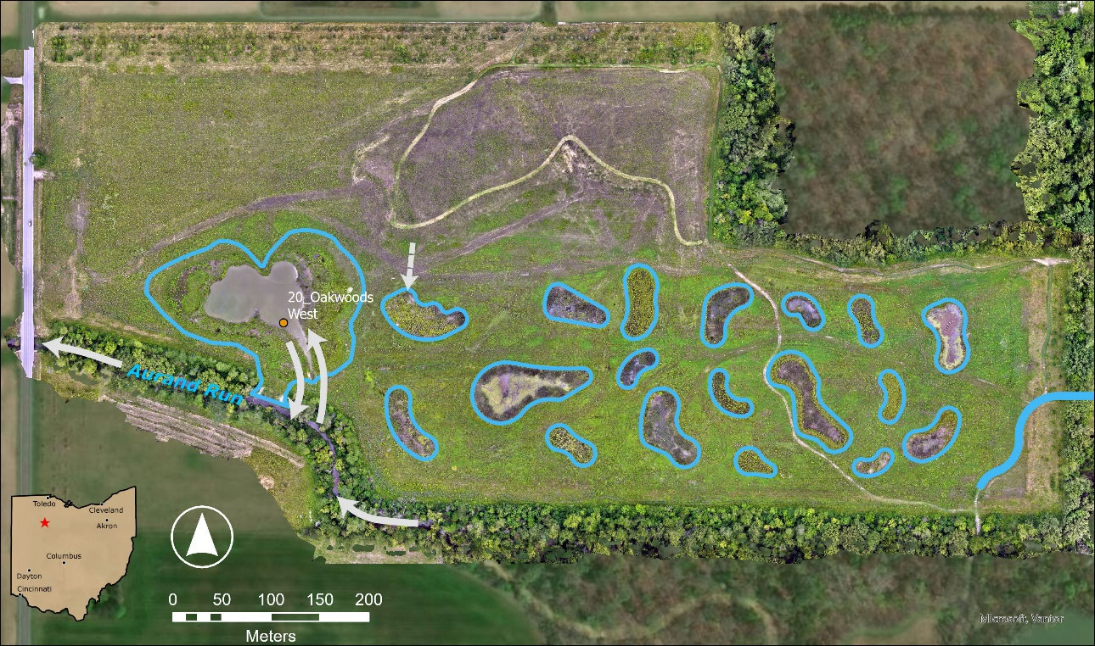
Figure 26. OAKW Flowpath Map. Blue outlines indicate wetland pools and arrows represent water flow direction.

Data used
Table 16. Datasets used in nutrient budget calculations.
Dataset Name | Source | Duration | Data Type
Area- Velocity | H2Ohio WMP | 3/25/25-present | Velocity, Water level
Weather | Iowa Mesonet | 10/1/22-present | Wind speed, min/max air temp, min/max relative humidity, Atmospheric pressure
Solar radiation | NASA | 10/1/22-present | Solar radiation
OAK Bathymetry | H2Ohio WMP | N/A | Bathymetry
Nutrients | H2Ohio WMP | WY 2022-present | TP, DRP, TN, Nox, Nh3
Water Level (VEGAPuls) | H2Ohio WMP Sensor Network | 2023/06-present | Water Level

Volume Budgeting
Flow at Oakwoods was only calculated for pool 1 which acts as a floodplain for Aurand Run:
Pool 1:
Pool 1 receives water as a floodplain for Aurand Run during stormflow. We created a stage-storage model to estimate the inflowing volume of water. We used bathymetric data of the pool and water depth measured using a [INSERT INSTRUMENT NAMES HERE] and created a generalized additive model to predict the volume based on the depth of the pool and bathymetry data. We calculated the mean depth for each day to minimize noise in our sensor (that occurs largely due to vegetation blocking the sensor), calculated volume with our bathymetric model, and then calculated the change in volume between each day. We summed up all positive changes in volume to calculate the volume of water flowing into the pool. We summed up all negative changes in volume and then subtracted evapotranspiration to calculate the volume of water flowing out of the pool. We are calculating evapotranspiration using the Penman-Monteith equation:
ET0=0.408∆(Rn-G)+900T+273u2(es-ea)∆+(1+0.34u2)

Where ET_{o} reference evapotranspiration [mm day⁻¹], R_{n} net radiation at the crop surface [MJ m⁻² day⁻¹], G soil heat flux density [MJ m⁻² day⁻¹], T mean daily air temperature at 2 m height [°C], u₂ wind speed at 2 m height [m s⁻¹], e_{s} saturation vapour pressure [kPa], e_{a} actual vapour pressure [kPa], e_{s} - e_{a} saturation vapour pressure deficit [kPa], D slope vapour pressure curve [kPa °C⁻¹], g psychrometric constant [kPa °C⁻¹]. Historical weather data was downloaded from Iowa Mesonet, and solar radiation data was downloaded from NASA.

Nutrient Concentrations
Pool 1:
Baseflow concentrations were calculated as the average monthly baseflow concentration across all years in the database because our data for the site is limited. For the inflow baseflow concentrations we used the mean monthly concentration for Aurand Run (OAKW_20, OAKW_21, OAKW_22). For outflowing baseflow concentrations we used concentrations from pool 1 (OAKW_01).
Storm inflow concentrations were calculated as the mean concentration in Aurand Run (OAK_20) from 2 storm events that were fully characterized using an ISCO (n samples = 25, 23 respectively for each storm event). Storm outflow concentrations were calculated as the mean concentration from 4 storm grab samples in pool 1 (OAK_01). Out of 15 total storm events, 2 were characterized with ISCO sampling at the outlet, and grab samples were collected for 4 storm events.

Nutrient Load Calculation
Daily inflow and outflow nutrient concentrations were multiplied by daily inflow and outflow volumes to calculate the mass of each nutrient entering and leaving the site. Retention was calculated as the difference between the mass of each nutrient entering and leaving the site. Daily values were summed to calculate monthly and yearly nutrient loading and retention.

Assumptions, Uncertainties, and Data Gaps
This approach assumes no meaningful net influence of groundwater to input or output nutrient loads. This approach assumes that there were no major flood events prior to May 17th in 2024. This approach assumes that tile contributions to the pool are minimal.

Redhorse Bend Preserve Restoration Project (REDB)

Introduction
The Redhorse Bend Preserve Restoration Project is a 54-acre site in Fremont, Ohio, with 28 acres of restored floodplain habitat along the Sandusky River. Berms were lowered to enhance river connectivity to wetland pools in the northern portion of the site, creating a river-driven floodplain system. Major inputs include overbank flow from the Sandusky River through a ditch during elevated discharge, direct precipitation, and localized runoff (including roadway runoff to the southern isolated pool), while outputs occur passively as floodwaters recede back to the river; no water-level control structures or pumping mechanisms are present. Nutrient sources include riverine sediment and nutrient loads during high-flow events, legacy agricultural soils, and roadway runoff. Hydrology is surface-water dominated with clear evidence of groundwater exchange as observed by a natural spring on the property. Hydrologic events are defined using the Sandusky River near Fremont, OH, with connectivity initiated above 3,800 CFS.
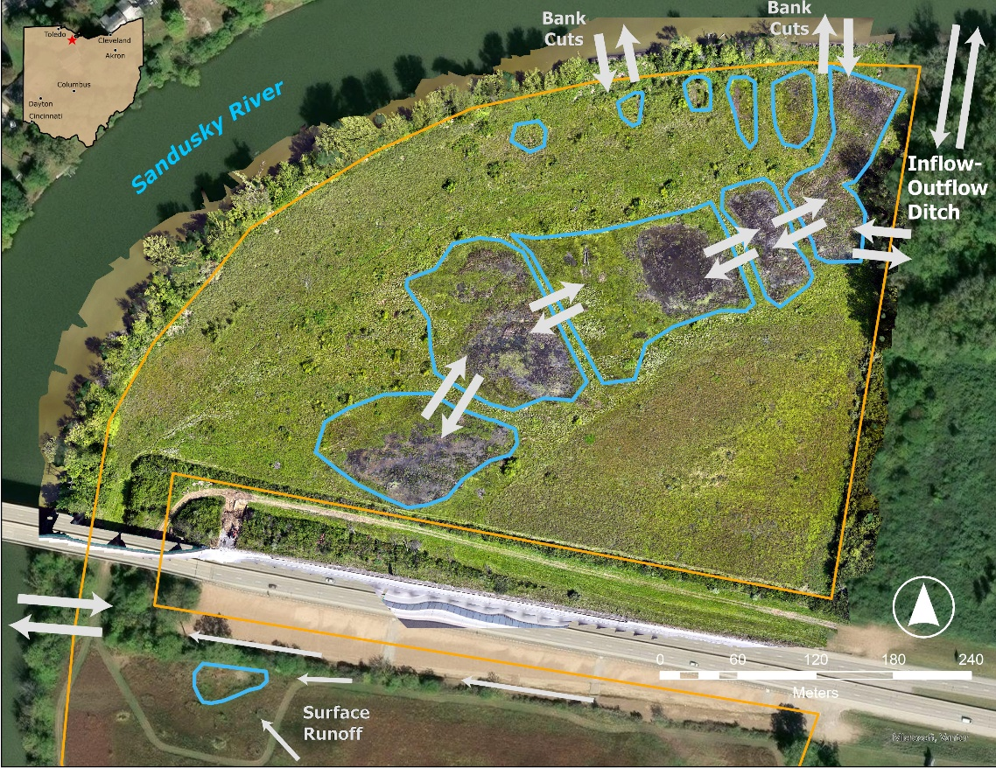
Figure 27. REDB Flowpath Map. Blue outlines indicate wetland pools and arrows represent water flow direction.

Flow values at this site were calculated using a stage storage model for each of 5 pools. Pool depths were calculated using a general additive model comparing pool depth with discharge in the Sandusky River. Inflowing volumes were calculated as net positive changes in depth, and outflowing volumes were calculated as net negative changes in depth minus evapotranspiration calculated using the Penman-Monteith equation. We used daily concentrations from the Sandusky river to calculate inflowing load to the first pool and then used monthly nutrient baseflow concentrations at each pool in the sequence as the average monthly nutrient concentration across all sampling years and replaced all storm event days with the mean storm event concentration across all samples for each pool. We multiplied inflow volume by the nutrient concentrations for the river or pool flowing into each pool, and outflowing volume by the nutrient concentrations for each pool.

Data used
Table 17. Datasets used in nutrient budget calculations.
Dataset Name | Source | Duration | Data Type
Water Depths | H2Ohio WMP | WY2022-present | Water depth
Sandusky River Nutrients | NCWQR | WY2022-present | TP, DRP, TN, Nox, Nh3
Sandusky River Discharge | USGS | 10/01/21-present | Discharge (cfs)
Weather | Iowa Mesonet | 10/1/22-present | Wind speed, min/max air temp, min/max relative humidity, Atmospheric pressure
Solar Radiation | NASA | 10/1/22-present | Solar radiation
Nutrients | H2Ohio WMP | WY 2022-present | TP, DRP, TN, Nox, Nh3

Volume Budgeting
Flow volumes into the treatment chain at Redhorse Bend were estimated using a stage storage model. Water level was recorded by sensor starting in April 2025, prior to that average pool depths for pools 1–5 and pool A were calculated using a combination of observed pool depths, and the relationship between the Sandusky river discharge volume and water entering the site for both ambient and storm conditions. Pool areas were calculated from Google Earth images of the site. Because the pools are responsive/related to Sandusky River water levels, and the resultant changes in groundwater levels, researchers estimate pool volumes on a daily time step based on Sandusky River discharge volume. Generalized additive models were fit for observed depths, and river discharge and all model fits had an R2 value above 0.64 (Pool 1: 0.73, Pool 2: 0.70, Pool 3: 0.65, Pool 4: 0.72, Pool 5: 0.76, Pool a: 0.64).
Pool area is multiplied by water depth each day to calculate pool volume. We do not have good bathymetric data for this site, so pool area for high flow was delineated using Google Earth Engine from days storm days, and pool area for low flow was delineated using Google Earth Engine for days during low flow. We considered low flow as any day where discharge was < 3,000 cfs, which is the threshold at which water begins to enter the system. For those days we used the area of the pools at low flow. When discharge is >10,000cfs more pathways for flow open up and the site becomes much more inundated so days with discharge >10,000cfs we used the full inundated area. For days in between 3,000 and 10,000cfs we used the mean area of the high and low areas combined.
Daily inflow is calculated as daily net positive changes in volume. We calculate daily outflow as daily net negative changes in volume minus evapotranspiration for the area of the pool. We are calculating evapotranspiration using the Penman-Monteith equation:
ET0=0.408∆(Rn-G)+900T+273u2(es-ea)∆+(1+0.34u2)

Where ET_{o} reference evapotranspiration [mm day⁻¹], R_{n} net radiation at the crop surface [MJ m⁻² day⁻¹], G soil heat flux density [MJ m⁻² day⁻¹], T mean daily air temperature at 2 m height [°C], u₂ wind speed at 2 m height [m s⁻¹], e_{s} saturation vapour pressure [kPa], e_{a} actual vapour pressure [kPa], e_{s} - e_{a} saturation vapour pressure deficit [kPa], D slope vapour pressure curve [kPa °C⁻¹], g psychrometric constant [kPa °C⁻¹]. Historical weather data was downloaded from Iowa Mesonet, and solar radiation data was downloaded from NASA. Weather data was not available from the nearest station until 09-22-2022, so water year 2021 partially does not account for evapotranspiration.

Nutrient Concentrations
Baseflow concentrations were calculated as the average monthly baseflow concentration across all years in the database, except for samples from the Sandusky River where daily concentration was used from the National Center for Water Quality Research at Heidelberg University. We changed inflow and outflow sites based on the direction of water flow into or out of the site. The inflow location used reflects inflowing water where water flows through the following sequence when water is flowing into the site: River (REDB_09) ➔ Pool 1 (REDB_01/2) ➔ Pool 2 (REDB_03) ➔ Pool 3 (REDB_04/5) ➔ Pool 4 (REDB_06) ➔ Pool 5 (REDB_07) and River (REDB_09) ➔ Pool A (REDB_13) (Figure 2). For example pool 1 would use concentrations from the River when volume is increasing. For decreasing pool volumes the concentration used reflects the flow of water out of the site as follows: Pool 5 ➔ Pool 4 ➔ Pool 3 ➔ Pool 2 ➔ Pool 1 (Figure 28).
For each day, the inflow and outflow concentrations are picked based on the direction flow. Baseflow nutrient concentrations were applied to all days, and then any days with Sandusky river discharge >3000 cfs were replaced with storm concentrations.

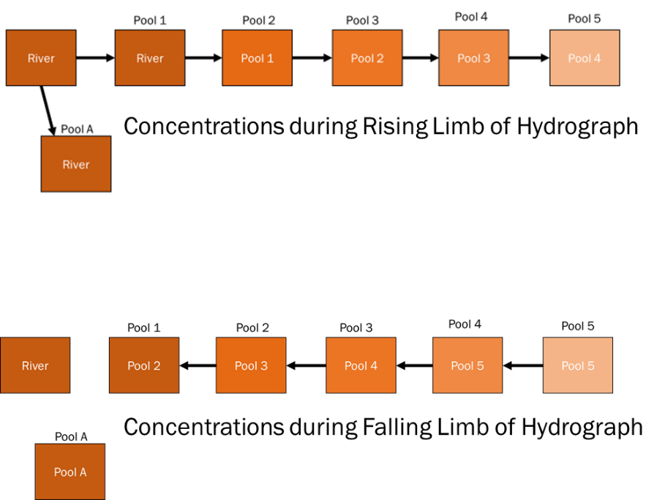
Figure 28. Concentrations used during rising and falling limb for REDB budget calculations.

Baseflow nutrient concentrations were calculated as the mean concentration at each pool when Sandusky river discharge was <3000 cfs. Stormflow concentrations were calculated as the mean concentration at each pool during all available stormflow (>3000 cfs) concentrations (n samples = pool 1: 12, pool 2: 8, pool 3: 15, pool 4: 9, pool 5: 13, pool a: 10). Out of 31 total storm events from WY 2022 - present, grab samples were collected for between 8 and 14 storms depending on the pool.

Nutrient Load Calculation
Daily inflow and outflow nutrient concentrations were multiplied by daily inflow and outflow volumes to calculate the mass of each nutrient entering and leaving the site. Retention was calculated as the difference between the mass of each nutrient entering and leaving the site. Daily values were summed to calculate monthly and yearly nutrient loading and retention.

Assumptions, Uncertainties, and Data Gaps
This approach assumes no meaningful net influence of groundwater to input or output nutrient loads. There is higher frequency data for inflowing concentrations (from the daily values from the Sandusky River) so the higher error and/or bias of outflowing concentrations may bias results. There is uncertainty around the volume There is uncertainty in how much baseflow concentrations collected in pools are representative of concentrations in inflowing or outflowing water. Weather data for WY2021 only begins on 09-22-2022, so evapotranspiration is not calculated until that date.

St. Joseph River Restoration Project (SJRE)

Introduction
The St. Joseph River Farm and Floodplain Restoration Project (hereafter known as St. Joe Restoration) is a 94-acre restoration Project in the Upper Maumee watershed. Thirty-three acres of the Project were converted to wetland pools by excavation. This Project has complex hydrology. Three large agricultural tile outlets and ditched drainage pathways deliver water to a mix of flow-through, floodplain, and isolated wetland pools. There are two major flow paths: Flow path C and Flow path B. In Flow path C, the North Tile first delivers water to Pool A and later converges with the Northwest Tile to deliver water primarily to Pool C and, if flow is very high, to Pool G. In Flow path B, the Northeast Tile delivers water primarily to Pool B. Floodplain connection at this Project intersects with both tile drain flow paths. The southeast area of this Project is flooded by water from the St. Joseph River when water level rises, including Pools B and G. Pools D, E, and F are pools without distinct inflows or outflows but do receive floodplain connection when water levels are very high. Flow out of this Project primarily exits Pool B and reaches the St. Joseph River. The mixture of flow-through, isolated, and floodplain pools necessitates the separate calculation of nutrient budgets for different flowpaths, which are then added together. There are no water control structures at this Project and no evidence yet of surface water/groundwater exchange. Hydrologic events usually occur after at least 0.5 inches of rain late winter through midsummer, resulting in tile drain delivery and flowthrough function. Major floodplain activity typically occurs in April and results in total inundation of the southern and eastern portions of the Project, including areas between and outside of pool boundaries.
Estimates of inflowing and outflowing volume in wetland pools at this site use bathymetry data and water depth to create a stage-storage model where increases in pool volume correspond to inflowing water for the site. In water year 2025 we used an area velocity sensor to directly measure the volume of backflow from the river during storm events. Outflowing volumes were adjusted by calculating evapotranspiration for the site using the Penman-Monteith equation and subtracting the amount lost to evapotranspiration from outflow volumes. We calculated monthly nutrient baseflow concentrations at the inflow and outflow of each flow path as the average monthly nutrient concentration across all sampling years and replaced all storm event days with the mean storm event concentrations across all samples for each flow path. We multiplied inflow volume by the inflow nutrient concentrations, and outflowing volume by outflowing nutrient concentrations.
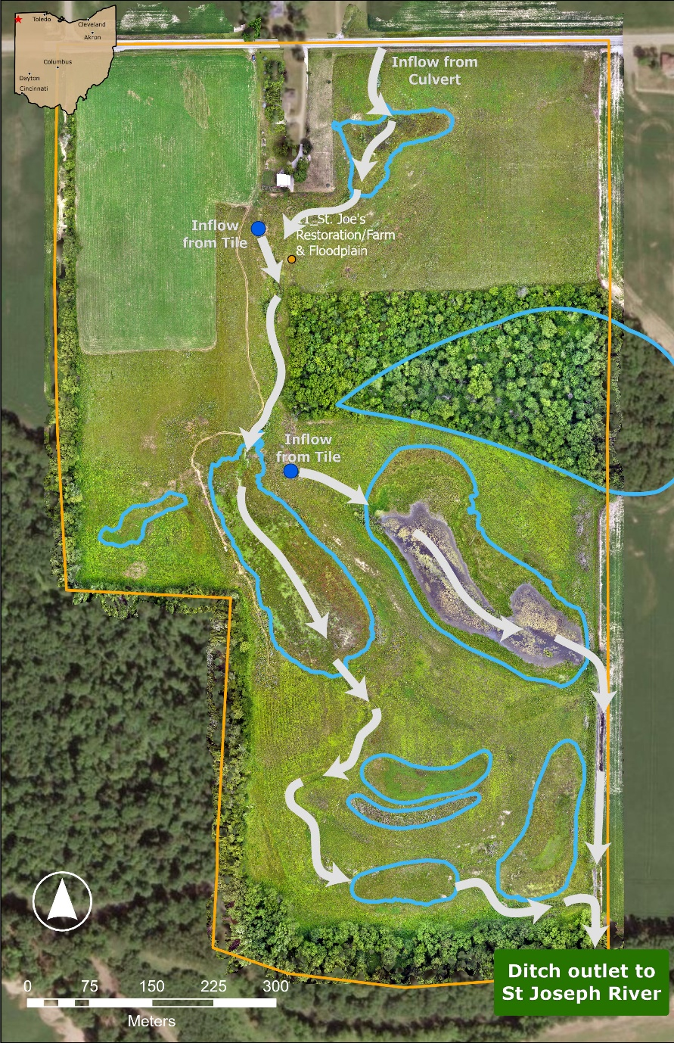
Figure 29. SJRE Flowpath Map. Blue outlines indicate wetland pools and arrows represent water flow direction.

Data used
Table 18. Datasets used in nutrient budget calculations.
Dataset Name | Source | Duration | Data Type
Rainfall 2023 | NOAA | WY 2023 | Rainfall
Rainfall 2024 | H2Ohio WMP | WY 2024-present | Rainfall
Area- Velocity | H2Ohio WMP | 3/25/25-present | Velocity, Water level
Weather | Iowa Mesonet | 10/1/22-present | Wind speed, min/max air temp, min/max relative humidity, Atmospheric pressure
Solar Radiation | NASA | 10/1/22-present | Solar radiation
SJRE Bathymetry | H2Ohio WMP | N/A | Bathymetry
Nutrients | H2Ohio WMP | WY 2022-present | TP, DRP, TN, Nox, Nh3
Water Level (VEGAPuls) | H2Ohio WMP Sensor Network | 2023/06-present | Water Level

Volume Budgeting
Flow at St. Joseph’s was calculated across two main flow paths:
Flow path B:
Flow path B receives water from both the Northeast (NE) tile drain and as a floodplain for the St. Joseph river when it backflows into Pool B through the agricultural ditch that drains the project (known as the East Ditch). The majority of water in the flow path is stored in Pool B, which is where we focused our budget. We created a stage-storage model to estimate the inflowing volume of water. We used bathymetric data of the pool to calculate the volume of the pool for every 0.2 meters of water depth, created a generalized additive model to create a curve, and then applied that model to estimate the volume for every depth measured by the VegaPuls C2 water level sensor located near the middle of Pool B. We calculated the mean depth for each day to minimize noise in our sensor (that occurs largely due to vegetation blocking the sensor), calculated volume with our bathymetric model, and then calculated the change in volume between each day. We summed all positive changes in volume to calculate the volume of water flowing into the pool. Starting in water year 2025 we directly measured outflow volumes from pool B using an area-velocity meter (ISCO 6172 Auto-analyzer paired with an ISCO 750 Flow Module and Low Profile Area Velocity Level Sensor) that measured velocity, flow direction, and water depth in the channel flowing out of the site at 5 minute intervals. We calculated volume from velocity by calculating the area of the channel as an irregular trapezoid. However, due to a beaver building a dam on top of the flow meter values were not consistently accurate and the area of the channel was altered, so directly measured flow was not used to estimate volume, but was used to identify when backflow was occurring to select appropriate nutrient concentrations.We instead calculate daily outflow as the sum of all negative changes in volume plus evapotranspiration for the area of the pool (assumes no significant transfer to or from groundwater).
We are calculating evapotranspiration using the Penman-Monteith equation:
ET0=0.408∆(Rn-G)+γ900T+273u2(es-ea)∆+γ(1+0.34u2)
Where ET_{o} reference evapotranspiration [mm day⁻¹], R_{n} net radiation at the crop surface [MJ m⁻² day⁻¹], G soil heat flux density [MJ m⁻² day⁻¹], T mean daily air temperature at 2 m height [°C], u₂ wind speed at 2 m height [m s⁻¹], e_{s} saturation vapour pressure [kPa], e_{a} actual vapour pressure [kPa], e_{s} - e_{a} saturation vapour pressure deficit [kPa], D slope vapour pressure curve [kPa °C⁻¹], g psychrometric constant [kPa °C⁻¹]. Historical weather data was downloaded from Iowa Mesonet, and solar radiation data was downloaded from NASA.
Flow path C:
Flow path C receives water from the tile drains. Pools A and C are not connected to the floodplain portion of the site, but Pool G near the end of the flow path also receives flood water from the East Ditch and St. Joseph River. We used bathymetric data of pool C and water depth measured using a VegaPuls C2 water level sensor and created a generalized additive model to predict the volume based on the depth of the pool. We calculated the mean depth for each day to minimize noise in our sensor (that occurs largely due to vegetation blocking the sensor), calculated volume with our bathymetric model, and then calculated the change in volume between each day. We summed up all positive changes in volume to calculate the volume of water flowing into the pool. We calculated daily outflow as the sum of all negative changes in volume minus evapotranspiration for the area of the pool. We are calculating evapotranspiration using the Penman-Monteith equation as we did for Pool B.

Nutrient Concentrations
Surface water samples were collected from all Locations of Interest at this Project approximately every 4 weeks.
Flow path B:
Baseflow concentrations were calculated as the average monthly baseflow concentration across all years in the database because our data for the site is limited. For the inflow baseflow concentrations we used the mean monthly concentration for the three tile drains that enter the site (SJRE_01, SJRE_02, SJRE_03). For outflowing baseflow concentrations we used concentrations from pool B at both the center of the pool and the outlet (SJRE_05, SJRE_41). Storm inflow concentrations were calculated as the mean concentration from 6 storm grab samples at the three tile drain inflows (SJRE_01, SJRE_02, SJRE_03). Storm outflow concentrations were calculated as the mean concentration from 7 storm grab samples within Pool B (SJRE_05, SJRE_41). For days when backflow was detected by the velocity sensor backflow concentrations were calculated as the mean concentration from 4 storm events that were fully characterized using an ISCO (n samples = 21, 24, 24, 23 respectively for each storm event). Out of 11 total storm events, 4 were characterized with ISCO sampling at the outlet, and grab samples were collected for 7 storm events.
Flow path C:
Baseflow concentrations were calculated as the average monthly baseflow concentration across all years in the database because our data for the site is limited. For the inflow baseflow concentrations we used the mean monthly concentration for pool C (SJRE_06). For outflowing baseflow concentrations we used concentrations from pool G which is further down the flow path from pool C (SJRE_10). Storm inflow concentrations were calculated as the mean concentration from 5 storm grab samples at pool C (SJRE_06). Storm outflow concentrations were calculated as the mean concentration from 4 storm grab samples within Pool G (SJRE_10). Out of 11 total storm events, grab samples were collected for 5 storm events.

Nutrient Load Calculation
Monthly mean concentrations were applied across each month except for storm days that were replaced with the mean storm concentration to create daily inflow and outflow nutrient concentrations. Daily inflow and outflow nutrient concentrations were multiplied by daily inflow and outflow volumes to calculate the mass of each nutrient entering and leaving the site. Retention was calculated as the difference between the mass of each nutrient entering and leaving the site. Daily values were summed to calculate monthly and yearly nutrient loading and retention.

Assumptions, Uncertainties, and Data Gaps
This approach assumes no meaningful net influence of groundwater to input or output nutrient loads. This approach assumes that mean backflow nutrient concentrations during storms in 2025 are representative of storms in 2024 as well. There is a data gap in the pool C flow path water level data (and thus all nutrient budget data) from 2024-08-05 to 2025-03-03. When outflow equals inflow there is no change in water level yet there can be large outflow, and there can be outflow even when the volume is increasing, so this algorithm will likely underestimate outflow. Likewise, inflow can be underestimated for the same reason, outflow can be occurring while there is inflow and that will reduce the change in volume. This rapid flow may have minimal effects on nutrient budgeting because of how rapidly it moves through the system, but higher frequency nutrient data, and more accurate flow data is needed to verify whether that is true.

Springcreek Confluence Off-Channel Wetlands (SPRC)

Introduction
The hydrology at Springcreek Confluence Off-Channel Wetlands is passively managed. The Project (25 acres of restored wetland) is a permanently flooded off-channel wetland consisting of two floodplain pools that are connected to one another by a channel. The North Pool exchanges water with Spring Creek, while the South Pool exchanges water with the Great Miami River. A hydrologic event at this Project is operationally defined as an event in which the Great Miami River and Spring Creek flood the wetland pools, possible at discharges of at least 5,250 cubic feet per second (cfs) and 203 cfs, respectively. Groundwater wells would be needed at the Project to determine if groundwater is entering the site.

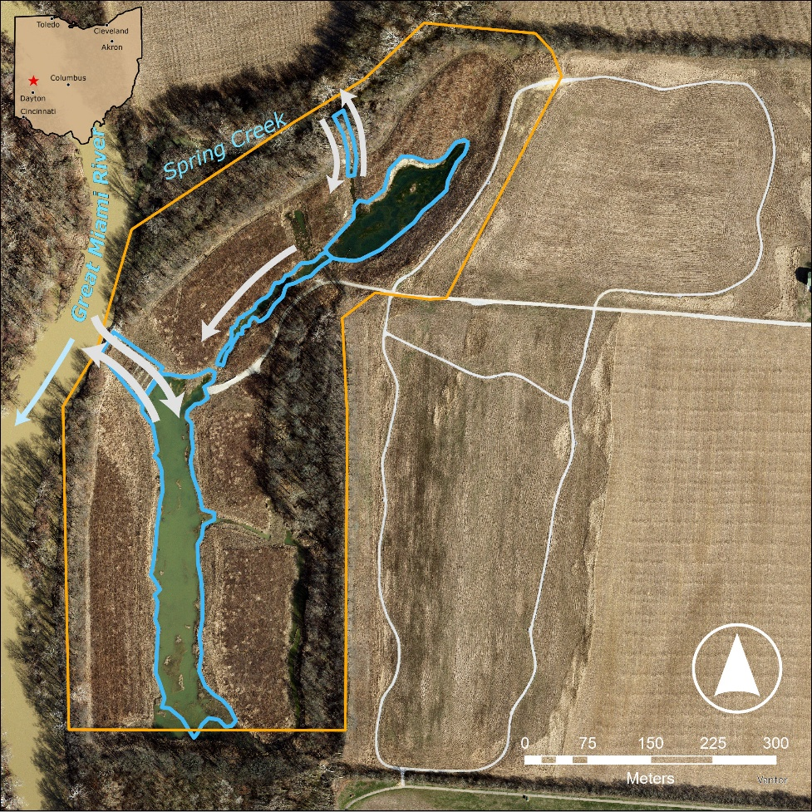
Figure 30. SPRC Flowpath Map. Blue outlines indicate wetland pools and arrows represent water flow direction.

The nutrient budget for Springcreek Wetland is the sum of the nutrient budgets for its North Pool and its South Pool. Daily pool inflow volumes were calculated by first estimating pool volume from sensor-supplied water height and Miami Conservancy’s bathymetry data and then filtering net positive changes from day to day. Daily inflow volumes (L) during baseflow conditions were multiplied by the average monthly nutrient concentration (mg/L) at each location of interest (LOI) to estimate total nutrient mass loads (mg). During storm events (i.e., dates during which the discharge of the Great Miami River at Troy reaches or exceeds 5,250 cubic feet per second), daily inflows (L) were multiplied by the average event nutrient concentration (mg/L) at each LOI to estimate total nutrient mass loads (mg). Total daily nutrient mass loads (mg) are summed by month and LOI.

Monthly Springcreek load in = Monthly North Pool load in + Monthly South Pool load in
Monthly Springcreek load out = Monthly North Pool load out + Monthly South Pool load out

Monthly nutrient load filtered by Springcreek = Monthly Springcreek load in - Monthly Springcreek load out

Data used
Table 19. Datasets used in volume and nutrient budget calculations
Dataset Name | Source | Duration | Data Type
River Flow | USGS NWIS | 10/1/21-present | Daily water flow in the Great Miami River at Troy OH in cubic feet per second
Nutrients | H2Ohio WMP | 5/7/21-9/9/25 | TP, DRP, TN, NOx, NH3
North Pool 2024 gapfill | Wright State University | 4/2/24-4/17/24 | Daily South Pool water volume
Water Level (HOBO/Solinst) | H2Ohio WMP | 11/8/21-present | Water Level

Volume Budgeting
Researchers at Miami Conservancy District (MCD) calculated pool volume by using bathymetric data. Relationships between surface water elevation and pool volumes were fit to cubic polynomial regressions. Average daily depths from water level loggers were translated to surface water elevations from which pool volumes were calculated. At surface water elevations above 828 ft, the cubic polynomial regression no longer applies. Therefore, volumes were calculated using the following conversion: 1 acre foot of water = 325,581 gallons. Max pool volume was added to the volume of water calculated using the conversion and total wetland pool acreage.

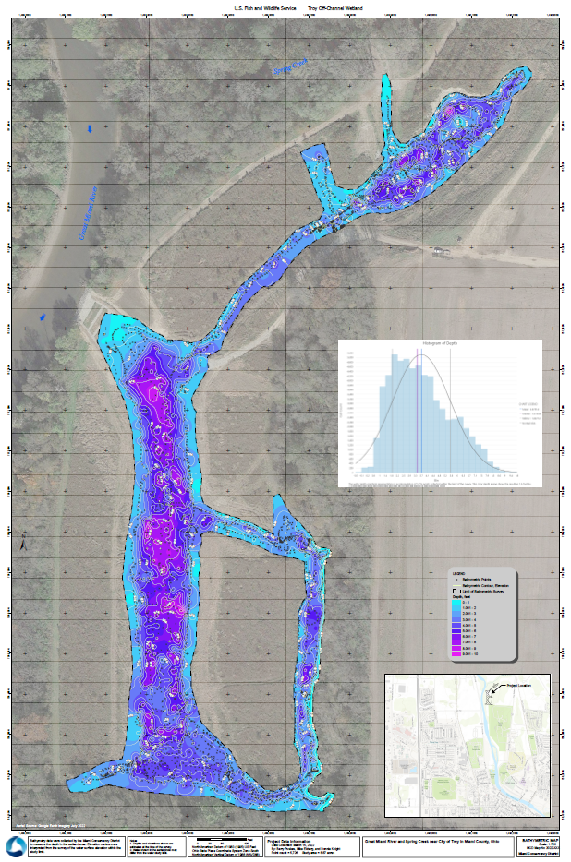
Figure 31. Bathymetry map of Springcreek Confluence Off-Channel Wetlands as provided by Miami Conservancy District.
Water heights in both the North and South Pool were recorded by sensors starting in November 2021 in 30 minute intervals. Dates during which the sensor was broken, removed, or reporting unusable data were identified by technicians at WSU, and the data for these dates were removed from calculations. Each day’s mean daily water height in feet was then added to the sensor’s elevation in feet at that time (dates and elevations provided by WSU techs) to find the water surface’s elevation.

Table 20. Sensors deployed at Springcreek Confluence Off-Channel Wetlands.
Sensor Number | Duration | Make | Model | SKU
HOBO 35 | 2022-05-24 to 2023-11-30 | HOBO | HOBO MX2001 | MX2001 – Top
HOBO 36 | 2021-11-08 to 2022-12-21 | HOBO | HOBO MX2001 | MX2001 – Top
HOBO 37 | 2021-11-08 to 2022-05-17 | HOBO | HOBO MX2001 | MX2001 – Top
HOBO 39 | 2022-08-11 | HOBO | HOBO MX2001 | MX2001-04-S
HOBO 50 | 2023-02-09 to 2023-11-30 | HOBO | HOBO 13ft Fresh Water | U20L
WLL 6 | 2023-11-29 to present | Solinst | Solinst Levelogger 5
WLL 8 | 2023-11-29 to 2025-04-23 | Solinst | Solinst Levelogger 5
WLL 26 | 2025-03-10 to present | Solinst | Solinst Levelogger 5

The pools’ volumes in gallons were calculated as described below:

North Pool volume when the water surface’s elevation is over 828 feet (i.e., full capacity) =
3397266 + (325851 * 2.69 * (elevation_ft - 828))
such that
3,397,266 = volume of the North Pool at 828 ft (full capacity),
325,851 = gallons of water in an acre foot,
2.69 = floodplain acreage of the North Pool
North Pool volume when the water surface’s elevation is under or at 828 feet =
3866.66 * (elevation_ft ^ 3) - (9492338.86 * (elevation_ft ^ 2)) + (7767632310.25 * elevation_ft) - 2118762457458.17
as calculated from bathymetry data

South Pool volume when the water surface’s elevation is over 828 feet (i.e., full capacity) =
14172870 + (325851 * 12.2 * (elevation_ft - 828))
such that
14,172,870 = volume of the South Pool at 828 ft (full capacity)
325,851 = gallons of water in an acre foot
12.2 = floodplain acreage of the South Pool
South Pool volume when the water surface’s elevation is at or under 828 feet =
9317.5701086139 * (elevation_ft ^ 3) - (22816397.8919351 * (elevation_ft ^ 2)) + (18623801908.7201 * elevation_ft) - 5067181357823.19
Most volumes for the dates that were previously removed (i.e., when the sensor was broken, removed, or reporting unusable data) were estimated by using the relationship between the two pools (described below). During one extreme storm event, however, the relationship as calculated did not work well. Experts at WSU had made note of this possibility before calculations began and estimated the North Pool volume based on field observations of the water surface’s height in the North Pool and comparison to the South Pool.

Table 21. List of gaps in hydrology data for Springcreek Confluence Off-Channel Wetlands.
Pool | Duration | Reason for Gap | Method of Gap-filling
North Pool | 2024-04-02 to 2024-04-17 | Solinst sensor was washed out during a large storm event, and the gap-filling equation made in the code does not address events of this magnitude well. | Estimation by Wright State University experts based on field observations of water height in the North Pool and its relationship with the South Pool.
South Pool | 2022-12-22 to 2023-02-03 | HOBO sensor was broken | Gap-filling equation in code to estimate South Pool volume from North Pool
North Pool | 2022-05-18 to 2022-07-05 | HOBO sensor was broken | Gap-filling equation in code to estimate North Pool volume from South Pool
North Pool | 2022-07-14 to 2022-08-10 | HOBO sensor was broken | Gap-filling equation in code to estimate North Pool volume from South Pool
North Pool | 2023-07-30 to 2023-12-02 | HOBO sensor was broken | Gap-filling equation in code to estimate North Pool volume from South Pool
North Pool | 2023-12-11 to 2023-12-16 | Solinst sensor was broken | Gap-filling equation in code to estimate North Pool volume from South Pool
North Pool | 2024-11-29 to 2025-03-10 | Solinst sensor was broken | Gap-filling equation in code to estimate North Pool volume from South Pool

When the relationships between pools were applied to estimate pool volume, they followed the scheme below. Three main linear relationships emerged between the North and South Pools: low volume relationship, medium volume relationship, high volume relationship. Note that the code is built to automatically use the coefficient that the model provides; the exact coefficients may change with more years of data.

Table 22. Scheme of applying interpool relationships in calculating pool volume at Springcreek Confluence Off-Channel Wetlands.
Pool Volume to Estimate | Defining Pool Volume | Relationship as Listed in Code
North Pool | South Pool > 25,000,000 L | South Pool to North Pool: LOW
North Pool | 25,000,000 L =< South Pool =< 50,000,000 L | South Pool to North Pool: MEDIUM
North Pool | South Pool < 50,000,000 L | South Pool to North Pool: HIGH
South Pool | North Pool > 3,650,000 L | North Pool to South Pool: LOW
South Pool | 3,650,000 L =< North Pool =< 3,800,000 L | North Pool to South Pool: MEDIUM
South Pool | North Pool < 3,800,000 L | North Pool to South Pool: HIGH

Finally, the daily change in volume for each pool was calculated by subtracting the current day’s volume from the previous days. The dataset was then filtered to retain only positive changes, so that only inflow volumes were recorded.

Nutrient Concentrations
Table 23. List of locations of interest (LOIs) used in the calculation of the nutrient budget for Springcreek Confluence Off-Channel Wetlands. Note that the intended sampling frequency is the frequency as reported in the Project-Specific Monitoring Plan, and that samples are not always able to be taken at this rate due to extenuating circumstances (e.g., inclement weather, staffing schedule changes, dry pools, etc.)
Location of Interest (LOI) | Pool | Inflow or Outflow | Intended Sampling Frequency
SPRC_01 | North Pool | Inflow | Monthly
SPRC_02 | North Pool | Outflow | Monthly
SPRC_05 | South Pool | Inflow | Monthly
SPRC_04 | South Pool | Outflow | Monthly

Baseflow nutrient concentrations were averaged per single month at each LOI. Because each LOI is sampled approximately monthly, this means that this monthly average usually equals the concentration of the only baseflow sample taken that month. Occasionally there were two baseflow samples taken in a month, in which case the monthly average concentration is the mean of the two concentrations. When a monthly sample was missed, it was estimated as the average monthly nutrient concentration at that LOI across years. Note that for future water year nutrient budget calculations, there is code written to find the average concentration at each LOI by season and flow as reported by the USGS gage Great Miami River at Troy OH, but there is currently not enough data to incorporate this.
Event nutrient concentrations (as reported by WSU techs in metadata according to the event definition as when discharge of the Great Miami River at Troy reaches or exceeds 5,250 cubic feet per second) were averaged per month at each LOI across all years of available data. During WY 2025, WSU measured nutrient concentrations during two of the four storm events.

Nutrient Load Calculation
Dates were defined as event dates when the USGS gage for the Great Miami River at Troy OH reported discharge of at least 5,250 cubic feet per second. All other dates were defined as baseflow dates. Event dates’ inflow volumes (L) were multiplied by the average event concentration (mg/L) at that LOI to find that LOI’s mass load (mg). Baseflow dates’ inflow volumes (L) were multiplied by that month’s average concentration (mg/L) at that LOI to find that LOI’s mass load (mg). Inflows, baseflow loads, and event loads were summed by month for each LOI. Total inflow load was calculated as the sum of the load from the North Pool’s inflow (i.e., LOI 01) and the load from the South Pool’s inflow (i.e., LOI 05). Total outflow load was calculated similarly (i.e., with the load from the North Pool’s outflow, LOI 02, and the load from the South Pool’s outflow, LOI 05). The monthly mass load that the wetland filtered was calculated as the monthly total outflow load subtracted from the monthly total inflow load.

Monthly North Pool load in =
(Monthly North Pool baseflow inflow * monthly average concentration at LOI 01) +
(Monthly North Pool event inflow * average event concentration at LOI 01)

Monthly North Pool load out =
(Monthly North Pool baseflow inflow * monthly average concentration at LOI 02) +
(Monthly North Pool event inflow * average event concentration at LOI 02)

Monthly South Pool load in =
(Monthly South Pool baseflow inflow * monthly average concentration at LOI 05) +
(Monthly South Pool event inflow * average event concentration at LOI 05)

Monthly South Pool load out =
(Monthly South Pool baseflow inflow * monthly average concentration at LOI 04) +
(Monthly South Pool event inflow * average event concentration at LOI 04)

Monthly Springcreek load in = Monthly North Pool load in + Monthly South Pool load in
Monthly Springcreek load out = Monthly North Pool load out + Monthly South Pool load out

Monthly nutrient load filtered by Springcreek =
Monthly Springcreek load in - Monthly Springcreek load out

Assumptions, Uncertainties, and Data Gaps
This approach assumes no meaningful net influence of groundwater to input or output nutrient loads. It also assumes that LOI SPRC_04 functions similarly to an outflow. This approach does not include evapotranspiration calculations.

City of St. Marys Treatment Train (STMA)

Introduction
City of St. Marys Treatment Train is an actively managed 60 acre restored wetland that treats water from the Miami Erie Canal in St. Marys OH. The primary flowpath inflows water via a gate valve (controlled by the city of St. Marys) from the Miami Erie Canal that then flows through ~0.8 miles of marsh flats and shallow pools before being pumped back into the Miami Erie Canal further downstream. There is no evidence of groundwater exchange at this site. Free flow over flat weir in water level control structures (WLCS; Agri Drain) is currently measured by the wetland manager. A hydrologic event at this site is defined as whenever the inflow gate valve is open.
The nutrient budget was calculated by first calculating the inflow and outflow discharge volumes. The nutrient concentrations of the Inflow (Canal) and Outflow (Outflow Settling Pool) were averaged into seasonal concentrations only while there was active inflow. Daily loads retained were then calculated as inflow load - outflow load, with positive values indicative of loads retained and negative values indicative of loads exported.
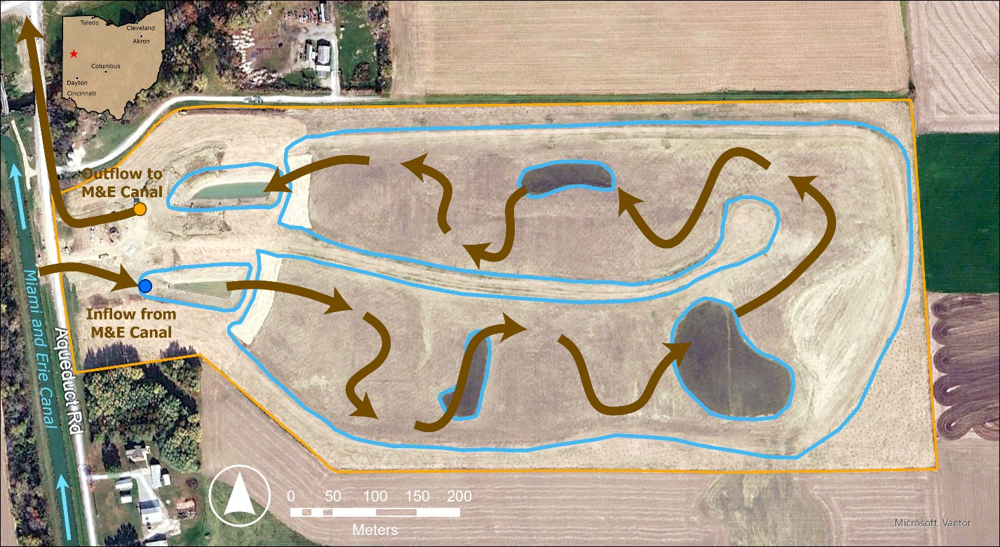
Figure 32. STMA Flowpath Map. Blue outlines indicate wetland pools and arrows represent water flow direction.

Data used
Table 24. Datasets used in volume and nutrient budget calculations.
Dataset Name | Source | Duration | Data Type
Nutrients | H2Ohio WMP | 5/20/25-9/23/25 | TP, DRP, TN, Nox, NH3
Flow | St. Marys | 7/29/25-9/26/25 | Flow

Volume Budgeting
Inflow and outflow discharge volumes were calculated for the dates in which free flow was measured by the wetland manager using a flow over flat weir equation. Inflow discharge was calculated as follows:

Volume=1495(4.0-0.2H)H^1.5

where volume is in gallons per minute and H is the depth of free flow over the weir in feet. Outflow discharge was calculated as follows:

if H≤0.27W,Q=3.19924(W-0.74H)H^1.48 if H>0.27W,Q=3.0318WH^1.37

where H is the height of water above the stop log in inches, W is the width of the weir (for this project W=29.31) and Q is the flow rate in gallons per minute. These inflow and outflow discharge values were then converted to gallons per day.

Nutrient Concentrations
Surface water samples were collected from the Inflow Canal (STMA_01) and Outflow Settling Pool (STMA_03) on a biweekly basis. An event at this project is defined as any time the inflow gate valve is open.

Nutrient Load Calculation
Nutrient loads were calculated for each date in which a flow measurement was taken. Loads were calculated as:
load=[avg seasonal concentration * 0.0022046 * volume ]/[0.26417*1000]
where load is in pounds, concentrations are in mg/L, and volume is in gallons. Daily loads retained were then calculated as inflow load - outflow load, positive values indicative of loads retained and negative values indicative of loads exported. These daily loads were then multiplied by the number of days till the next free flow measurement in order to obtain weekly load retained. These weekly sums were totaled to obtain a yearly total load retained.

Assumptions, Uncertainties, and Data Gaps
This approach assumes no meaningful net influence of groundwater to input or output nutrient loads. It also assumes that inflow and outflow volumes stay constant until another measurement was taken/inflow weir or outflow stoplog height was adjusted. It is assumed that storms do not play a major role at this wetland because all inflow water is delivered by pump.

Tipp City Off Channel Wetland (TIPC)

Introduction
Tipp City contains 10 acres of restored wetland in Miami County. The wetland was engineered to function as an off-channel, or side channel, wetland to intercept and capture water from the Great Miami River. The primary input is a notch that connects the river to the wetland pool. The primary output is the same notch. However, most of the time water generally flows into the pools and fills the pool, and it will not flow out aside from evaporation and any infiltration through soil. During the characterization process, researchers found no evidence of groundwater seeps or springs. There are no water level control structures or pumps at this project. There is no active management at this project. A hydrologic event is operationally defined as a flow event when the river discharge rate at the inflow notch reaches approximately 2,627 cubic feet per second, causing river water to flood the wetland pool.
The general approach researchers took to calculate nutrient filtration at this project was to first assume that any water that enters from river is processed by the wetland. Effectively, researchers calculated the difference in mass of nutrients in water entering from the river and mass of nutrients leaving from the wetland , and assume the difference is what was transformed or processed by the wetland. Positive water level change in the wetland pool was used to estimate the “inflow” volume (assuming any change in volume was due to water flowing in from the river). Water volume loss due to evaporation was subtracted from negative water level changes to identify the amount of water flowing out of the wetland. Outflowing volume was multiplied by pool concentrations to calculate the outflowing load, and inflowing volume was multiplied by river concentrations to calculate the inflowing load.
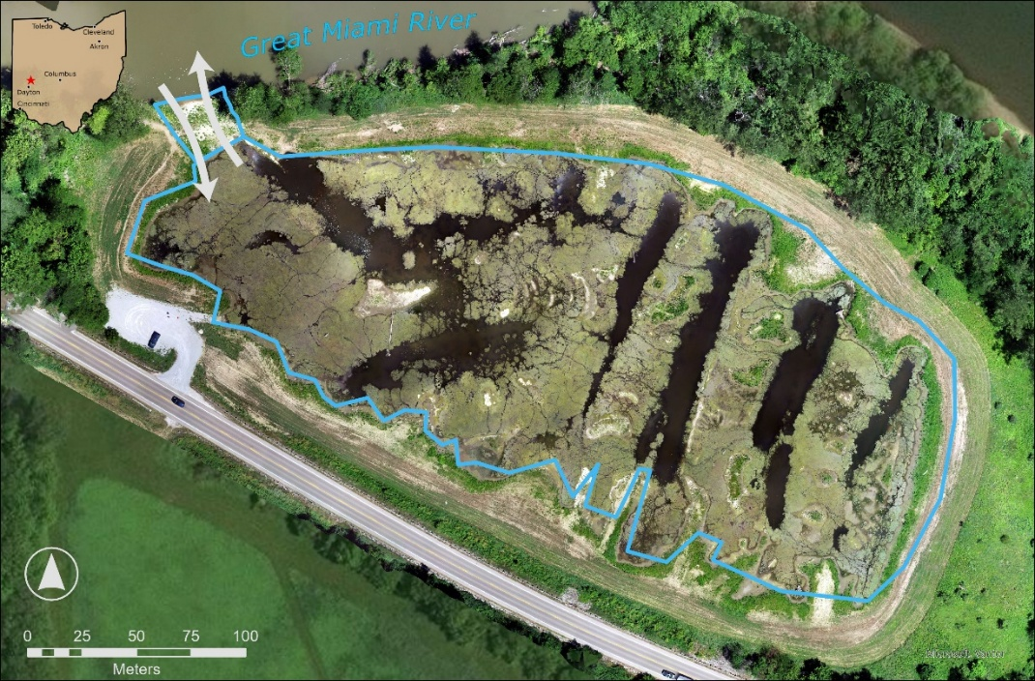
Figure 33. TIPC Flowpath Map. Blue outlines indicate wetland pools and arrows represent water flow direction.

Data used
Table 25. Datasets used in volume and nutrient budget calculations.
Dataset Name | Source | Duration | Data Type
Water Level (VHOBO) | H2Ohio WMP | daily average of data logged every 30 minutes; WY 2023 - WY2025 | Water Depth
Weather | Iowa Mesonet | N/A | Wind speed, min/max air temp, min/max relative humidity, Atmospheric pressure
Solar Radiation | NASA | N/A | Solar radiation
Bathymetry | Miami Conservancy District | N/A | Bathymetry
Nutrients | H2Ohio WMP | WY 2023-WY 2025 | TP, DRP, TN, Nox, NH3

Volume Budgeting
Water volume was calculated as a stage storage model, using bathymetry of the wetland to create a linear model based on water depth:
(volume (gallons) = (depth (feet) * 326000 * 7) + (577411.2)
Where:
- Depth: daily value from sensor (ft)
- 326,000: to convert ft to acre ft
- 7: approximate area (acres) of wetland pool
- 577,411.2: remaining volume of water that is assumed to be permanently/persistently present in the deepest areas of the wetland (gal)

Water depth data was collected using aHOBO water level logger (measurement frequency = 30 minutes) and average daily depths were used to calculate daily volume for the pool using the equation above. At a monthly time scale, inflowing volume was calculated the sum of all increases in volume in the pool, while outflowing volume was calculated as the sum of all decreases in volume followed by subtracting the volume of water lost to evapotranspiration.
Researchers calculated evapotranspiration using the Penman-Monteith equation:
ET0=0.408∆(Rn-G)+900T+273u2(es-ea)∆+(1+0.34u2)
Where ET_{o} reference evapotranspiration [mm day⁻¹], R_{n} net radiation at the crop surface [MJ m⁻² day⁻¹], G soil heat flux density [MJ m⁻² day⁻¹], T mean daily air temperature at 2 m height [°C], u₂ wind speed at 2 m height [m s⁻¹], e_{s} saturation vapour pressure [kPa], e_{a} actual vapour pressure [kPa], e_{s} - e_{a} saturation vapour pressure deficit [kPa], D slope vapour pressure curve [kPa °C⁻¹], g psychrometric constant [kPa °C⁻¹]. Historical weather data was downloaded from Iowa Mesonet, and solar radiation data was downloaded from NASA.

Nutrient Concentrations
Surface water samples were collected from Monroe Creek (Inflow; MERW_11) and Outflow Pool (outflow; MERW_13) on a bi-weekly basis. Monroe Creek (Inflow) and Outflow Pool (Phase 3) concentrations were calculated as a seasonal average.

Nutrient Load Calculation
Seasonal mean concentrations were applied across each month to calculate inflowing and outflowing load. Seasonal inflow and outflow nutrient concentrations were multiplied by daily inflow and outflow volumes to calculate the mass of each nutrient entering and leaving the site for each day. Retention was calculated as the difference between the mass of each nutrient entering and leaving the site. Daily values were summed to calculate monthly and yearly nutrient loading and retention.

Assumptions, Uncertainties, and Data Gaps
This approach assumes no meaningful net influence of groundwater to input or output nutrient loads. It assumes no meaningful increases to pool volume from precipitation, and that any positive volume change was an increase in water due to inflow via the inflow notch.

Trumbull Creek Wetland (TRUC)

Introduction
The Trumbull Creek Project is built on past agricultural land which was converted into forested wetland, marsh, and upland forest in December 2021. A new rendition of the hummock-hollow design was used at this site. The Trumbull Creek Project receives no major nutrient loads, and the primary nutrient retention benefit of the Project is its conversion from agricultural land use to wetland. The Project is located in the middle of a watershed divide between Mill Creek and Bronson Creek and is not directly connected to any streams, tile drain outlets, or other potential nutrient inputs. There is no evidence of surface/groundwater exchange. Precipitation is the primary input of water to the Project. The outflow is a passively managed agridrain water level control structure (WLCS) with plates set to determine the maximum water height in the wetland. Outflow from the WLCS is the main hydrologic event of interest related to the nutrient budget. Outflow events can occur year-round, after heavy rain events or after mid-winter thaw events. A rain event at this project is defined as >0.5 inches of rain within 48 hours as measured by the nearest USGS gage (414514081174400), though an event of this magnitude does not necessarily equate to an outflow event. The outflow volume of water from the site was estimated using a flow over flat-weir equation provided by Agridrain combined with continuous water level data from a sensor located in the WLCS pool. The coupled with water samples measuring nutrient concentrations was used to estimate the export of nutrients from the wetland. It was assumed that no nutrients entered the wetland.

Data used
Table 26. Datasets used in nutrient budget calculations.
Dataset Name | Source | Duration | Data Type
Nutrients | H2Ohio WMP | WY 2022-present | TP, DRP, TN, NOx, Nh3
TRUC Water Level | H2Ohio WMP | 2024-09-26-present | Water level
Agridrain Flow Equation | Agri Drain | N/A | Equation
Weather | Iowa Mesonet | 10/1/22-present | Wind speed, min/max air temp, min/max relative humidity, Atmospheric pressure

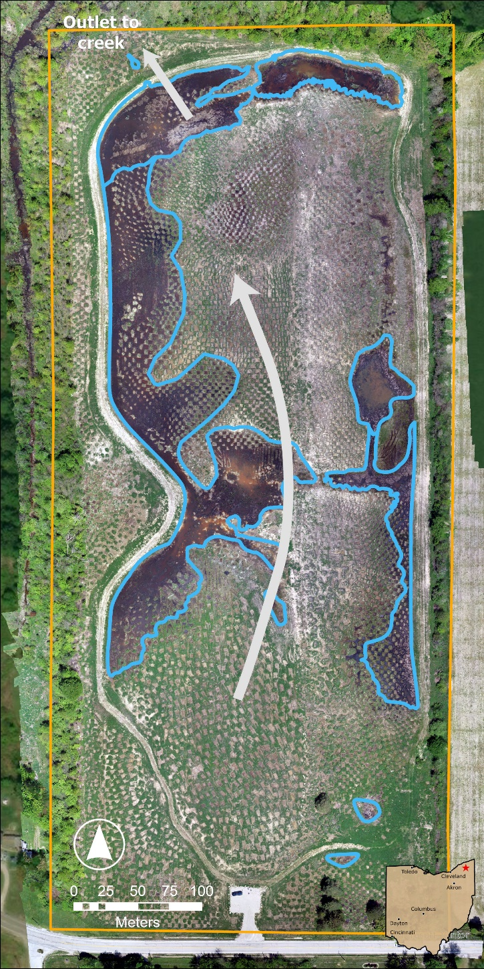
Figure 34. TRUC Flowpath Map. Blue outlines indicate wetland pools and arrows represent water flow direction.

Volume Budgeting
Outflow was directly measured using a manufacturer-provided equation from Agridrain for flow over a flat-weir. The equation relates the height of the water above the stop-log board (H, inches) to the discharge over the weir (Q, gpm), given the width of the control structure (W, inches). For the Trumbull Creek Agridrain, the outlet uses an 18-inch control structure, which corresponds to a weir width of W = 22.31 inches (Agridrain equation, pg 1). Field technician observations from March 18, 2025 confirmed that outflow begins when the sensor in the WLCS pool reading is >= 734 mm. Therefore, the hydraulic head above the stop log was defined as zero for sensor readings below 734 mm, and the difference of the measured height and 734 mm for sensor readings at or above 734 mm. These values were then converted from mm to inches for use in the agridrain equation. The agridrain flat-weir rating equation is as follows:
For 0 < H 0.27W:
Q = 3.19924(W - 0.74H)H1.48
For H > 0.27W:
Q = 3.0318WH1.37
Where:
H = height of water above the stop log (inches)
W = width of the control structure (inches)
Q = flow rate (gpm)
The discharge was calculated for each WCS sensor measurement, taken at ten minute intervals, and converted into liters per second. This gave an estimate of discharge for every ten minutes. Outflow discharge rates were averaged daily and multiplied by 24 hours to get a total volume of water for each day. To avoid noise and inaccurate readings from snow and ice, only sensor values from the time period where no ice was observed by the technician (before November 20, 2024 and after March 18, 2025) were used. Otherwise, a daily discharge rate was calculated for each day since the installation of the water level sensor on September 26, 2024.
We additionally estimated how much runoff there would have been if there was not a wetland on site using the drainage area of the project calculated using a digital elevation model and the ‘flowdem’ package in R, and the National Resource Conservation Service (NRCS) curve number method (USDA-NRCS 2004). A curve number of 83 was selected because the drainage area is a mix of forest and agriculture so was classified as woods for a conservative estimate, and the soils were determined to be hydrologic group D (Ohio Department of Natural Resources SOILS MapServer). We used daily precipitation data from the nearest station to the project on the Iowa Environment Mesonet and calculated runoff for each day in the dataset.

Nutrient Concentrations
Concentrations were calculated as the average monthly nutrient concentrations across all years in the database because our data for the site is limited. For the outflow concentrations we used the mean monthly concentration for only the WCS pool (TRUC_04). Water samples are typically collected once per month, with additional samples collected following a 0.5 inch rain event at least once per season. Monthly nutrient concentrations were the average of baseflow and ‘event’ samples. A rain event typically did not correlate with an outflow of water, and does not represent a source of new nutrients brought into the wetland. Therefore, we felt justified including those values in the monthly average.
Winter nutrient concentrations were calculated two ways given the uncertainty surrounding thaw events. For a higher end concentration estimate, the average of all water samples from only the technician-observed thaw events in February. For a lower end concentration estimate, the nutrient concentrations from all water samples from November through February were used. For the concentrations we used the average from both the WCS pool and Outflow (TRUC_04 and TRUC_05).

Nutrient Load Calculation
Daily outflow volumes were multiplied by daily pool concentrations to calculate the mass of each nutrient leaving the site. Daily values were summed to calculate monthly and yearly nutrient exports.
Winter volume discharge was calculated by multiplying the cross sectional area of flow by the measured flow rate within the outflow culvert during a thaw event. Only one flow measurement from a thaw event was available for use. This rate was multiplied by the nutrient concentration to calculate the per second, per hour, and per day nutrient load for thaw events. The number of thaw events was estimated by comparing the ambient air temperature and precipitation conditions of the observed thaw events with those same conditions from 11/22/25-3/18/25 (the first and last fully thawed observations). This allowed us to create a threshold for estimating the number of thaw dates that occurred. The estimated number of thaw events was then multiplied by the winter daily nutrient load to calculate the total winter nutrient export.
In addition to the export of nutrients we also estimated how much runoff would have occurred if there were not a wetland on the site as the runoff volume calculated using the NRCS curve number method multiplied by the mean concentration for each month. This allowed us to compare 3 runoff scenarios: 1. If the area was agricultural field, 2. If the wetland was not constructed but was removed from agricultural production, 3. With the wetland constructed and functional.

Assumptions, Uncertainties, and Data Gaps
This approach assumes no meaningful input of nutrients to the site. This approach assumes there is no meaningful net influence of groundwater to input or output nutrient loads. The volume of water exported and duration of winter thaw events is unknown. Ice and snow cover under the water level sensors makes the data useless for estimation. Flow velocity was only measured for one thaw event. The weather conditions that lead to a thaw event export of nutrients is unclear. The concentration of nutrients in the winter thaw events is unknown, the duration of ice cover before the thaw event may influence the flux of nutrients from the soil to the water but this has not been investigated.

Upper Blanchard River Watershed Project (UPPB)

Introduction
The Upper Blanchard River Restoration Project is a flow-through wetland located off County Road 64, southeast of Forest, Ohio. An agricultural drainage ditch originates approximately 500m upstream of the site and conveys a combination of surface runoff and subsurface tile drainage into the property. This ditch delivers inflow to the main wetland pool, which is equipped with a water-control structure at its western edge and when open, discharges to a roadside ditch along County Highway 215. In addition to the main pool, the project includes a series of large, branching pools and an adjacent wet meadow. The branching pools lack water-control structures but appear to connect to the roadside ditch during high-water conditions, when water overtops the pool margins and drains directly to the ditch. There is no evidence of interaction with groundwater at this Project.

The nutrient budget for this site is calculated as the difference in monthly mean concentration in the main and branching pools multiplied by mean monthly pool volume. Volume was calculated using a stage storage model built using the change in depth over time at both the main pool and the branching pool. All increases in volume are considered to be inflows, whereas evapotranspiration is calculated to subtract from all decreases in volume to calculate outflow. This is combined with monthly mean nutrient concentrations to calculate the mass of each nutrient in and out of the wetland.
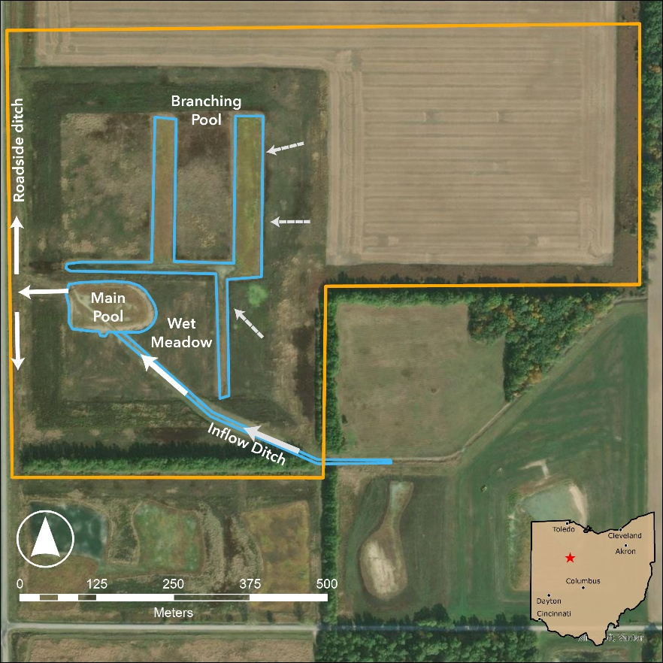
Figure 35. UPPB Flowpath Map. Blue outlines indicate wetland pools and arrows represent water flow direction.

Data Sources
Table 27. Datasets used in volume and nutrient budget calculations.
Dataset Name | Source | Duration | Data Type
Water Depth | H2Ohio WMP | WY 2022-present | Water Depth
Weather | Iowa Mesonet | 10/1/22-present | Wind speed, min/max air temp, min/max relative humidity, Atmospheric pressure
Solar Radiation | NASA | 10/1/22-present | Solar radiation
Pool Volumes | Mesmer Group | N/A | Constructed volumes
Pool Nutrients | NCWQR/H2Ohio WMP | WY 2022-present | TP, DRP, TN, Nox
Nutrients | H2Ohio WMP | WY 2022-present | TP, DRP, TN, Nox

Volume Budgeting
Main Pool:
The Main pool receives water from the overwide ditch and drains through the water control structure on the western side of the parcel. We created a stage-storage model to estimate the inflowing volume of water. We calculated the volume of the pool by multiplying the area of the pool by the depth measured by a VEGA PULS C21 sensor. We calculated the mean depth for each day to minimize noise in our sensor (that occurs largely due to vegetation blocking the sensor), calculated volume, and then calculated the change in volume between each day. We summed all positive changes in volume to calculate the volume of water flowing into the pool. We instead calculate daily outflow as the sum of all negative changes in volume plus evapotranspiration for the area of the pool (assumes no significant transfer to or from groundwater).
We are calculating evapotranspiration using the Penman-Monteith equation:
ET0=0.408∆(Rn-G)+γ900T+273u2(es-ea)∆+γ(1+0.34u2)

Where ET_{o} reference evapotranspiration [mm day⁻¹], R_{n} net radiation at the crop surface [MJ m⁻² day⁻¹], G soil heat flux density [MJ m⁻² day⁻¹], T mean daily air temperature at 2 m height [°C], u₂ wind speed at 2 m height [m s⁻¹], e_{s} saturation vapour pressure [kPa], e_{a} actual vapour pressure [kPa], e_{s} - e_{a} saturation vapour pressure deficit [kPa], D slope vapour pressure curve [kPa °C⁻¹], g psychrometric constant [kPa °C⁻¹]. Historical weather data was downloaded from Iowa Mesonet, and solar radiation data was downloaded from NASA.
Branching Pool:
The Branching pool receives water from overland flow, and only drains when it overtops the pool boundary. We created a stage-storage model to estimate the inflowing volume of water. We calculated the volume of the pool by multiplying the area of the pool by the depth measured by VEGA PULS C21. We calculated the mean depth for each day to minimize noise in our sensor (that occurs largely due to vegetation blocking the sensor), calculated volume, and then calculated the change in volume between each day. We summed all positive changes in volume to calculate the volume of water flowing into the pool. We instead calculate daily outflow as the sum of all negative changes in volume plus evapotranspiration for the area of the pool (assumes no significant transfer to or from groundwater).

Nutrient Concentrations
Nutrient concentration data for UPPB were collected in four primary locations, The main pool (UPPB_02), the branching pool (UPPB_03), the feeder stream (UPPB_01) that enters the main pool and the roadside ditch (UPPB_04). Baseflow collections were typically every two months between March and August, and storm sampling occurred sporadically throughout the period of record. Monthly mean concentrations were calculated for each site. The median concentration across all data was used to gapfill for any months where water samples were not taken. Concentrations from the feeder stream were used as the inflow for the Main Pool, and concentrations from the Main Pool were used as the outflow. For the branching pools concentrations in the pool were used to calculate both inflow and outflow concentrations, so the reduction in nutrients is primarily based on the volume of water retained by the pool. The roadside ditch values will be used as a comparison to the inflow stream, but were not used to calculate total nutrient mass or retention for the site.

Nutrient Load Calculation
Monthly mean concentrations were applied across each month for both the Main pool and the branching pool. Monthly inflow and outflow nutrient concentrations were multiplied by daily inflow and outflow volumes to calculate the mass of each nutrient entering and leaving the site. Retention was calculated as the difference between the mass of each nutrient entering and leaving the site. Daily values were summed to calculate monthly and yearly nutrient loading and retention.

Assumptions, Uncertainties, and Data Gaps
The water control structure on site has not been observed operating, but we assume that quick drawdown in water depth was caused by drawdown in nutrient values. Additionally, there are large gaps (2+ months) in the data within individual years, and we assume that median concentrations are representative of actual concentrations. There are also uncertainties about how storm events affect nutrient retention at the Project. There was not sufficient sampling to include storm events in the nutrient budget so it was assumed to not have a major effect on nutrient loading. There are also uncertainties about whether there are cryptic connections between the pools and nearby streams/creeks that may affect the flow of water between different compartments of the wetland.

Evapotranspiration Estimation
Reference evapotranspiration (ET₀) was calculated from meteorological data using the Penman-Monteith FAO-56 method (Allen et al., 1998), which requires air temperature, air humidity, wind speed, and radiation data. Daily meteorological inputs, including minimum and maximum air temperature, minimum and maximum relative humidity, and wind speed at 2 meters, were obtained from the nearest Ohio station of the Automated Surface Observing System (ASOS) network via the Iowa Environmental Mesonet (IEM). Where wind speed was only available at 10 meters, it was adjusted to the 2-meter reference height using the logarithmic wind profile equation (Allen et al., 1998). Atmospheric pressure was either obtained directly from ASOS station records or estimated from the elevation above sea level of the wetland project using the barometric formula:
$$P=P_{0}⋅{(\frac{T_{0}-L⋅h}{T_{0}})}^{\frac{g}{R⋅L}}$$
where $P$ is the atmospheric pressure (kPa) at $h$, $P_{0}$ and $T_{0}$ are respectively the reference pressure and temperature at sea level, $L$ is the temperature lapse rate in the troposphere, $h$ is elevation above sea level (m), $g$ is the gravitational acceleration, and $R$ is the universal gas constant for air. Daily solar radiation (MJ/m²/day) was sourced from the National Aeronautics and Space Administration (NASA) Langley Research Center's Prediction Of Worldwide Energy Resources (POWER) database using the wetland project coordinates and the nasapower R package (Sparks, 2018).
ET₀ was computed following the Penman-Monteith FAO-56 equation, which combines a radiation term (r_{s}) and an aerodynamic term (r_{a}) to estimate the evaporative demand of the atmosphere over a hypothetical reference crop (Allen et al., 1998). Key intermediate variables (e.g., slope of the saturation vapor pressure curve, the psychrometric constant, mean saturation and actual vapor pressure) were calculated from the daily meteorological inputs and project-specific parameters (latitude, elevation). Soil heat flux density ($G$) was assumed negligible for daily time-step calculations, consistent with FAO-56 guidance. Final ET₀ was expressed in both mm per day and inches per day.
References
Allen, R. G., Pereira, L. S., Raes, D., & Smith, M. (1998). Crop evapotranspiration: Guidelines for computing crop water requirements. FAO Irrigation and Drainage Paper No. 56. Food and Agriculture Organization of the United Nations.
Sparks AH (2018). “nasapower: A NASA POWER Global Meteorology, Surface Solar Energy and Climatology Data Client for R.” The Journal of Open Source Software, 3(30), 1035. 10.21105/joss.01035.

